Communication Passport
Accident and Emergency

Nursing and medical staff please look at my passport before you do any interventions with me.

Name:

Things you must know about me
These things are important to me
My likes and dislikes

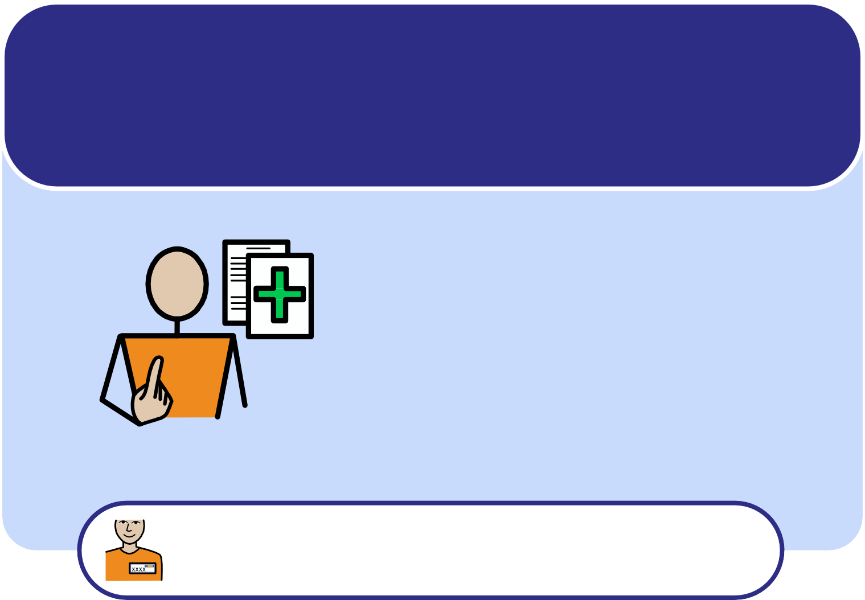
www.widgit-health.com
Gloucestershire Hospitals
NHS Foundation Trust
Royal Berkshire
NHS Foundation Trust

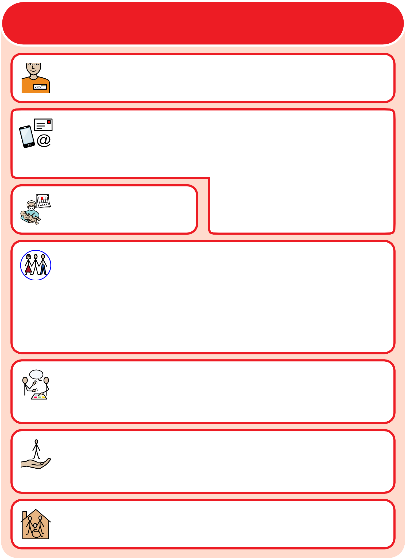
Things you must know about me

Name:

Like to be known as:

Phone: Address:

Email:

Date of birth:

Next of Kin contact: Address: Relationship (e.g. Mum):

Phone:

How I communicate/what language I speak:

My support needs and who gives me the most support:

Who I live with:

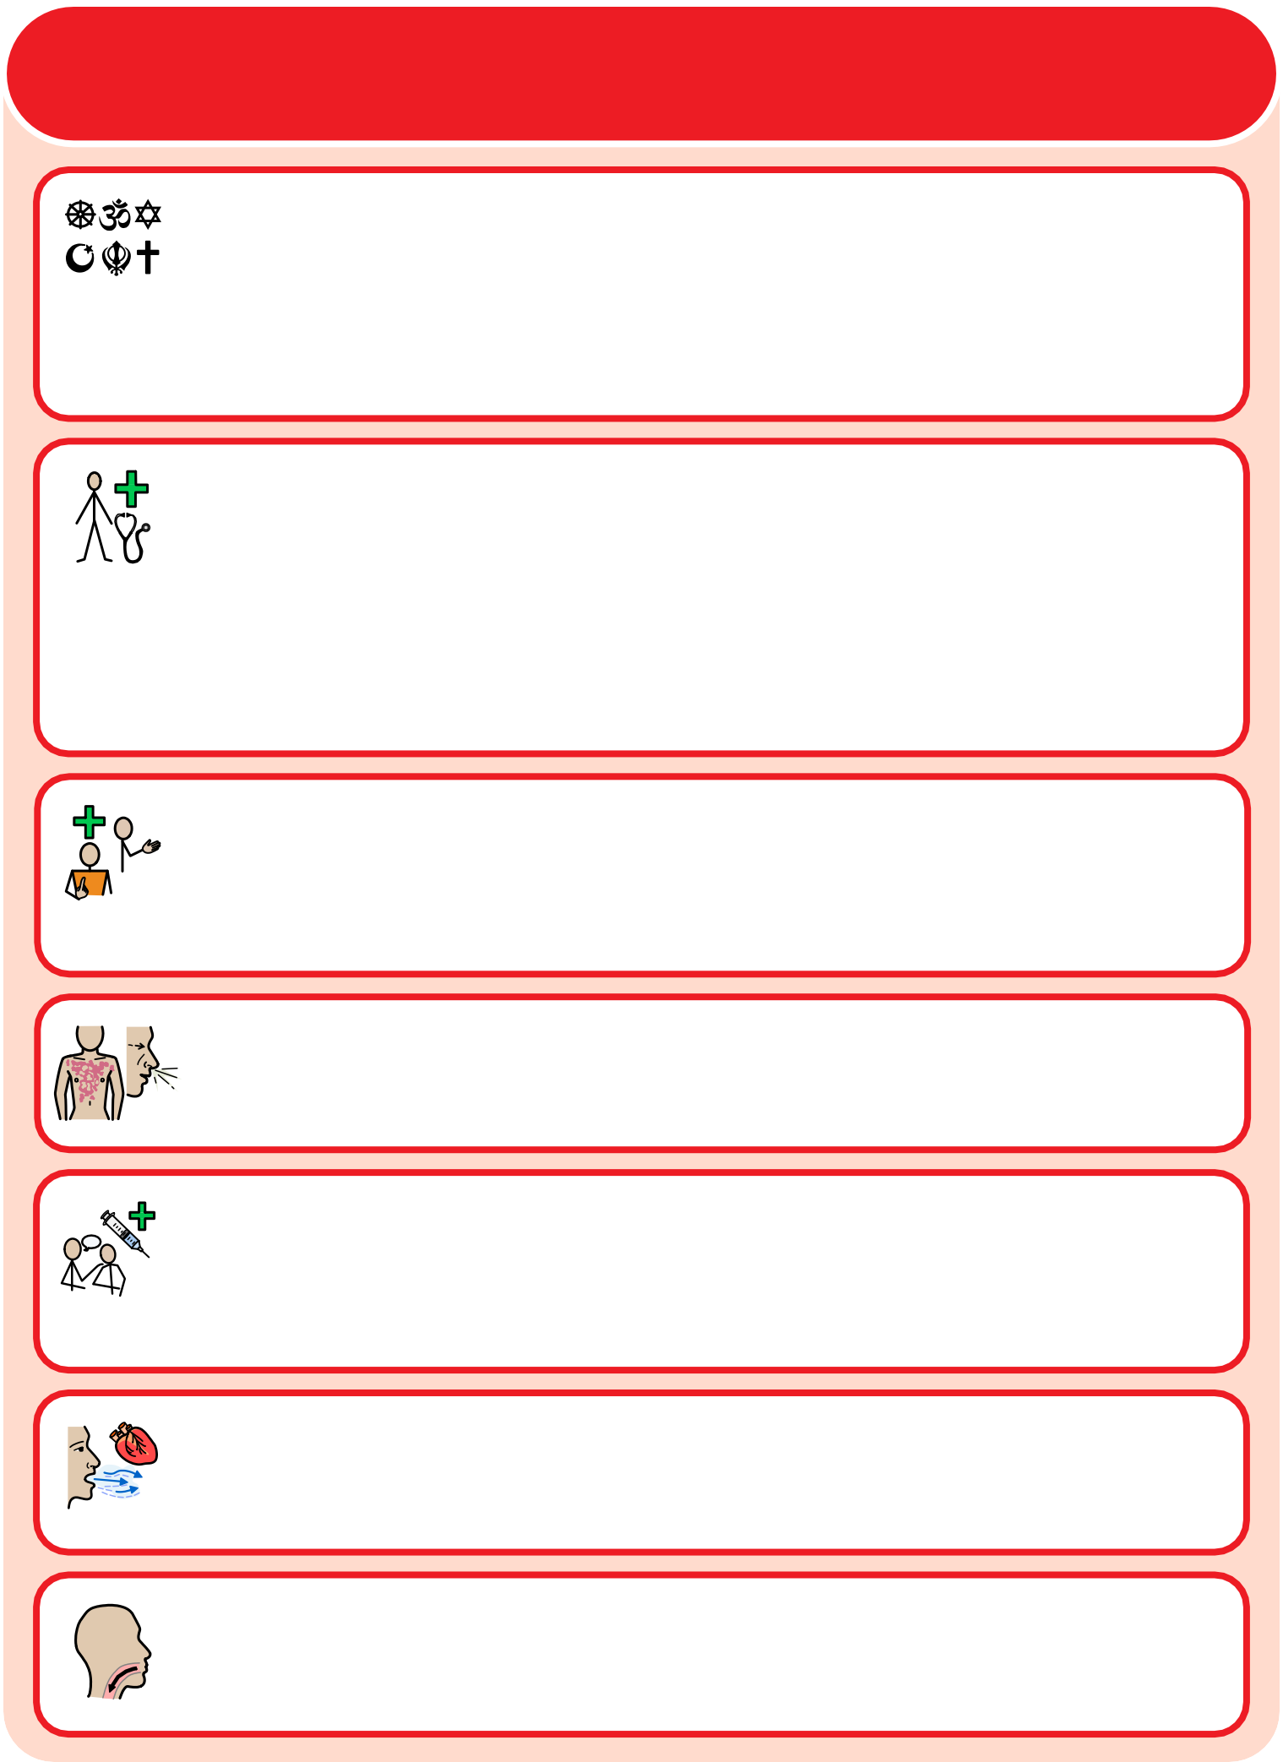
Things you must know about me

Religion:

Religious needs:

Ethnicity:

GP: Address:

Phone:

Other services/professionals involved with me:

Allergies:

Medical Interventions (how to take my blood, give injections, BP etc):

Heart/Breathing problems:

Risk of choking, Dysphagia (eating, drinking and swallowing):

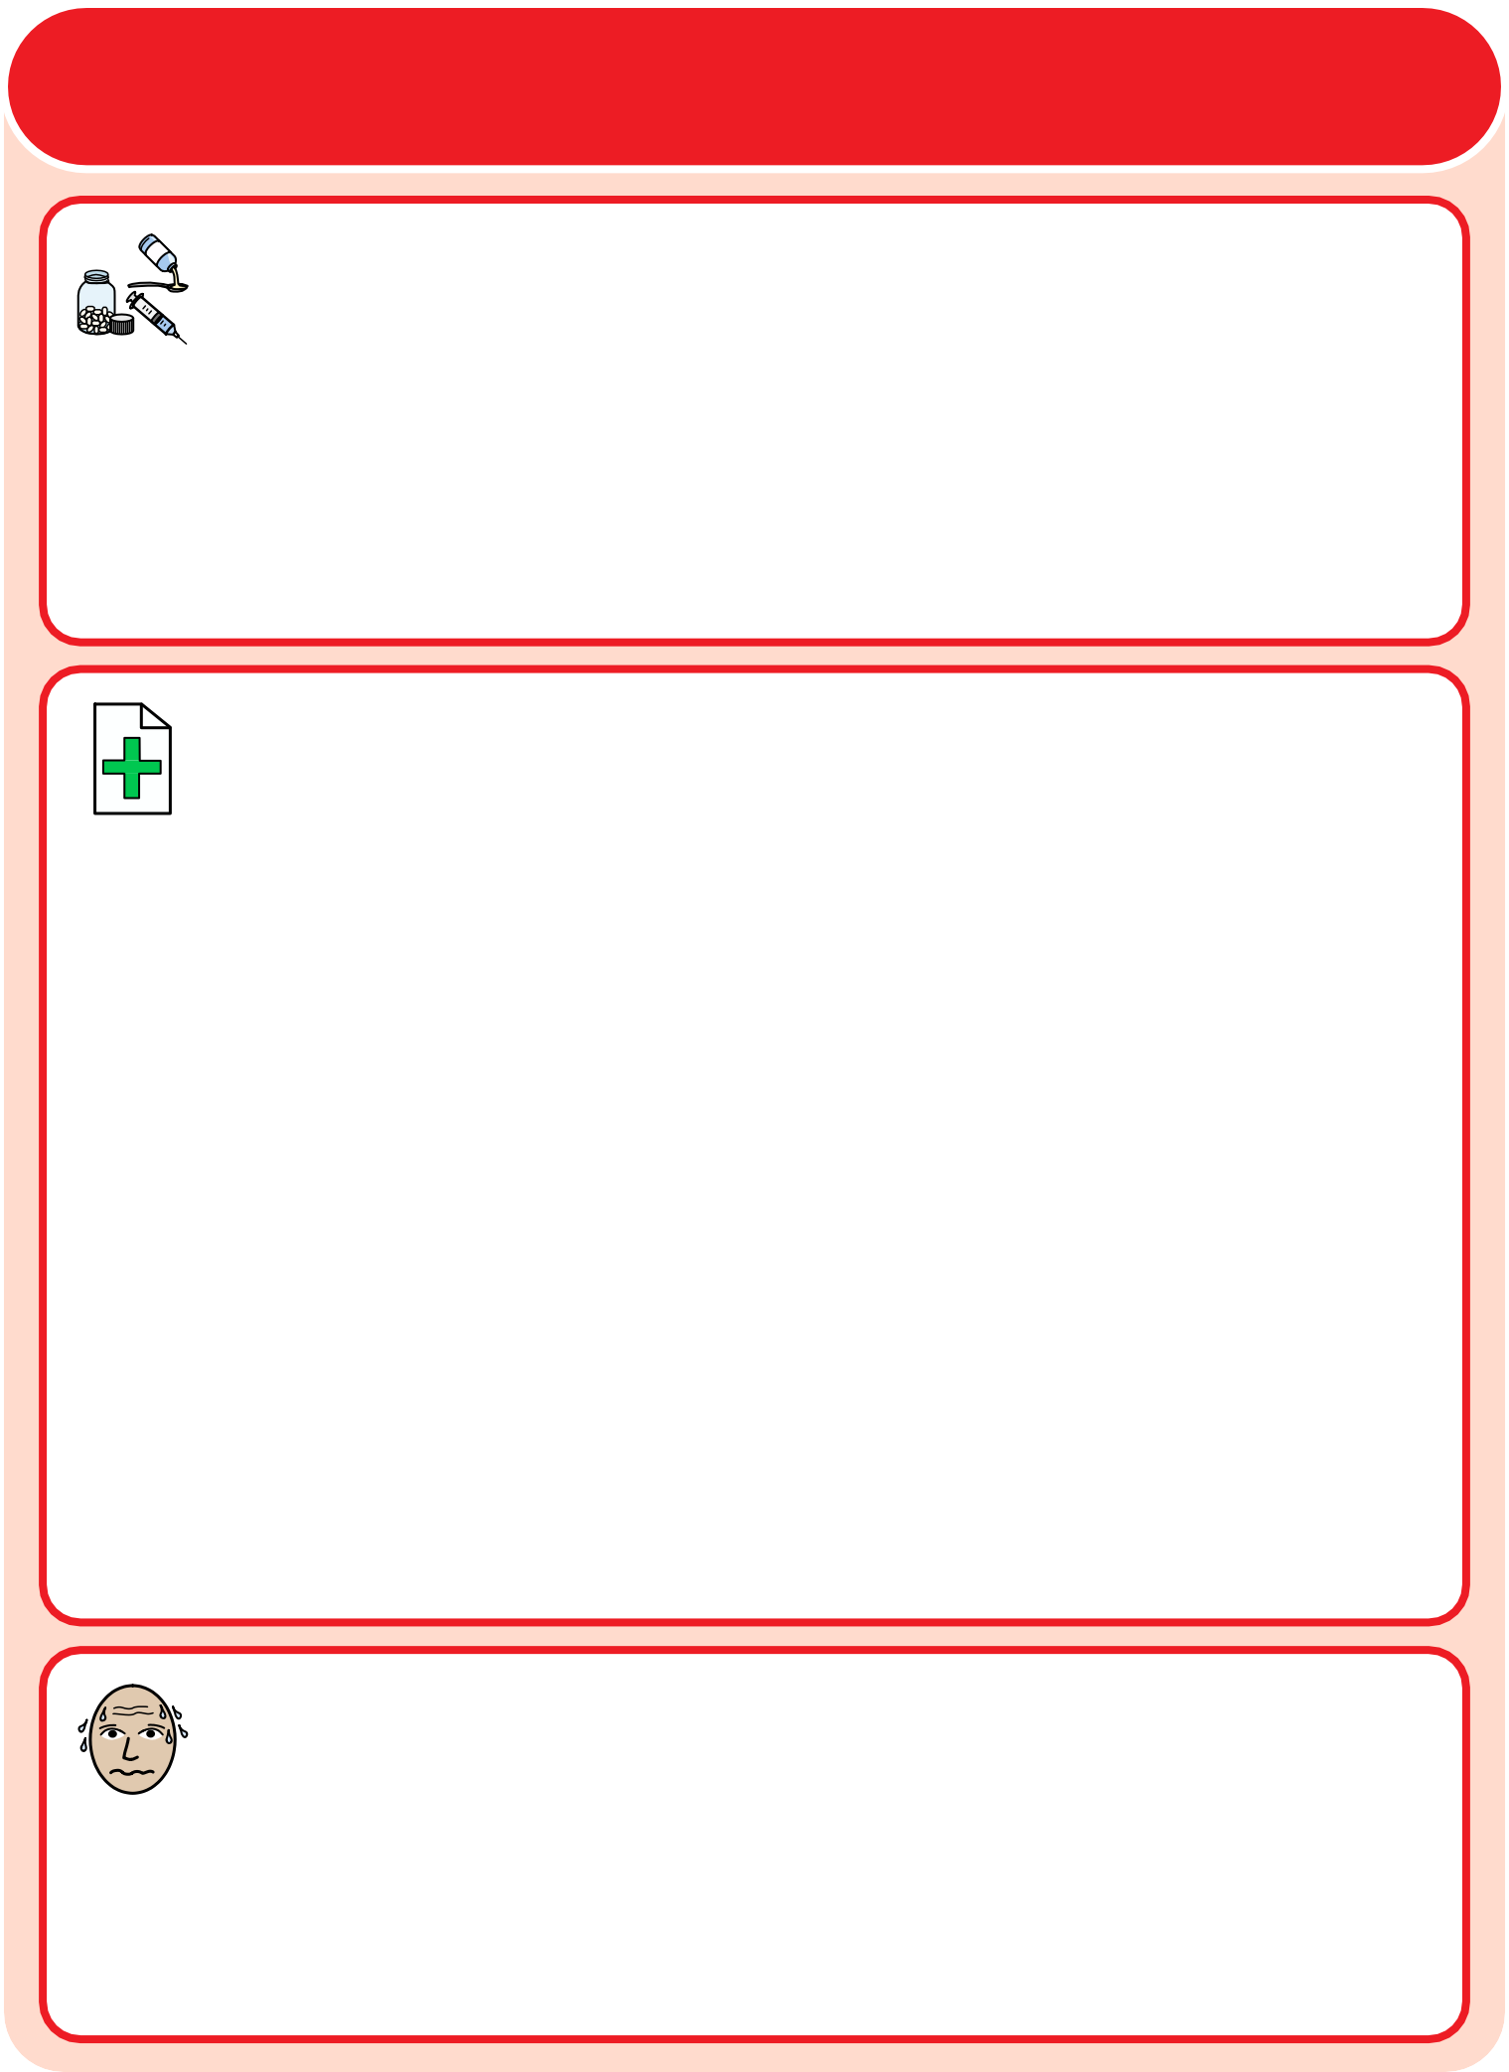
Things you must know about me

Current medication:

My medical history and treatment plan:

What to do if I am anxious:

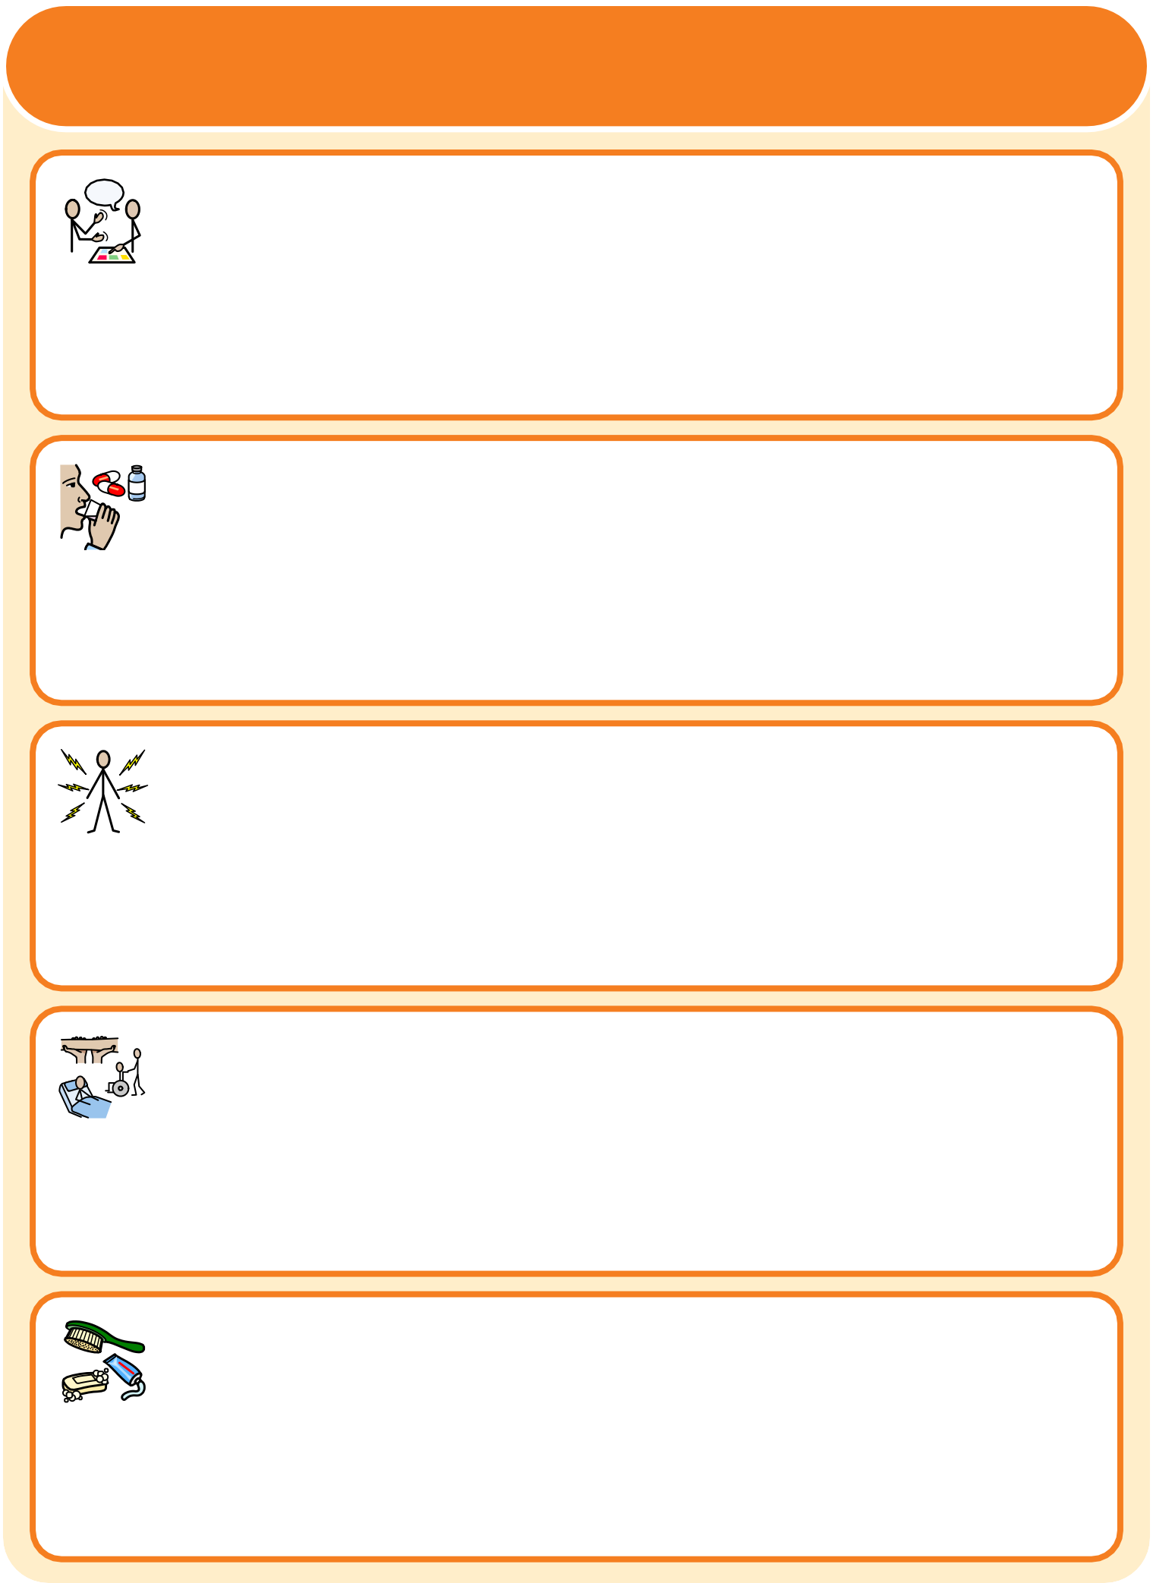
These things are important to me

How to communicate with me:

How I take medication (crushed tablets, injections, syrup, etc):

How you know I am in pain:

Moving around (posture in bed, walking aids, etc):

Personal care (dressing, washing, etc):

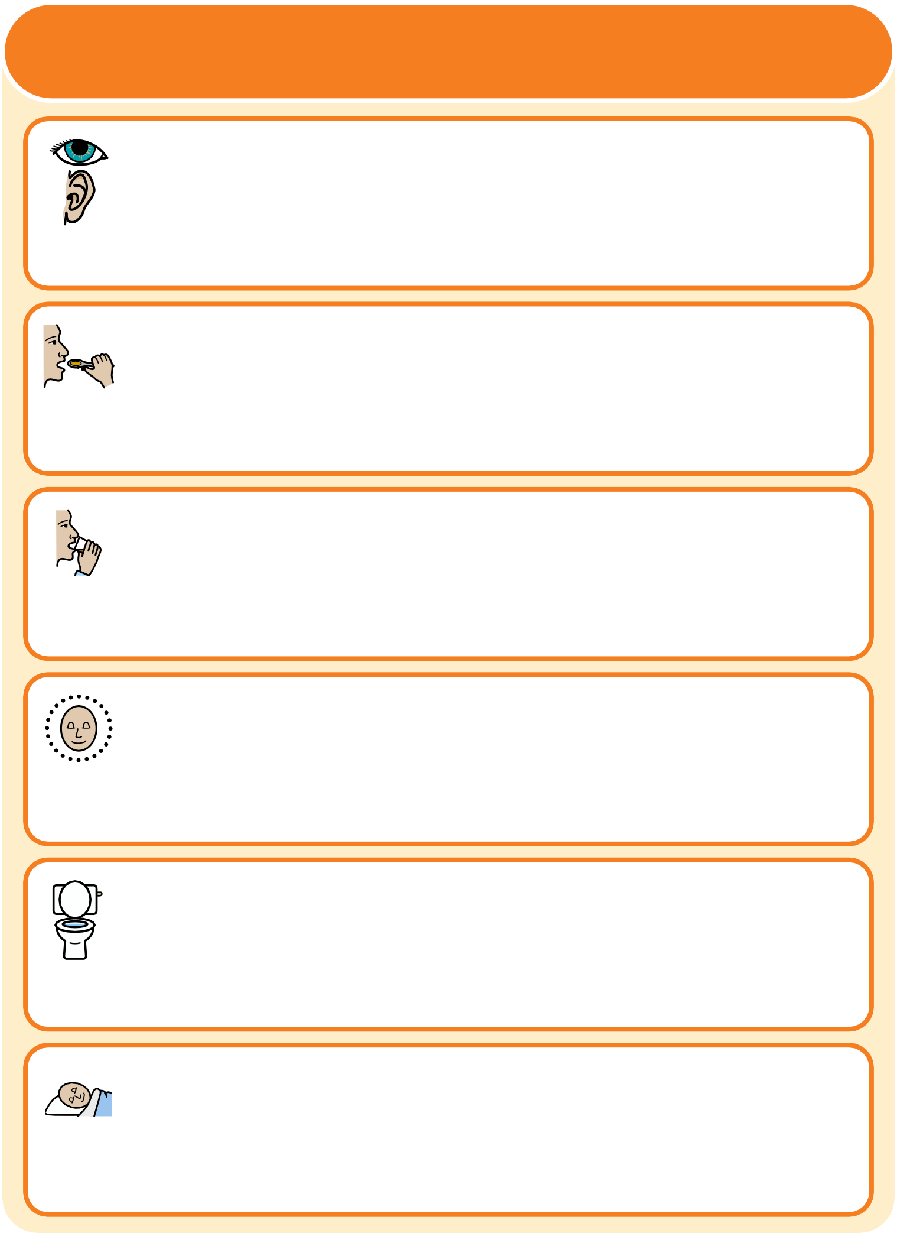
These things are important to me

Seeing/Hearing (problems with sight or hearing):

How I eat food (food cut up, risk of choking, help with eating, etc):

How I drink (drink small amounts, thickened fluids, etc):

How I keep safe (bed rails, support with challenging behaviour, etc):

How I use the toilet (continence aids, help to get to toilet):

Sleeping (sleep pattern/routine):

My likes and dislikes

Likes: e.g. what makes me happy, things I like to do.

Dislikes: e.g. don’t shout, food I don’t like, physical touch.

Things I do like
Please do this:

Things I don’t like
Please don’t do this:

Notes

Completed by: Date:

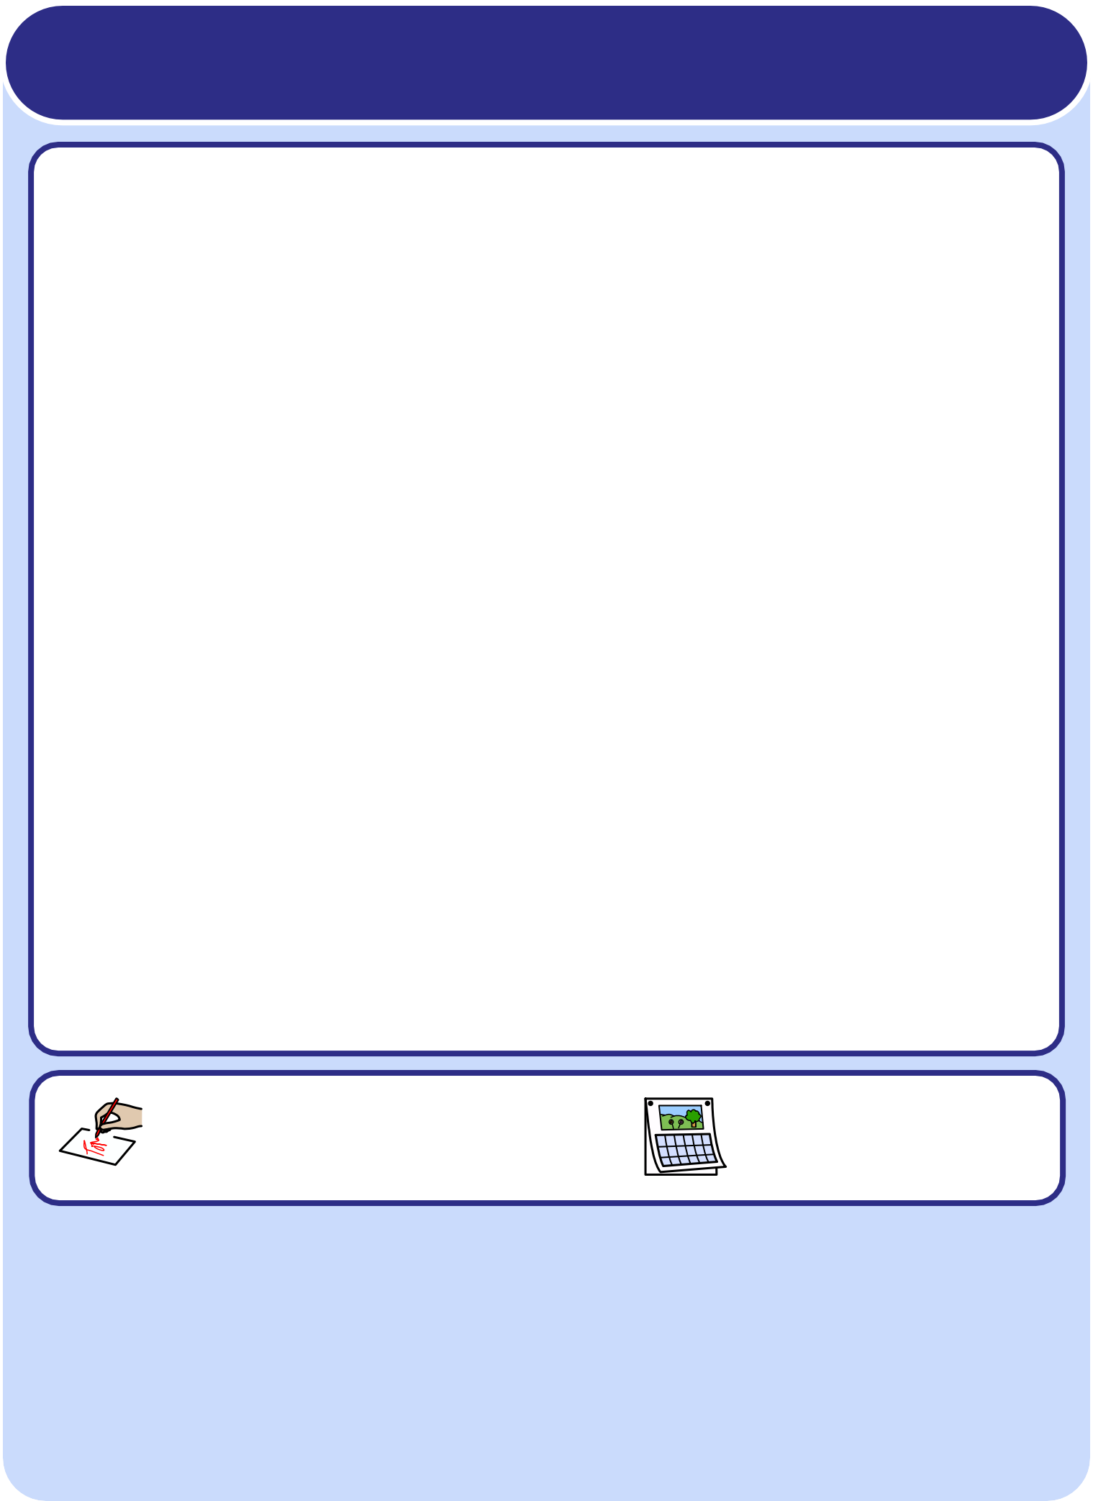
This communication passport is based on original work by
Gloucestershire NHS Foundation Trust.

Produced by Widgit Software in association with
Sarah Stancer A&E Sister (2009)
Royal Berkshire NHS Foundation Trust.

Gloucestershire Hospitals
NHS Foundation Trust

Royal Berkshire
NHS Foundation Trust

