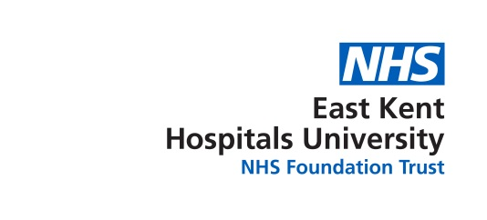



Equality, Diversity & Inclusion

Annual Report 2021-22

# Contents

**Page**

1. Our commitment 3

2. Report Summary 4

3. Equality, Diversity & Inclusion (EDI) – the context 5

4. East Kent Hospitals in Numbers 7

5. Our services, hospitals and values 8

6. Community & staff demographics 10

7. Workforce race equality standards (WRES) summary 12

8. Workforce disability equality Standards (WDES) summary 13

9. Gender pay gap summary 15

10. EDI Activity – for patients and staff 17

11. EDI Governance 20

12. Conclusion 21

# Our Commitment

Events over the last few years, including the Covid-19 pandemic and the rise in profile of the Black Lives Matter movement, have helped bring many of the issues surrounding inequality into sharp focus.

All the evidence points to some people in our community – our friends, relatives, neighbours and colleagues– having poorer health outcomes and dying earlier because of their skin colour, their sexuality or disability. As an organisation whose reason for being is to change and save lives, improving these health outcomes lie at the very heart of our mission.

We have the opportunity to work together to make East Kent Hospitals a supportive and inclusive place to work and be treated for all, where we challenge injustice, proactively work to reduce inequality and begin to create opportunities for everyone, so that it is not only health we improve, but life chances too.

We are taking positive action in a number of areas. Firstly, we are establishing a senior operational committee responsible for addressing health inequalities. The committee will be led by our Chief Operating Officer and will exploit opportunities to use data and analysis to provide assurance around equitable access, patient experience and outcomes delivered at East Kent Hospitals – tackling any health inequalities that might exist. Progress will be reported in next years’ annual report.

Secondly, the Chief Nursing and Midwifery Officer, has recently recruited a Patient Voice and Involvement team with the aim of working in partnership with patients and their families to ensure the diversity of their needs are met.

Thirdly, to ensure we are focusing on the right things for our staff, we have launched an Equality, Diversity & Inclusion (EDI) strategy and detailed delivery plan. This strategy was built using staff feedback and highlights a number of key areas, for example, culture, involvement, networks and community.

As part of our People & Culture team, we have recently recruited a Head of EDI who will lead a small EDI team to help us drive forward the change that is needed. We know the issues cannot be tackled by one small team – it is everyone’s responsibility and we are asking staff at every level to bring EDI to the forefront of their minds and think about how we can all make positive improvements.

We are beginning to make progress and we need to do more. We must all keep pushing forwards to build on the work we’ve done until we can be assured that East Kent Hospitals is completely supportive and inclusive for all.

cid:image001.png@01D8429A.E75C6AE0

**Andrea Ashman, Chief People Officer, People & Culture**

# Report Summary

The purpose of this report is both to demonstrate East Kent Hospitals’ compliance with the Public Sector Equality Duty (PSED) and to celebrate the work that we are undertaking to promote inclusion, diversity and equality at the Trust.

The Public Sector Equality Duty (PSED) specifies the core EDI aims for NHS trusts – to eliminate unlawful discrimination, advance equality of opportunity and foster good relationships between those that have a protected characteristic and those who do not.

As part of the PSED, NHS trusts are required to publish annual data on the workforce race equality standard (WRES), the workforce disability equality standard (WDES) and the gender pay gap. East Kent Hospitals has submitted detailed data for these three reports separately – this report provides a summary of the results.

Although this years’ WRES data presents a slightly improving picture we know there is more work to be done across all nine indicators of the standard. Specifically, increasing minority ethnic staff at all levels and understanding why more have a higher relative likelihood of entering the disciplinary process. Our work on de-biasing the recruitment process and developing a ‘just and learning’ culture aim to help with these indicators.

Our WDES data presents a mixed picture – some areas improving (decrease in those experiencing bullying and harassment from managers) whilst other areas showing a less positive trend (adequate adjustments and staff engagement).

Work will focus on encouraging more staff to declare a disability (or not) as currently over 20% of staff are categorised as ‘not declared’. This will give us a clearer picture overall. We will also continue to work closely with the staff disability network and implement the ‘reasonable adjustments’ policy.

Although replicating a national picture, our gender pay gap continues to be greater than we would like, with an average gap of 32.5% between men and women colleagues within the Trust. This will be kept under review and action taken where possible to reduce this.

Significant work to promote inclusion and diversity at East Kent Hospitals includes the Accessible Information Standard Programme for patients along with development of the network groups and de-biasing recruitment for staff. Future plans include the delivery of our EDI strategy, focusing on, for example, leadership development and embedding a focus on EDI within the culture of the Trust.

# Equality, Diversity & Inclusion – the context

The purpose of this report is both to demonstrate the Trust’s compliance with the Public Sector Equality Duty (PSED) and to celebrate the work that we are undertaking to promote inclusion, diversity and equality.

## 3.1 Public Sector Equality Duty (PSED)

The Equality Duty (2010) consists of a general duty with three main aims. It requires the Trust to have due regard to:

* **Eliminate** unlawful discrimination, harassment and victimisation and any other conduct which is unlawful under the 2010 Act
* **Advance** equality of opportunity between people who share a protected characteristic and those who do not; and
* **Foster** good relations between people who share a protected characteristic and those who do not

In addition, there are two specific duties that the Trust is required to meet:

* publish equality information at least once a year to show how they have complied with the equality duty
* prepare and publish equality objectives at least every four years

## 3.2 Equality Delivery System 2 (EDS2)

The NHS Equality Delivery System was designed to support NHS organisations to deliver better outcomes for patients and communities and better working environments for staff which are personal, fair and diverse. The EDS is mandated by the NHS Standard Contract. EDS2 enables the Trust to review equality performance and identify future priorities by setting equality objectives. It also helps to assess how well equality and diversity is embedded in the organisation.

NHS organisations assess and grade themselves against 18 outcomes – covering health outcomes, patient experience, representative workforce and inclusive leadership. The results of the EDS2 assessment provide EKH with information that can inform priorities for service users and staff.

## 3.3 Protected characteristics

The Equality Act 2010 requires organisations to take account of nine protected characteristics:

* race (including ethnic or national origins, colour or nationality)
* age
* gender
* disability
* gender reassignment
* marriage and civil partnership
* pregnancy or maternity
* religion and belief (including lack of belief)
* sex and sexual orientation

As an NHS trust we ensure compliance with the Public Sector Equality Duty, use the Equality Deliver System to assess and grade our EDI work and take account of the nine protected characteristics when planning and implementing our EDI activity.

# East Kent Hospitals by numbers

Test in image: 
9000 Staff
Over 1000 beds 
98,000 inpatient spells 
Serving a Population of 695,000
268,000 emergency attendances per year
860,000 outpatient attendances per year
More than 4,500,000 tests and scans per year
And over 6,500 births per year 
We have five sites 
Offer care at home and in the community for dialysis, paediatrics, mobile chemotherapy and stoma care.  


# Our services, hospitals and values

## 5.1 Our services

East Kent Hospitals provide a range of core and specialist healthcare services from five hospitals and other NHS facilities across east Kent. We provide a range of specialist services to the wider population of Kent and Medway, including emergency cardiac services for all of Kent and renal services in Medway and Maidstone. We also provide a number of services in the local community, including in people’s own homes. This includes home dialysis, community paediatrics, mobile chemotherapy and stoma care.

As a teaching Trust, we play a vital role in the education and training of doctors, nurses and other healthcare professionals, and are working in partnership with the new Kent and Medway Medical School.  We will continue to work with our long-term partner, King’s College University in London and with St George’s Medical School.

We value participating in clinical research studies, and we consistently recruit high numbers of patients into research trials. We are proud of our national reputation for delivering high quality specialist care, particularly in urology, kidney disease and head and neck surgery.

## 5.2 Our hospitals

**Buckland Hospital** provides a range of local services. Its facilities include a minor injuries walk-in centre, outpatient facilities, renal satellite services, day hospital services, child health and child development services, ophthalmology surgery and diagnostic facilities, including a CT scanner.

**Kent and Canterbury Hospital (K&CH)** provides a range of surgical and medical services. It is a central base for many specialist services in east Kent such as elective orthopaedics, renal, vascular, interventional radiology, urology, dermatology, neurology and haemophilia services. It also provides a 24/7 urgent treatment centre. Kent & Canterbury Hospital has a postgraduate teaching centre and staff accommodation.

**Queen Elizabeth The Queen Mother Hospital, Margate** (QEQMH)provides a range of emergency and elective services and comprehensive trauma, orthopaedic, obstetrics, general surgery and paediatric services. It has a specialist centre for gynaecological cancer and modern operating theatres, Intensive Therapy Unit (ITU) facilities, children’s inpatient and outpatient facilities, a Cardiac Catheter Laboratory, a Renal satellite service and Cancer Unit. QEQM has a postgraduate teaching centre and staff accommodation. On site there are also co-located adult and elderly mental health facilities run by the Kent & Medway NHS and Social Care Partnership Trust.

**The Royal Victoria Hospital**, Folkestone provides a range of local services including a minor injuries unit with a walk-in centre (both operated by the local Clinical Commissioning Group), a thriving outpatients department, the Derry Unit (which offers specialist gynaecological and urological outpatient procedures), diagnostic services, and mental health services provided by the Kent and Medway NHS & Social Care Partnership Trust.

**The William Harvey Hospital** (WHH), Ashford provides a range of emergency and elective services as well as comprehensive maternity, trauma, orthopaedic and paediatric and neonatal intensive care services. The hospital has a Renal satellite service, a specialist cardiology unit undertaking angiography, angioplasty, a state-of-the-art pathology analytical robotics laboratory that reports all east Kent’s General Practitioner (GP) activity and a robotic pharmacy facility. A single Head and Neck Unit for east Kent includes centralised maxillofacial services with all specialist head and neck cancer surgery co-located on the site. WHH has a postgraduate teaching centre and staff accommodation.

## 5.3 Our vision and ‘We care’ values

Our vision is to be a leading provider of acute healthcare services by delivering 'Great Healthcare from Great People‘, our mission is to improve health and wellbeing, for our patients and our staff.

Our values are very important to us and we want everyone who experiences our Trust to feel cared for, safe, respected and confident we are making a difference.

We are focusing on five priorities to continue to transform our Trust and deliver our vision of great healthcare, from great people:

* We care about our patients
* We care about our people
* We care about our future
* We care about our sustainability
* We care about our quality and safety.

East Kent Hospitals is a multi-site, complex organisation serving a very large geographical area. The east Kent population has a diverse range of healthcare needs and challenges, influencing the extensive range of services that the Trust provides. Our vision, mission, values and priorities provide the foundations for our staff to focus on providing the best care and experience for our patients and each other.

# Community and staff demographics

The 2021 census data has begun to be reported. The following graphs consider the east Kent population compared to EKH staff, by gender and then ethnicity.

## 6.1 Populations by gender

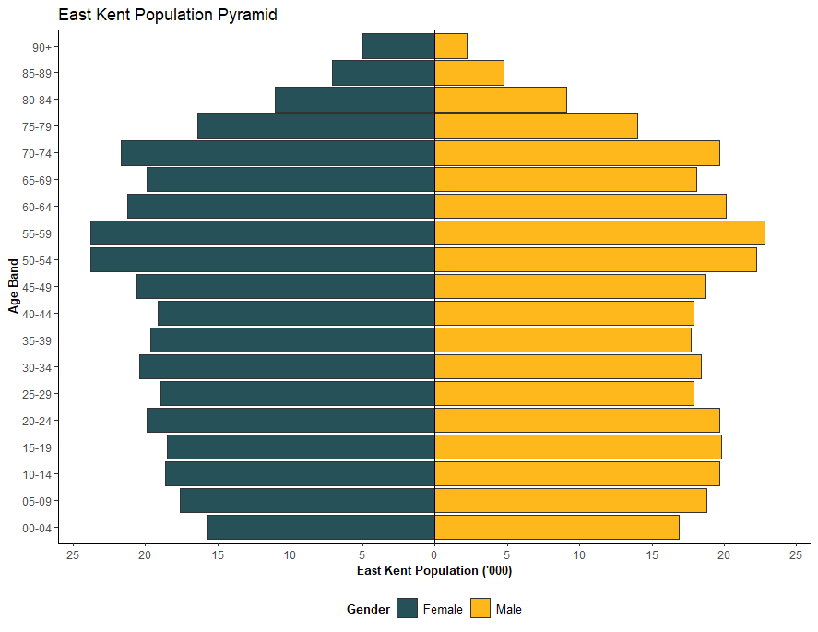

The population of east Kent residents is fairly evenly spread across the ages and genders.

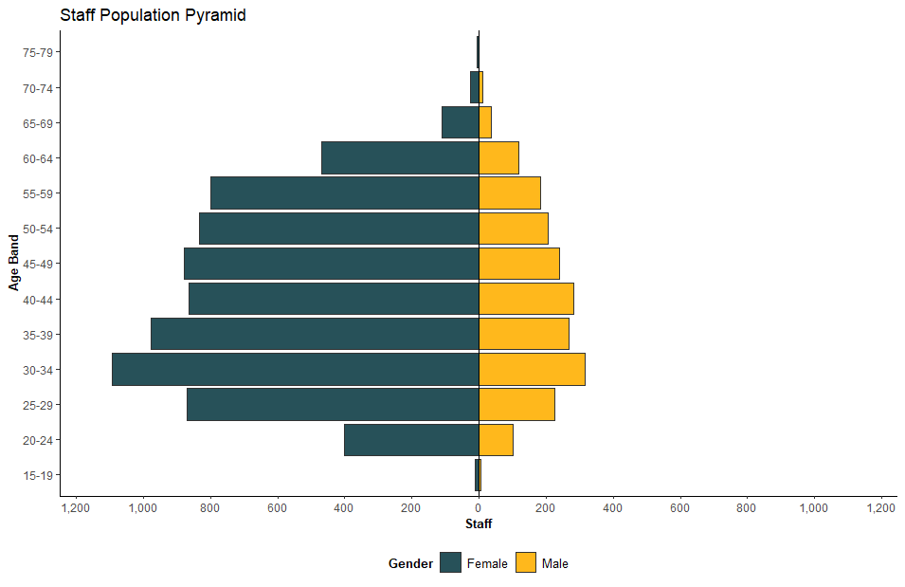

East Kent Hospitals’ staff population can be seen to be skewed with a majority of females across most of the age groups. This follows a national pattern from NHS acute trusts where the largest staff group is nurses – still a predominantly female profession.

## 6.2 Populations by ethnicity

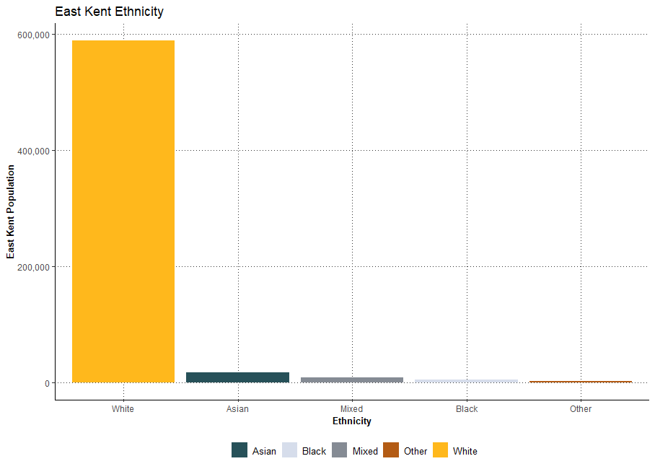

The population of east Kent is seen to be predominantly white. The populations covers a wide geographical area and includes pockets of deprivation and health inequalities.

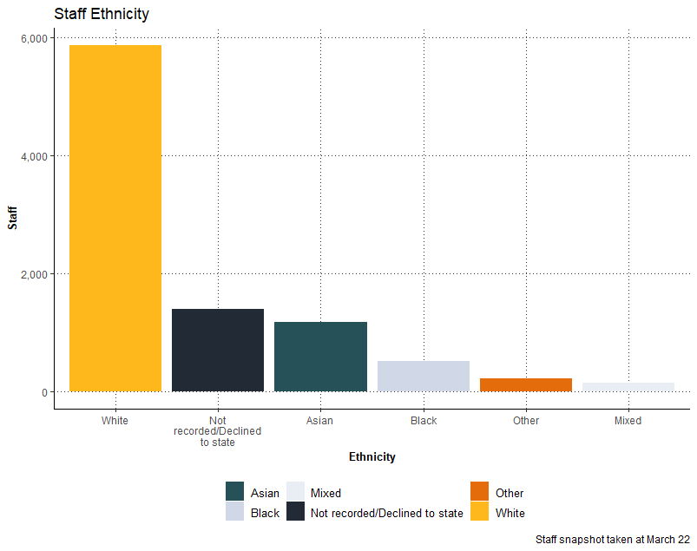

East Kent Hospitals’ staff is not entirely representative of the wider population as although, still predominantly white, there are higher numbers from ethnic minority groups which continue to increase due to recruitment of internationally educated nurses and doctors.

# Workforce race equality standard (WRES) summary

The workforce race equality standard (WRES) was launched and mandated for all NHS trusts in 2016. It was introduced to ensure employees from minority ethnic backgrounds have equal access to career opportunities and receive fair treatment in the workplace.

There are nine WRES indicators – four covering recruitment, promotion, career progression and staff development, four covering harassment, bullying and abuse and one specifically measuring minority ethnic representation at Board level.

Results are submitted annually for national publication and a separate detailed report is produced. Our results for 2021/22 can be summarised as follows:

* 22% of EKH staff are from minority ethnic background compared to 63% who are white (15% unknown)
* for non-clinical staff the representation of ethnic minority staff across all bands is low (<10%)
* clinical staff have higher ethnic minority representation (e.g. 41% at Band 5) but this declines for higher bands (<10%)
* the likelihood of ethnic minority staff being shortlisted and appointed, as part of a recruitment process, has slightly improved
* ethnic minority staff have a higher relative likelihood of entering the disciplinary process. This has changed in trend from previous years.
* ethnic minority staff are more likely to access non-mandatory training.
* there has been a 6.8% reduction in ethnic minority staff experiencing harassment, bullying or abuse from patients/ service users, relative or the public – and levels for ethnic minority staff are lower than for their white counterparts
* there has been an 11.3% reduction in minority ethnic staff experiencing harassment, bullying or abuse from staff – with B&H levels now lower for ethnic minority staff than their white colleagues
* more ethnic minority staff (up by 4.8% to 43.6%) believe the organisation provides equal opportunities for career progression – but there is still a 11% gap between them and their white colleagues (54.8%)
* there has been a 4.7% reduction in ethnic minority staff experiencing discrimination at work from other colleagues – but they are still 2x more likely to experience discrimination (19.3%) than their white colleagues (8.5%)
* representation at Board level is not representative of the workforce

Although this years’ WRES data presents a slightly improving picture we know there is more work to be done across all nine indicators. Specifically, increasing minority ethnic staff at all levels and understanding why more have a higher relative likelihood of entering the disciplinary process. Our work on de-biasing the recruitment process and developing a ‘just and learning’ culture aim to help with these indicators.

# Workforce disability equality standard (WDES) summary

The NHS workforce disability equality standard (WDES) launched on 1 April 2019. The overall aim is to make the NHS an exemplar employer for staff with disabilities and to address the issues they face.

There are nine WDES indicators which include representation across pay bands, recruitment and experiences of bullying and harassment.

Results are submitted annually for national publication and a separate detailed report is produced. Our results for 2021/22 can be summarised as follows:

* the percentage of reported disabled staff is typically low across all pay bands (<5%). However, 15% of apprentices report a disability
* there has been an improvement in likelihood of disabled staff being appointed from shortlisting
* the likelihood calculation of disabled staff going through capability demonstrates inequality for this metric, however the number of staff is only 2 in the last 12 months
* there has been an improvement (1.7%) in the percentage of staff with long-term conditions (LTC) experiencing harassment, bullying or abuse from patients, service users or the public, although levels still remain higher for colleagues with a LTC than for those without
* there has been a significant improvement (5.5%) in the number of staff with a LTC experiencing harassment, bullying or abuse from managers, although it remains approximately 10% higher for staff with a LTC (25%) than for those without (15%)
* there has been an improvement (1.7%) in the percentage of staff with LTC experiencing harassment, bullying or abuse from other colleagues, although it remains 7% higher than for staff without (21%)
* there is a 6% difference in the percentage of staff with a LTC (48%) and without (54%) who believe the organisation provides equal opportunities for career progression
* fewer staff (3%) with a LTC have felt pressure to come to work despite not feeling well enough, although there is a 10% difference between those with a LTC and those without
* fewer staff (1.7%) with a LTC are satisfied with the extent to which the organisation values their work – and there is a 10% difference in experience between those with a LTC and those without
* fewer staff (3.5%) with a LTC feel we are making adequate adjustments to enable them to carry out their work
* there is a significant gap in the staff engagement scores between colleagues with a LTC (6.0) and those without (6.4)
* we do not have any declared disability at Board Exec and Non-Exec level

Our WDES data presents a mixed picture – some areas improving (decrease in those experiencing bullying and harassment from managers) whilst other areas showing a less positive trend (adequate adjustments and staff engagement).

Work will focus on encouraging more staff to declare a disability (or not) as currently over 20% of staff are categorised as ‘not declared’. This will give us a clearer picture overall. We will also continue to work closely with the staff disability network and implement the ‘reasonable adjustments’ policy.

# Gender pay gap

Gender pay gap reporting was introduced as a statutory requirement from March 2018. The indicators on which each trust is required to report are:

* the hourly rate of ordinary pay
* the difference between the mean hourly rate of ordinary pay of male and female employees
* the proportions of male and female employees in the lower, lower middle, upper middle and upper quartile pay bands by number of employees rather than rate of pay
* the difference between the mean (and median) bonus pay paid to male and female employees.

## 9.1 Average & median hourly rates

|  |  |  |
| --- | --- | --- |
|  | |  |
|  |  |  |
| **Gender** | **Avg. Hourly Rate £** | **Median Hourly Rate £** |
| **Male** | 25.6956 | 20.0706 |
| **Female** | 17.3514 | 15.6225 |
| **Difference** | 8.3443 | 4.4481 |
| **Pay Gap %** | 32.4735 | 22.1621 |

## 9.2 Gender pay gap per quartile

|  |  |  |  |  |
| --- | --- | --- | --- | --- |
| **Quartile** | **Female** | **Male** | **Female %** | **Male %** |
| **1 Lower (£4.50 - £14.82 Hourly Rate)** | 1889.00 | 349.00 | 84.41 | 15.59 |
| **2 Lower Middle (£14.83 - £20.36 Hourly Rate)** | 1885.00 | 386.00 | 83.00 | 17.00 |
| **3 Upper Middle (£20.37- £26.28 Hourly Rate)** | 1889.00 | 366.00 | 83.77 | 16.23 |
| **4 Upper (£26.29 Plus Hourly Rate)** | 1371.00 | 884.00 | 60.80 | 39.20 |

The data demonstrates that

* females have higher representation in all quartiles of pay at East Kent Hospitals. However, it shows a gender pay gap in both average hourly rate and median hourly rate
* it also shows that there is a significant increase of male representation in the upper quartile (still significantly lower than female representation)

Our mean gender pay gap is 32.5% (down from 33.7% in 2021) and our median gender pay gap is 22.2% (down from 26.3% in 2021). These gaps are slightly higher than the average for all NHS acute trusts (mean 27%, median 12% in 2021).

We are confident that our gender pay gap is not because we pay men and women differently for the same or equivalent work. Our gender pay gap is because men and women at the Trust work in different types of roles and those roles have different salaries.

Across the UK economy, men are still more likely than women to be in more senior roles and roles that are paid more e.g. technical and IT-related. Women are more likely to be in front-line roles at the lower end of organisations and are also more likely to work part-time, in jobs that are relatively low paid. This pattern is reflected in the make-up for East Kent Hospitals.

We are committed to continuously reviewing our gender pay gap and to take action to further reduce it. Some of the areas we will investigate are as follows:

* Do certain colleagues get stuck at certain levels in the organisation
* Is there a gender imbalance in promotions?
* Are women more likely to be recruited at lower band roles?
* Do men and women leave the Trust at different rates?
* Do particular aspects of pay (such as starting salaries and bonuses) differ by gender?
* Are we doing all we can to support women and men with caring or flexible working needs?

Our Women’s Network are keen to be involved in this work. Also, our updated flexible working policy will ensure that colleagues are better supported to work flexibly and this will be better monitored across the Trust.

# EDI Activity

This section reports on progress East Kent Hospitals has made since the last annual EDI report. It considers both EDFI activity for patients and staff and then summarises future plans.

## 10.1 EDI services for Patients

### 10.1.1 Accessible Information Standard Programme

NHS England published the Accessible Information Standard (AIS) in July 2016. It is a legal requirement of the Equality Act 2010 and applies to all organisations included within the Health and Social Care Act.

The AIS programme at EKH has involved, and listened to, volunteers/patients and other stakeholders (‘experts by experience’) who have a sensory loss impairment or disability. By responding to their feedback, EKH has implemented a number of initiatives to make sure our patients, carers receive information in formats that they can understand and receive appropriate support to help them communicate. Some of the initiatives include:

* development of AIS policy
* easy read patient information leaflet service
* hearing loop audit in preparation for installation of hearing loops and equipment
* recruitment of AIS champions
* audio and braille transcription service
* remote video interpreting service for British Sign Language users
* training package which includes neuro-diversity, deaf and sight awareness
* staff and patient web-pages to improve accessibility
* patient-specific action plans for e.g. outpatients, pharmacy and radiology

Feedback to date on these initiatives has been very positive with patients/carers feeling that they have been really listened to. The AIS programme will continue to develop to enhance patient experience.

### 10.1.2 Patient voice and involvement team

This newly recruited team has stated their vision is to ‘…*work towards a situation where patients and families work in partnership with frontline staff to co-design services and service improvements where patient voice is a central part of the debate when decisions are made’.*

One of the first projects for the team will be to improve communication with patients, starting with appointment letters which often lack clear directions on where they need to go, which car park is closest and which entrance to use. They will also identify pilot wards to recruit existing staff as patient voice champions, making sure feedback is shared with the rest of the team and acted on.

As well as working with inpatients, the team will reach out to community organisations to gather feedback from their members about their experiences and perceptions.

Internally, the team will collaborate with the Equality, Diversity and Inclusion team to ensure a holistic approach for EKH’s patients and staff.

## 10.2 EDI Services for staff

A number of feedback mechanisms have led to the development of a clear EDI strategy for East Kent Hospitals. This feedback has come from previous WRES and WDES metrics, the national NHS staff survey data, an independent review by Jagtar Singh Associates and staff feedback.

The EDI strategy has provided a clear focus for our work under key headings:

* Culture
* Leadership & management
* Involvement
* Talent Management
* Networks and community
* Impact analysis
* Governance

Each of these headings have related detailed actions. The following provides examples of progress:

* development of a respect and inclusion charter, an outcome of our culture programme
* a clear EDI focus within our leadership development programme, along with an EDI ‘golden thread’ across all the programmes
* introduction of a pilot of ‘Inclusion Ambassadors’ to ensure diversity and fairness on recruitment panels
* a reasonable adjustments working group to ensure guidance and support is

available for staff who need it

* further development of our staff networks including the introduction of executive sponsors. Current networks groups – black, Asian and minority ethnic (BAME) staff network, LGBTQ+ network, staff disability network and women’s network – offer the opportunity for social engagement as well as the opportunity to enact change within EKH e.g. a photo project to increase representation of disabled staff in communications
* launch of ‘*What does inclusion mean to me?*’ video – providing the opportunity for all staff to listen to the lived experience of colleagues across the Trust

As well as progressing with our own EDI agenda, we have also been working with system colleagues to align and contribute to regional EDI work. This has been focused on career development for minority ethnic staff i.e. a mentoring programme and development centres. This work will continue and developed over the coming year.

## 10.3 Future EDI plans

Using the data we have from the workforce race equality standard, the workforce disability standard, the national staff survey and patient feedback we will continue to build on the work that we have started above and work to deliver the EDI strategy. Specifically in the coming year we aim to:

* pilot the NHS Equality Delivery System 3 to self-assess and grade our EDI performance
* develop an EDI dashboard – ensuring up-to-date data of our EDI position to inform our activity
* introduce reverse mentoring for our executive team
* further embed our Just & Learning culture principles
* ensure that collaboration between the Patient Voice and EDI teams to address inequalities for patients and staff
* continue the work to de-bias our recruitment process
* contribute to and access regional work on career development for ethnic minority staff

# EDI Governance

In order to ensure that we focus on the right areas and keep EDI a priority, it is important that we have a clear governance structure in place. The governance structure for EDI at East Kent Hospitals can be summarised as follows:

|  |  |
| --- | --- |
| **Body** | **Responsibilities** |
| Board of Directors | Has ultimate responsibility that EKH is progressing against equality and diversity priorities and is compliant with all relevant legislation |
| People and Culture Committee (P&CC) | P&CC is a sub-committee of the Board and is responsible to discharging all requirements relating to people and culture, including equality, diversity and inclusion |
| Equality, Diversity & Inclusion (EDI) Steering Group | A steering group responsible for ensuring the implementation of the EDI strategy and associated delivery plan. The group is made up of representatives from the People & Culture team, Staff Networks and Staff-side colleagues |
| Chief People Officer, People & Culture | Executive Director responsible for delivering equality, diversity and inclusion in the organisation |
| Assistant Director of Organisation Development | Responsible for the strategic development and operational delivery of EKH People Strategy including staff engagement, wellbeing and equality, diversity and inclusion |
| Head of EDI | Newly appointed role to bring knowledge and experience to lead the implementation of the EDI strategy and delivery plan |

# Conclusion

The Public Sector Equality Duty (PSED) specifies the core EDI aims for NHS trusts – to eliminate unlawful discrimination, advance equality of opportunity and foster good relationships between those that have a protected characteristic and those who do not.

The Equality Delivery System (EDS) provides us with a comprehensive self-assessment process to grade our health outcomes, patient experience, diversity of our workforce and inclusive leadership.

We have a new EDI strategy based on staff feedback, recent data from our WRES and WDES reports and a growing body of patient feedback. We also have extra resource in the form of a new Patient Voice team and a Head of EDI – people that are focused on supporting East Kent Hospitals to become a supportive and inclusive place to work and be treated.

We know we still have a way to go but by continuously working towards the PSED aims, and with robust EDS self-assessment, we will consistently build on our work to date to embed EDI at East Kent Hospitals.