Case study – Literate client with slow degeneration condition; high tech AAC and low tech AAC outcome

Background
Dave has Parkinson’s disease, and he lives at home with his family. Dave reported that he struggles to communicate verbally and this can be frustrating. Dave’s speech is quiet and slurred, which requires careful listening by his conversation partners. He does not have any form of AAC to help him communicate. A scenario was given whereby Dave fell and he was trying to say something but he could not be understood. Dave uses skype and telephone but his speech can be difficult to understand by others. Dave said that during group conversations he misses the opportunity to interject and join in, so he feels left out.

Assessment

Physical abilities
Dave was observed mobilising with a 4 wheeled walker, this had a laser beam guide to reduce ‘freezing’/improve stride length when walking. Dave is able to sit in midline unsupported. However, he cannot maintain this posture and tends to gradually fall forward.
Dave has some generalised weakness of his upper limbs. His movements are slowed with some reduced co-ordination. Dave has difficulties with activities which require fine motor skills. Dave is waiting for a powered wheelchair. Dave is computer literate and knowledgeable in technology. Dave no longer works due to his condition.

Sensory
No visual or hearing deficits observed or reported. Dave is able to read standard size text approx. 12 – 14 point, at near distance (approx. 30cm).

Cognition
Dave was able to attend in tasks and he showed some insight into his condition. However, there were some minor cognitive difficulties noted during the intervention.

Language and literacy
Dave is literate and has no language difficulties.
Dave tried 3 text based communication devices during the assessment. Dave was able to use the Allora and Lightwriter, he benefited from use of the keyguard for accurate targeting. Dave was able to access the iPad by using a stylus, as when using his finger he would make mistakes (mis- hits). Dave expressed that he preferred using the iPad as he liked the easy selection from prediction, and the easy editing of the phrase bank on the AAC app Predictable. Dave also quite liked the Allora.
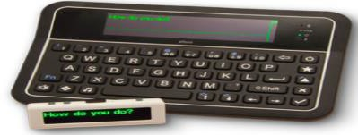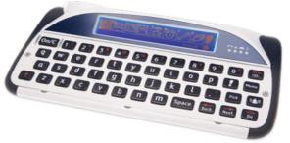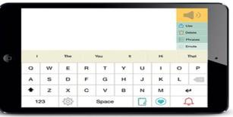
Lightwriter
iPad
Allora
Dave was given the opportunity to try the iPad with the Predictable App and the Allora during a trial period. Following the trial Dave said that he preferred using the iPad. Dave was also shown another text-based app, Proloquo4text as it has other features to speed up communication. Paul had time to explore the app but preferred Predictable.

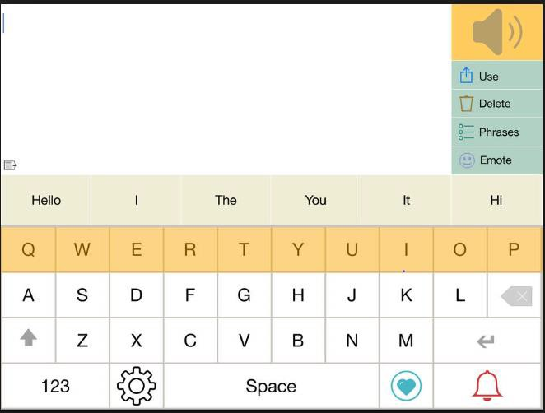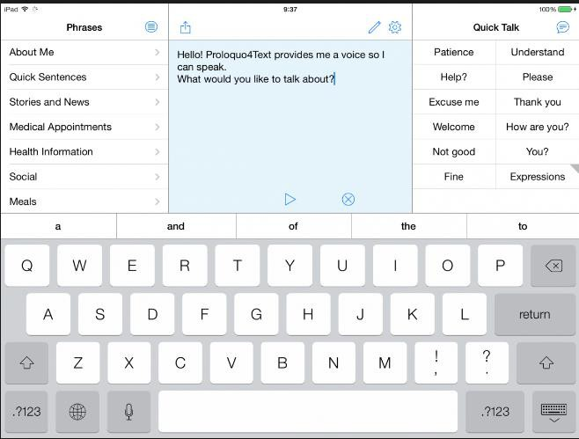
Left: Predictable App Right: Proloquo4Text App

Outcome / recommendations
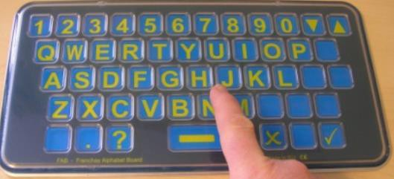
Frenchay Alphabet Board (FAB) - Qwerty
Plan and Recommendations: In the first instance the KM CAT team advised Dave’s speech therapist that Dave would benefit from a paper-based alphabet chart which could be used via partner assisted scanning, as on some days Dave would find it difficult to point to the letters. Also for Dave to have a communication passport for when he goes into hospital etc.
Dave was issued with an iPad with Predictable app.
Dave was also introduced to a FAB for days when his access is not so good and he struggles to use his iPad. Dave finds that the FAB helps him get his message across when he is feeling poorly and less able. The inbuilt keyguard on the FAB helps his targeting.
Dave is able to use his AAC. However, he needs prompts to use them in some instances when his speech is unclear.

