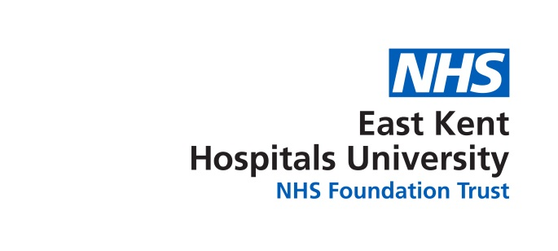

BAME Network Meeting
Tuesday 14th November 2017
10.30- 12.30 Conference Room KCH
Teleconferencing None Available
Agenda

1 | Chair’s Welcome
2 | Apologies for Absence
3 | Declaration of interests
4 | Agree minutes of DATE
 | AGENDA
5 | WRES | BCS
6 | Secretarial duties. | SA
7 | AGM  - 17th May 2018 ( booked @kch)  - Candidate’s  - Agree a date that candidates have to put their name forward by.  - How will the voting be carried out  3 Suggestion re speakers/ agenda items. What do members wish to have on the day?  4 Marketing
8 | AOB

