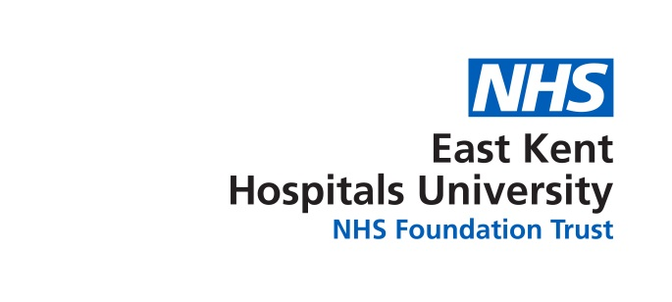
BAME Network Meeting
Tuesday 10th April 2018
11:00 -12.15
Tutorial Room, Education Centre,
Kent & Canterbury Hospital
Agenda
1 | Chair’s Welcome
2 | Apologies for Absence
3 | Declaration of interests
4 | Agree minutes of 13th February 2018
 | AGENDA
5 | WRES
6 | UPDATE  Update re: the postcards  Update Web  survey
7 | Conference
8 | AOB

