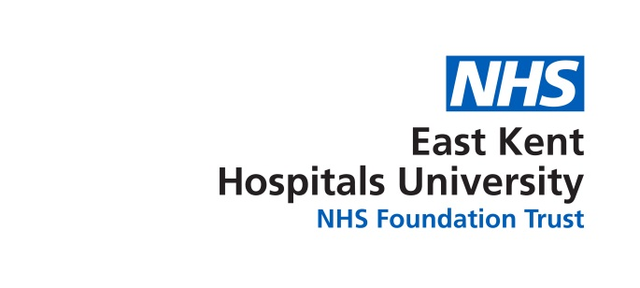

BAME Network Meeting
Agenda
8th May 2018
0930-1100 am
Tutorial Room, Education Centre, Kent & Canterbury Hospital

1 | Chair’s Welcome
2 | Apologies for Absence
3 | Declaration of interests
4 | Agree minutes of

 | AGENDA
1 | Survey results | SA
2 | BAME Conference  - Questions for panel  - update
3 | Postcards
 | AOB

Next meeting 5th June 12 – 13.45 Conference Room KCH
Don’t forget The BAME Conference 17th May Harvey Hall, Kent & Canterbury Hospital Education Centre Registration at 9.30 – ending with lunch at 12.30

