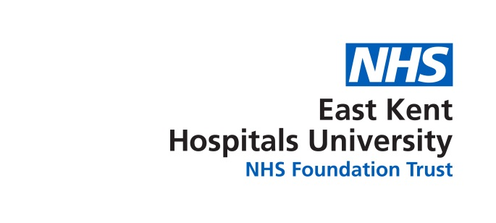
BAME Council
Minutes of Meeting;
Held on;
At:

Members Present
Chi Davies | CD | Consultant Anaesthetist (Chair)
Yvonne Davis | YD | Ward Manager
Ference Inkovics | FI | IT Directorate
Jaz Mallan | JM | Head of Strategic Resourcing
Francescah Hayward | FH | Surgical
Brenda Asante | BA | Clinical Photography
Bola Odunlami | BO | Eye Clinic
Bruce Champion Smith | BCS | Head of Diversity and Inclusion
Sue Abbott | SA | Diversity and Inclusion Officer

Apologies
Sally Smith | SS | Chief Nurse & Director of Quality

1 | Chairs Welcome  The Chair welcomed members to the meeting
2 | Apologies for Absence  Sally Smith
3 | Declaration of Interests  There were no declarations of interest.
4 | Minutes of Meeting  The minutes of 12th September 2017 were read and approved.  Outstanding actions carried forward
 | Agenda Items
5 | AG M  - BCS talked to the group about the lack of uptake for  places on the AGM (13th Oct)., a general discussion explored why it might be that only 18 members of staff had registered and the cost . It was agreed that at this time in the Trust it may be very hard for staff to leave their posts for a day. It was also agreed that we could not warrant spending two thousands pound on an AGM that has so few delegates attending BSC purposed a postponement of the AGM until the new year. The middle of May was agreed on as a potential date and that rooms would be booked at KCH. JM raised the point that a long lead into the event would give everyone more time to help raise the BAME profile, hopefully leading to a good event well attended.  ACTIONS; BCS& SA to cancel the AGM 13th Oct 2017  SA to book rooms at KCH for March 2018  - BCS offered to pay for some postcards that can be used to advertise the BAME network. JM will let BCS have the costing of the postcard. It was agreed the network would prioritise; postcards, website and word of mouth to encourage other staff to join BAME.  ACTION; JM to advise BCS about the costing of the postcards.  - There has been an on-going problem of bullying in the Trust, it was questioned where staff report this especially young doctors. , Kelly Martella is to be approached to discuss this with the aim of supporting cultural change .BO talked about having representatives of each site that staff could turn to for support and advice. It was agreed that everyone should be available to give this support and advice. That all members’ names/email addresses should be on the BAME website, unless they choose to opt out.  ACTION SA to email all BAME members about their name being available on the website so they can be contacted for support.  BCS ; suggested that we have Q & A sessions at all three sites with the CEO and Sandra La Blanc , this had proved very successful in the past . When this happens we will ask SS to blog about its importance. We could also see if we can get a link on the HR portal  ACTION BCS; To approach all the above when it is agreed
6 | Website  FI requested that we all send photos and a few lines about ourselves so he can add then to the BAME website.  ACTION; all staff to send photos and a few lines to FI
6 | BADGES  J.M presented the new BAME badges. It was agreed that we would only give the badges to BAME Members. BO will send out the badges to the members and the rest will be kept to give out in the future.  Action to send badges.
7 | AOB  SA presented a breakdown of the secretarial duties.  Secretarial l duties take some time and it would be easier if the duties were shared among a few staff. This will be thought about. It was suggested that when the funding for the network is asked for that some set hours are also asked for ( to be associated with each committee post )

Next Meeting Date:
14TH November | 10.30-12.30pm | KCH  Conference room | QEQM  Diabetes Meeting Room  ( St Peters Rd side of the hospital , first floor) | WHH  NONE AVALABLE

