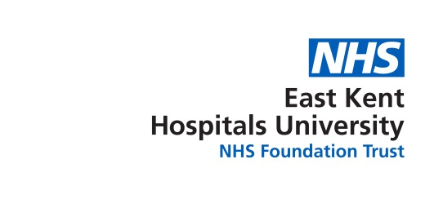
Tuesday 14th November 2017
10:30 – 11:30 AM Conference Room Kent and Canterbury Hospital

Present
Bruce Campion-Smith | Head of Diversity & Inclusion | BCS
Susan Abbott | Diversity & Inclusions Officer | SA1
Ferenc Inkovics | Deputy Head of IT Service Deliver | FI
Stella Adegoke | Ophthalmic Nurse | SA
Manju Banerjee | Trauma Coordinator | MB
Apologies for Absence
Sally Smith | Chief Nurse & Director of Quality | SS
Sandra Le Blanc | Director of Human Resources | SLB
Yvonne Davies | Ward Manager (ICU) – Deputy Chair | YD
Brenda Asante | Clinical Photography | BA
Jaz Mallan | Head of Strategic Resourcing | JM
Chinekwu Davies | Consultant Anaesthetist - Chair | CD

 | Subject | Action
1 | Welcome  MB welcomed to the meeting
2 | Declarations of Interests  There were no declarations of interest
3 | Quorum  Advised that there wasn’t a quorum present (which was very disappointing) so a formal meeting could not take place. However, this meeting should still be minuted.  No Chair present today either.
4 | Staff Survey  BAME staff need to be encouraged to complete this survey, which BCS assured is completely anonymous. Without more BAME staff completing the surgery the results may not truly reflect their opinions and give a “false” picture of how things actually are.  BCS reports to the Board of Directors and wants to hear what BAME staff really feel/think about working in the Trust etc. – and the survey is a good way of show facts and figures. | All
5 | WRES – Workforce Race Equality Standard  NHS Providers are expected to show progress against 9 indicators.  WRES data for this Trust was briefly discussed with those present. Though some of the figures show improvement it was discussed that they may not be a true reflection.
6 | General discussion  - It was discussed that BAME staff felt that there are very few opportunities or limited support for professional development for them. Potentially an unconscious bias by non-BAME staff.  - Cultural differences and behaviours can be misunderstood or not appreciated – these are the sort of issues that need to be raised so that changes or support can be offered.  - Mentoring for BAME staff would be welcomed if it could be arranged.  - Getting time to come to these meetings can be challenging as some Managers do not really understand what the meetings are about or why they are held. BCS advised that he is more than happy to speak to Managers and send them the requisite information if required.
7 | AGM  This was to have taken place this year (October), but was cancelled due to only a few delegates registering to attend.  Now planned for 17 May 2018 – Agenda items being finalised, as well as a Speaker. The plan is also to elect a new committee – TBC
8 | BAME Secretarial Duties  MB offered her assistance with this and will liaise with SA1. | MB
9 | Next BAME Meeting  10th January 2018 1100am to 1300 in the Conference Room in the Educational Centre in K&C Hospital.  Teleconference facilities are available at:  - The QEQM in the Pfizer MDT Room  (Voice only – Audio Conference Extension No. 725-5126)  - The WHH in the Conference Room | ALL

