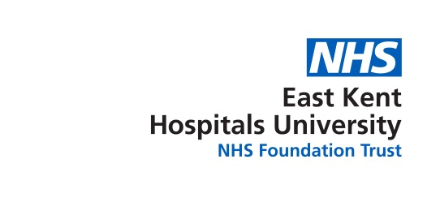
Tuesday 8th May 2018
1300-1430 Education Conference Room, Kent and Canterbury Hospital
+ Video link*

Present
Bruce Campion-Smith* | Head of Diversity & Inclusion | BCS
Susan Abbott | Diversity & Inclusions Officer | SA1
Chinekwu Davies | Consultant Anaesthetist - Chair | CD
Manju Banerjee | Clinical Site Manager (QEQM) | MB
Stella Adegoke | Eye Clinic, QEQM | SA
Ritoo Kapoor | Consultant Anaesthetist | RK
Apologies for Absence

 | Subject | Action
1 | Welcome  CD welcomed everyone to the meeting.
2 | Declarations of Interests  There were no declarations of interest
3 | Quorum  CD confirmed that the meeting was quorate
4 | Apologies for Absence  Nil
5 | Minutes of the Meeting held on 13 February 2018  The minutes for Aprily2018 meeting were read and agreed as an accurate record.
6 | BAME Meeting attendance Survey  - SA1 reported a poor response to the survey; only 5 members replied. Unclear as to whether the poor response is completely due to apathy on the part of members or other reasons.  - Discussed and agreed that it would be a good idea for the survey to be distributed at the forthcoming Conference and collected from all attendees before they leave.  - SA1 to organise/make a box for the surveys to be put in. | SA1
7 | BAME Conference on 17 May 2018 – “Viewing the inequalities landscape”  - Changes made to the agenda – see attached new format  - BCS to send (to CD) the names of all (potential) Panel Members that did not respond to the request to be part of the Q&A Panel for the Conference.  - It was discussed that these Panel Invitees (despite not responding) may still turn up on the day to take part in the Panel. As the Panel has not been set this would be possible, but these guests would be very helpful in supporting the current Panel and thus it was agreed that they should be allocated seats in the front of the Conference Room. A BAME member should be allocated to meet and greet these specific invitees (should they attend) and show them to their allocated seats.  - CD will manage the questions for the Panel  - It was discussed that BAME members (especially those holding specific positions) should be given time to attend meetings within their work hours (full or part-time members). CD advised that this had been agreed with the previous Chief Executive and should not have been rescinded. Suggested that this is a question that should be put to the Q&A panel at the Conference. BCS to locate the agreement and send to CD so that an appropriate question can be raised.  - SA1 will arrange for (Trust) feedback forms to be distributed and collected at the Conference  - A theme for the Conference was discussed and CD suggested “raising the inequalities landscape” this was later amended to “viewing the inequalities landscape” with input from BCS. All agreed that “Viewing the inequalities landscape” as at good title/theme for the Conference.  - MB will format a Certificate of Attendance for the Conference – see attached. | CD  BCS  SA1  MB
9 | AOB  - WRES – Workforce Race Equality Standard - Insufficient time to discuss, so BCS to present at the Conference | BCS
10 | Next BAME Meeting  Tuesday 5th June from 12:00 to 13:45 in the Conference Room, Education Centre, Kent & Canterbury Hospital | All
11 | CONFERENCE  Thursday 17th May 2018 – Harvey Hall, Education Centre, Kent & Canterbury Hospital – starting at 09:15 | All

