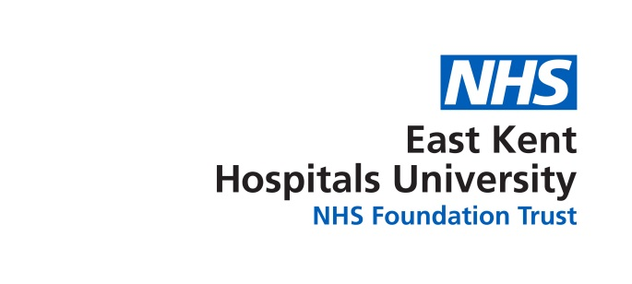
BAME Network
Minutes of Meeting;
Held on;
At:

Members Present
Chi  Davies | Consultant Anaesthetist | CD
Umesh Rastog | Doctor | UM
Bruce Campion-Smith | Head of Diversity and Inclusion | BCS
Sue Abbott | Diversity and Inclusion Officer | SA
Yvonne Davies | Ward Manager | YD

Apologies
Manju Banerjee
Ferenc Inkovics
Bridget Creighton
Christopher Parokkaran
Sally Smith
Sandra la Blanc
Stella Adegoke.

1 | Chairs Welcome | Chi Davis
2 | Apologies for Absence | As listed
3 | Declaration of Interests | None
4 | Minutes of Meeting | AGREED
 | Agenda Items
5 | Survey results  20 surveys completed  Out of the 20 surveys completed only eight were completed by members of staff who belong to the BAME network.  Six members of staff have access to video conferencing and only 4 members of staff have attended a BAME meeting before.  When answering the question “ what are the obstacles that stop you attending “ (referring to BAME meetings ) the overwhelming answer was workload, this included time spent travelling to the meetings not being able to get cover and needing longer period of notifications of meetings so they can arrange rotor cover.  The second section of the survey were statements we asked staff to agree or disagree with, this section was not answered by most people however statement “I will be seen as a troublemaker if I become a member of BAME “was ticked, as was “my manager will only let me have time off to attend BAME meetings if I take it as annual/study leave”.  The results showed there was a preference for the BAME meetings to be held every two months with use of WebEx and videoconferencing.  In answer to the question is there anything that can be done to support you attending the BAME network meetings there was real iteration of needing more notifications of meetings along with more support from managers to allow staff to attend meetings.  Finally when asked to leave any comments about anything that concerns them the response was;  Keep trying your best you are doing a good job well done.  BAME Newsletter /achievement in Trust  Issues related to transparency and fairness harassment and subtle bullying  Suggestion; does BAME a contribute to staff induction days  Lack of training to line managers regarding BAME needs and challenges we face every day
6 | BAME Conference  The feedback from the conference has been very positive staff had indicated they would have liked more interaction with the board and the speaker. There has been particular feedback about the WRES in relation to the percentages of BAME staff to white staff who are disciplined (higher percentage of white staff). It has been suggested that white managers may be frightened of disciplining BAME members of staff fearing being accused of racism. There was also a suggested that there may be correlation with long-term sickness and disciplining, would account for percentage of white staff being disciplined being higher than BAME staff.?  The results from the survey and feedback from the conference all indicate that line managers need to be educated about network attendance and what networks do. Action Chi to talk to Sandra BCS to liaise with Jane Walters about adding extra training on the unconscious bias leadership training for managers this training would include opportunities ,training and for the BAME staff  - Feedback form report  - Issues arising  - Band 5 to 6 programme  - Band 2 to 5 programme  - Next year’s programme  there followed a general discussion covering points ABCD and E;  YD suggested that ideally we would have a link nurse on every board or link person in every department, BCS suggested before we put this forward and asked for volunteers to do this we need to write a job role and expectations.  Action YD to write-up the role of a link nurse.  U R suggested that managers nominated people from different departments to attend unconscious bias course so they could cascade formation BCS suggested that we offered unconscious bias training to all our BAME members making them knowledgeable and equipping them how to deal with unconscious bias. C.D would like this to happen as soon as possible and we offered twice a year hopefully we could start doing this in September offering 20 places at time. Action BCS and SA to amend current training update arrange time space and deliver training. The committee went on to agree that managers need to know that staff are allowed to attend network meetings and why networks are essential. We will ask FI to explore the use of WebEx and video links from personal laptops as every site should have video and phones for logging into meetings this would cut down time staff need to be away from their duties by cutting travel time thus with the hope of increasing attendance at meetings.  CD suggested we need to get our band 5 nurses prepared to interview when a band six role becomes available  CD went on to outline a potential program involving interview skills training ,updating CVs and how to get management experience.BCS stated that Susan Accott is concerned about the discrimination of BAME staff at interview and BCS feels she would be interested in looking at the potential of having a BAME member of staff each interview Panel, which was also discussed by the attending members .BCS suggested that the scored interview papers are sent to and seen by Sandra to monitor to understand the reasons BAME staff are not being offered jobs .  There was a discussion as to whether it would be beneficial or not to establish a register of staff who want to go from a band 5 to 6 , logging when staff acted up into the role 6 and the length of time they had been a band five as well as any management experience .
7 | Postcards and pins | Place on agenda for next meeting
 | AOB

Next Meeting Date:
3 July 2018

