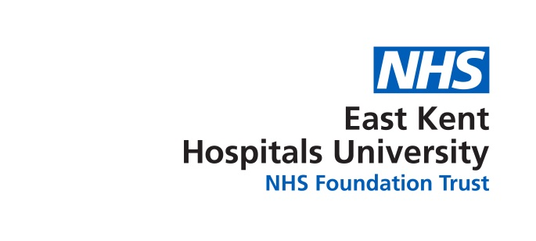

BAME Network Meeting
.
03/09/2018
KCH Executive meeting room, QEQM, WHH Endoscopy seminar room
Diversity and Inclusion office (QEQM)
Present
Bruce Campion-Smith | Head of Diversity & Inclusion | BCS
Susan Abbott | Diversity & Inclusions Officer | SA1
Ferenc Inkovics | Deputy Head of IT Service Delivery | FI
Umesh Rastogi | Speciality Doctor (Anaesthetics) | UR
Ananth Rajagopalan | Specialist Dr neurology | AR
Dr. Kamal El-Rashid | Doctor, VASCULAR | KE
Yvonne Davis | Ward Manager ICU, WHH | YD
Brita Joseph | Qualified Nurse ICU | BJ

1 | Chair’s Welcome | Yvonne Davis ( deputy)
2 | Apologies for Absence | Chinekwu (Chi) Davies  Manju Banerjee  Sally Smith
3 | Declaration of interests
4 | Agree minutes of

 | AGENDA
1 | SAS Doctors  BCS is responsible for the WRES and has seen a correlation between parts of the SAS doctors survey feedback and the WRES feedback, namely in the surgery and trauma orthopaedic areas. There are a lot of BAME members of staff working in these areas there is notable dissatisfaction. BCS is working with Surgical Services HR Business Partner to respond and take action linking the surgical service action plan in with the two surveys. BCS would like BAME members to give their feedback on the surgical service action plan as soon as possible so he can take their findings to the Clinical Executive Management Group. There is concern that this survey is outdated and the action plan lacks any dates for upcoming workshops | BCS
2 | Black History Month  The question was posed of how we are going to celebrate Black history month in October it is felt that it is extremely important this year with tthe anniversary of Wind Rush and NHS celebrating 70 years it was agreed that we would have an event at the William Harvey Hospital in the hub in October  Action YD to book hub 11-3 ( now confirmed 23rd October)  we would like to put on a wind rush display ,70 years of NHS nursing ,run the recent TV advert and for as many people as possible to bring and share food as a way of showing different cultures.  Action SA1 to work with comms to advertise this as soon as possible  we would like to ask some of the senior management to attend it was agreed that we will ask CD to do this | SA1
3 | Enabling BAME nurses and midwives  Unfortunately the last meeting was very poorly attended however this was during the summer holidays which often proves a difficult time for people to attend meetings coupled with a failed link to the William Harvey Hospital there was nothing to report. However BCS will set up a new meeting in the future. | BCS
 | AOB  the question was asked what do we respond when people ask us why do we need a BAME network. It was felt that the diversity and inclusion website (under the BAME banner) explained in various ways. https://www.ekhuft.nhs.uk/search/?q=diverity+and+inclusion  YD would like some more badges for the new members, many thanks Yvonne for spreading the word and getting new members on board.  Action SA1 one to email CD about badges.  A suggestion was put forward that we tried to network with other BAME networks locally to exchange information, understand how they run their network and ask them to attend our next meeting.  Action SA1 to investigate if there are any other networks locally and to extend invitations to next meeting. | BJ  YD  UR

