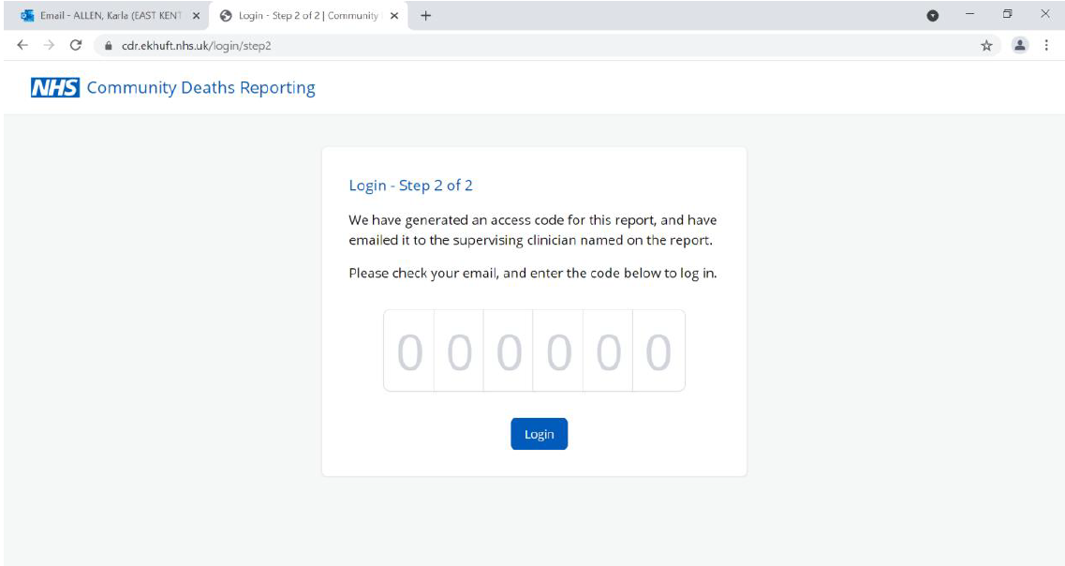

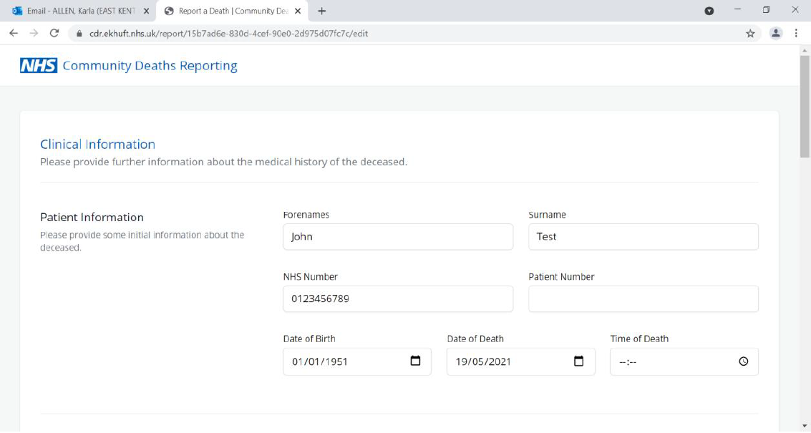

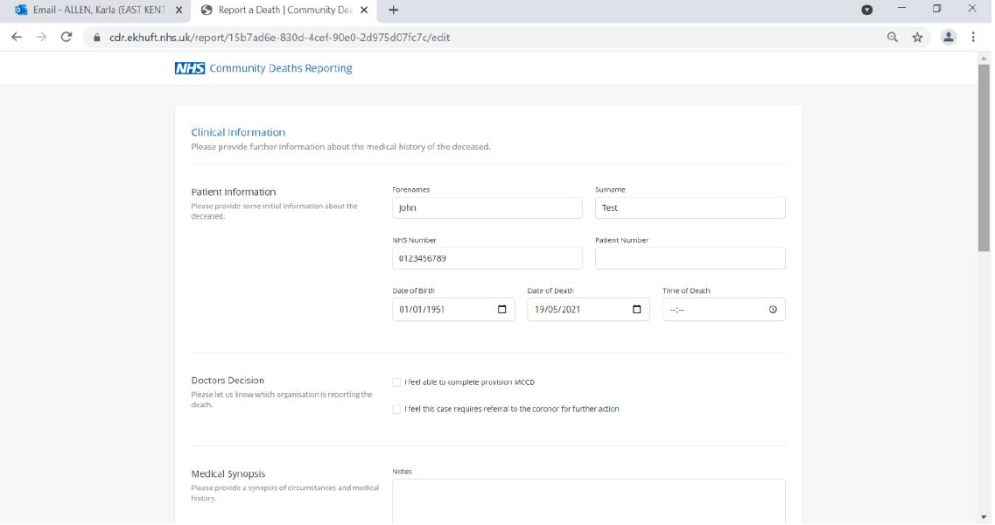

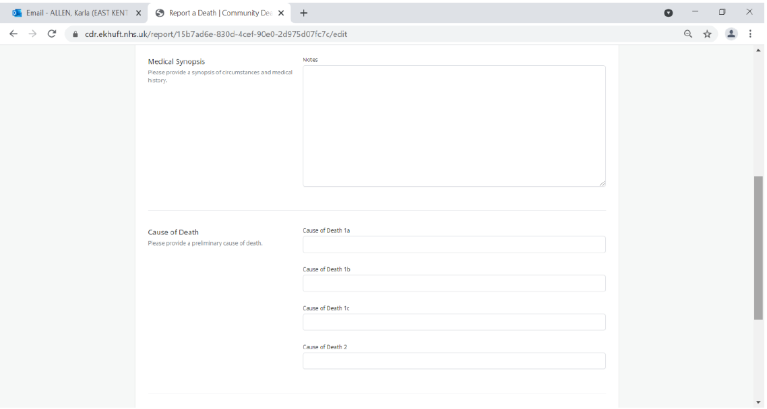
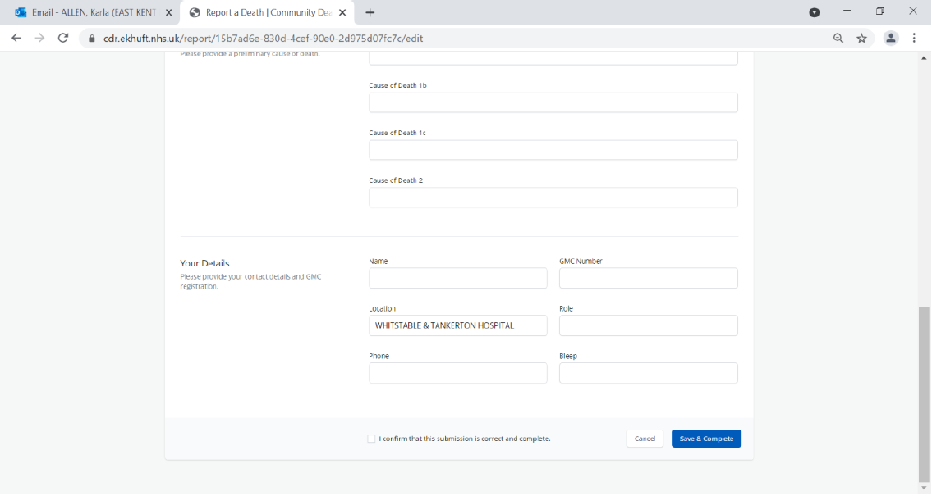

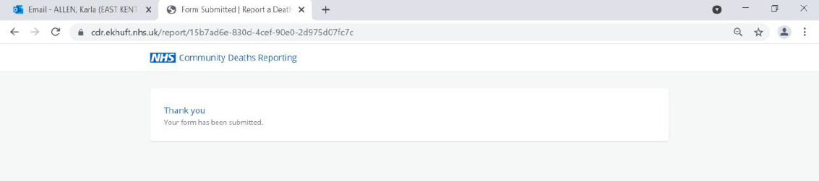

Following submission of the form by the supervising clinician, the ME Office will contact you within 24 hours. This will be either via phone or email with your admin team CC’d into the return.

N.B – the system has been set up so that an entry has to be made into 1a for the form to submitted. If the cause of death is unknown, please put ‘Unknown’ in 1a.

