INFECTION PREVENTION AND CONTROL
ANNUAL REPORT

APRIL 2021 – MARCH 2022

Contents
 | Section | Page Number
1. | Introduction | 3
2. | The Year 2020 – 2021 and the Pandemic of Covid-19 | 3
3. | The Infection Prevention and Control Team | 5
4. | Infection Prevention and Control Committee | 5
5. | The Care Quality Commission (CQC) | 6
6. | We Care | 6
7. | Education and Training | 6
8. | Audit | 7
9. | Hand Hygiene | 7
10. | Hospital hygiene and the Healthcare Environment | 7
11. | Incidents/Outbreaks of Healthcare-Associated Infection | 8
12. | Surveillance and Epidemiology including  Clostridioides difficile  Staphylococus aureus (MSSA and MRSA) bloodstream infections  Gram Negative bloodstream infections  Carbapenamase Producing Organisms (CPO) | 8
13. | Antimicrobial Stewardship Group | 13
14. | Trauma and Orthopaedic Surgery Surveillance of Surgical Site Infection | 16
15. | Conclusions | 16
16. | Appendix 1: The Covid-19 Infection Prevention and Control Board Assurance Framework at March 2022. | 17

East Kent Hospitals University NHS Foundation Trust

INFECTION PREVENTION AND CONTROL ANNUAL REPORT

April 2021 – March 2022

- Introduction

The Director of Infection Prevention and Control (DIPC) is required to produce an Annual Report on the state of healthcare associated infection (HCAI) in the organisation for which s/he is responsible and release it publicly according to the Code of Practice on the prevention and control of infections and related guidance (The Health and Social Care Act 2008). The Annual Report is produced for the Chief Executive and Trust Board of Directors and describes Infection Prevention and Control activity during the year, including, under normal circumstances, progress made against the work plan and objectives identified in the Infection Prevention and Control Annual Programme and against any external objectives.

- The Year 2021 – 2022 and the Pandemic of Covid-19

This report covers the period from April 2021 to the end of March 2022. Although the peak of the second wave of Covid-19 had passed at the beginning of this year, healthcare and infection prevention and control (IPC) continued to be dominated by the response to the pandemic and increasingly by the efforts to recover from its effects. The response of the Trust as guided by the DIPC and the Infection Prevention and Control Team (IPCT) continued, throughout this period to be driven by national policy and guidance from external bodies. In particular, this included policy and guidance from NHE England and Improvement (NHSE/I) and the United Kingdom Health Security Agency (UKHSA) formerly Public Health England (PHE). Increasingly this policy and guidance sought to strike a balance between IPC precautions and the opportunity to treat greater numbers of patients, particularly those very large numbers of people whose wait for treatment has been adversely affected by the impact of the pandemic on waiting lists for a range tests and procedures. In a similar manner to the previous year, the Trust-wide response to the Covid-19 pandemic involved and affected all staff, across all specialties and departments, including 2gether Support Solutions (2gether) and Spencer Private Hospitals (SPH) and this report needs to be read in that context. By the end of this reporting year the Trust had diagnosed 13,044 cases of Covid-19 (Figure 1) compared to 6,925 at the same point in the previous year. These numbers include staff, patients and tests conducted for other organisations in East Kent.

The pandemic in the UK in the year April 2021 to March 2022 was characterised by relatively low levels of Covid-19 in the summer followed by the emergence from around October of the Omicron variant of Covid-19, the incidence of which peaked in January 2022 with around one hundred and seventy inpatients. This was then followed quickly by BA.2 sub-variant of Omicron, the incidence of which was approaching its peak at the end of March 2022 (Figure 2), going on to peak at around two hundred and thirty-five inpatients in early April 2022. Despite these very large numbers of inpatients, greater than those seen in April/May of 2020, though fewer than the numbers seen in January at the peak of the Alpha (previously Kent) variant, there were significant changes in the clinical outcomes from infection with these variants as compared with earlier peaks of infection. The Omicron and BA.2 variants have increased transmissibility, possibly up to ten times as transmissible compared with the original ‘wild type’ Covid-19 virus. However, they also have lower virulence (the propensity to cause serious illness and death) than previous variants and this, in combination with the successful vaccination programme in the UK, meant that cases of serious illness and death (morbidity and mortality) were considerably fewer than in previous periods. One of the significant changes in the way that cases presented in this latter period was that for very many, nationally estimated as at least half, of the patients who tested positive for Covid-19, this was an incidental finding, i.e. that the individual was in hospital for a reason unrelated to the result. The main consequence of this change in the epidemiology and presentation of Covid-19 was the propensity for cases to arise in all specialties and across all patient pathways. This, in combination with high numbers of staff testing positive and being required to stay at home, created new and significant challenges for IPC and, more importantly, the ability to maintain the required Covid-19 precautions while continuing to run the Trust’s services.

Figure 1. Cases of Covid-19 detected by EKHUFT
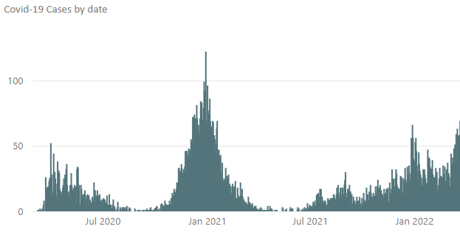

Figure 2. Covid-19 inpatients by date EKHUFT

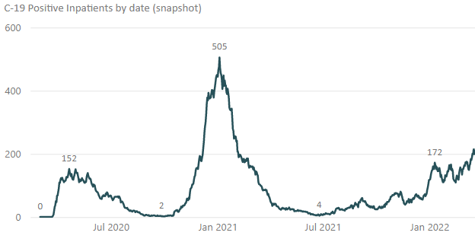

As in the report from the previous year, the operational and organisational response is not described in detail within this report but continued to be supported by clinical and non-clinical staff from all specialties. There were numerous changes to the national policy and guidance described above and although much of the focus of these changes was on recovery of services, there were still many requirements on staff to work differently and flexibly to treat as many patients as possible, while maintaining IPC precautions and patient safety. Changes included changes to personal protective equipment (PPE), patient testing and pathways as well as restoring increasing normality to visiting and social distancing. The IPCT (described in more detail below) had the responsibility to work with the trust response, managed by the incident response command and control structures, providing expert advice and practical support to all staff, clinical and non-clinical. The support included providing guidance and tools, education and training, audit and feedback as well as supporting the identification and management of healthcare associated cases of Covid-19 and outbreaks. Outbreaks were managed and reported in line with national requirements and with the support of the affected areas and colleagues from Occupational Health and the local Health Protection Teams.

By the end of March 2021, the end of the period covered by this report, the BA.2 sub-variant was dominant and the number of in-patient cases was increasing as described above. Throughout this reporting year the Trust response to the pandemic has been recorded and reported to the Trust Quality and Safety Committee and Trust Board using the NHS England and Improvement (NHSE/I) IPC Board Assurance Template (BAF). The BAF has been updated and reported on a monthly basis. The BAF updated to the end of March 2022 (for the period of this report) is appended as Appendix 1.

- The Infection Prevention and Control Team

The IPCT are the medical and nursing specialists responsible for undertaking the work described, under normal circumstances, in the IPC annual programme. During this reporting year the IPCT resource has been strengthened with the appointment of a substantive Deputy DIPC who started in June 2021 and the creation of, and appointment to three IPC site leadership posts with additional Trust-wide portfolio responsibilities. These colleagues have been in post since late 2021/early 2022 and development of their roles was in train at the end of March 2022. Consultants in Medical Microbiology and Virology as well the Consultant Clinical Scientist in Virology and Infection have given support to the IPC needs of the organisation throughout the year. One Consultant in Medical Microbiology has acted as ‘Infection Control Doctor’ with another providing a leadership role in Antimicrobial Stewardship (see below), but all have supported IPC operationally throughout the year. There have been some challenges with long-term sickness and vacancies and some interim support has been required to maintain the service during this period. Support from the Kent and Medway Clinical Commissioning Group (transitioning to the Integrated Care Board) has provided professional development opportunities for a number of the members of the IPCT and the Trust has supported the provision of team development activities. The team have developed and promulgated a comprehensive Annual IPC Work Plan for the forthcoming year 2022-2023, something that has not been possible in the two previous years to the end of March 2022, due to the pandemic.

- Infection Prevention and Control Committee

The EKHUFT Infection Prevention and Control Committee (IPCC) is a multidisciplinary Trust committee with outside representation from UKHSA and Clinical Commissioning Group (CCG). The IPCC oversees the activity of the IPC Team and, under normal circumstances, supervises the implementation of the IPC annual programme. During this reporting period, the disruption associated with the pandemic led to there not being a formal IPC annual programme as described above. During this reporting year, the IPCC has continued to meet monthly and the format has remained largely unchanged as the ongoing pandemic pressures have not allowed for the planned review of the committee. However, this review is included in the IPC Annual Work Plan for 2002-2023 and will reflect the organisation’s needs in what will hopefully be a post-pandemic (or technically, between pandemics) era.

- The Care Quality Commission (CQC)

Following the lifting of the Section 31 regulation notice at the end of the previous year there have been no IPC specific CQC inspections of EKHUFT during 2021-2022. Inspections of specific services have been undertaken, but these have not focussed specifically on IPC.
The inspection of Maternity Services in July 2021 noted that at the William Harvey Hospital (WHH) “the service controlled infection risk well”. At the Queen Elizabeth the Queen Mother Hospital (QEQM) the CQC noted that some improvement was needed to ensure that cleaning of birthing pools was fully documented and the Trust should “put in place a system to provide assurance that the pools were cleaned in line with protocol after every use and were safe for women to use.” - This matter was addressed by the Care Group, there were no IPC “must” requirements.

The inspection of Children and Young People services in July 2021 noted that at both the WHH and QEQM sites that “The service controlled infection risk well”. There were no IPC specific requirements.

- We Care

The Trust is engaged an organisational programme intended to create transformational change and, over a five to ten year period, achieve the trusts strategic objectives, described as True North. The detail of We Care is not given here, however within the True North target to achieve zero avoidable harm, the reduction of healthcare associated infections (HCAI) was identified as a ‘Breakthrough Objective’ prior to the appointment of the current DIPC. This Breakthrough Objective was stood down in September 2021 as other processes were in place to deliver the necessary reductions in HCAI and the Breakthrough Objective was identified as not the best methodology for delivery of this outcome, due to the mismatch between the focussed nature of the intervention and the disseminated nature of the outcome. The IPCT are working towards using the improvement approaches that form part of We Care in all aspects of the 2022-2023 IPC Annual Work Plan.

- Education and Training

The Code of Practice requires that all staff undertake mandatory infection prevention and control training on a regular basis. The specific requirement is:

‘that relevant staff, contractors and other persons whose normal duties are directly or indirectly concerned with patients care receive suitable and sufficient training, information and supervision on the measures required to prevent and control risks of infection’.

Education and training continued to be disrupted and necessarily changed due to the pandemic of Covid-19. Mandatory IPC and hand hygiene training continued, primarily via e-learning and virtual platforms. A video featuring the interim DIPC explaining the necessary Covid-19 IPC requirements continued to be a mandatory requirement for all staff in addition to the existing mandatory e-learning. At the end of this reporting period (March 2022) compliance with IPC mandatory training requirements was 94%.

- Audit

The programme of audits was disrupted and refocussed by the Covid-19 pandemic. There has been an increasing recognition that the IPC audit programme needs to be reviewed, both in response to the changing epidemiology of the pandemic, but also to align as much as possible to the wider Fundamentals of Care and Ward Accreditation Programme. This review is included in the IPC Work Programme for 2022-2023. For the reporting year 2021-2022 the following audits have continued.

Audit | Completed | Achievement
Antimicrobial prescribing |  | Please see Antimicrobial Stewardship Report.
Infection Prevention and Control Audits of Environmental and Clinical Practice | Yearly | Regular audits (every 12-18 months) of the clinical environments have been resumed. The completed audit report is sent to the Ward/ Department Manager, who is responsible for both formulating and implementing an action plan. The results of these Audits are being reported monthly in the Infection Prevention and Control Monthly Report.
“Saving Lives” | Monthly | Monitoring of compliance with the management of invasive devices, e.g. peripheral cannula, central vascular catheter and urinary catheter, insertion and continuing care. The results of these Audits are being reported monthly in the Infection Prevention and Control Monthly Report.

- Hand Hygiene

Hand hygiene and the use of personal protective equipment (PPE) continued to be a key focus during 2021-2022, with particular reference to the enhanced PPE requirements caused by Covid-19. Hand hygiene, use of PPE and ‘bare below the elbows’ status is audited within care groups and by the IPC and the results are shared at the monthly IPCC. As of March 2022, the snapshot compliance with the composite hand hygiene audits was 97%. Audits are used to reinforce good practice and for learning and improvement within front-line teams. The hand hygiene audit is included in the forthcoming review described above.

- Hospital Hygiene and the Healthcare Environment

The IPC Team have continued to monitor standards of cleanliness within the Trust and promote good practice in conjunction with the Hospital and Facilities Managers through participation in the following activities:

- Patient-led Assessment of the Care Environment (PLACE).
- Environmental audits of cleanliness and the healthcare environment.
- Advising contractors/contract management on cleaning and domestic issues.
- Day to day advice/intervention/escalation to facilities management as appropriate, with regard to cleaning issues.
- Advising, with engineering colleagues from 2gether Support Solutions, through the site based and trust wide Water Safety Groups on the safe management of water supplies, to prevent risks associated with Legionella and, in augmented care settings, Pseudomonas aeruginosa.

Two major developments relevant to the healthcare environment have been in progress during this reporting year;

- The “ARUP” comprehensive report on the Trust’s requirements for all aspects of backlog maintenance was delivered to the Trust. The DIPC and Deputy DIPC engaged with 2gether and clinical leaders to prioritise the annual backlog maintenance budget and any additional funds as they became available during 2021-2022.
- With the support of the DIPC the Trust agreed a significant investment in excess of two million pounds per year extra funding for cleaning resources, in order to work towards compliance by the deadline of October 2022 with the revised NHS National Cleaning Standards 2021.

- Incidents/Outbreaks of Healthcare-Associated Infection

Note that all matters related to the Covid-19 pandemic are described in section 2. Individual outbreaks of Covid-19 as nationally defined and reported using the official ‘IIMARCH’ reporting system are not reported here and are a matter of formal record elsewhere.

There have been no confirmed outbreaks of infection or decontamination incidents of note during 2021-2022. One episode of confirmed transmission of C. difficile at QEQM was investigated and managed with local lessons for the ward implemented. Other suspected outbreaks have been investigated, with the support of the local Health Protection Team of UKHSA and the CCG where necessary, but no evidence to support the definition of outbreak identified.

  - Seasonal viral infections

The Covid-19 pandemic has continued to have an impact on the incidence and prevalence of seasonal viral infections such as Influenza and Norovirus, with many fewer cases during the winter season of 2021-2022.

- Surveillance and Epidemiology

Reportable Infections

The introduction of thresholds for Gram negative bacteraemias was postponed during 2020-2021 due to the Covid-19 pandemic, however thresholds for Clostridioides difficile and Gram negative bacteraemias were published for 2021-2022. Trust performance against these thresholds and data for those infections where no threshold has been set are given below.

  - Clostridioides difficile (previously known as Clostridium difficile)

All cases of C. difficile identified from samples taken on day 2 of admission (where the day of admission is day 0) are hospital attributable.

These cases are described as Hospital Onset Healthcare Associated (HOHA). In addition, any patient discharged from hospital in the 28 days prior to a positive test for C. difficile are also hospital attributable. These cases are described as Community Onset Healthcare Associated (COHA). These two categories are combined in the revised figure 3 showing performance compared with 2020-2021 and a linear trajectory to the externally set threshold.

Figure 3:

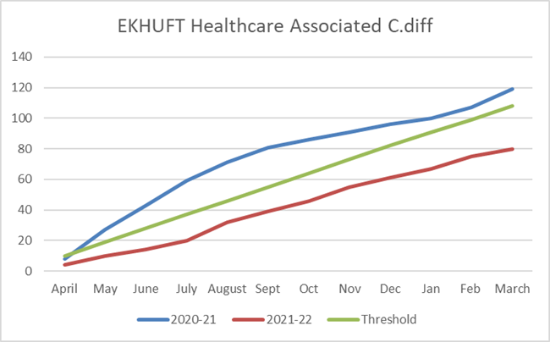

For the full year 2021-2022 the Trust is below the external threshold. There has been a 33% reduction in cases compared with the previous year. The March cases have taken the three-month rolling average further below the average to achieve the threshold (figure 4).

Figure 4:
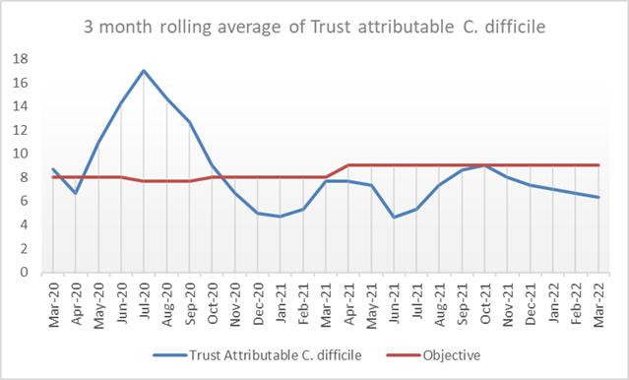

The C. difficile counts and 12 month rolling rates of HOHA and COHA infections published by Public Health England (PHE) to the end of December 2021 show that EKHUFT continues to be lower for HOHA cases than the all England benchmarks with rates of 16.2 per 100 000 bed days for HOHA (benchmark 18.9) (figure 5) but remains higher (unchanged) at 12.2 per 100,000 bed days for COHA (benchmark 7.9).

Figure 5
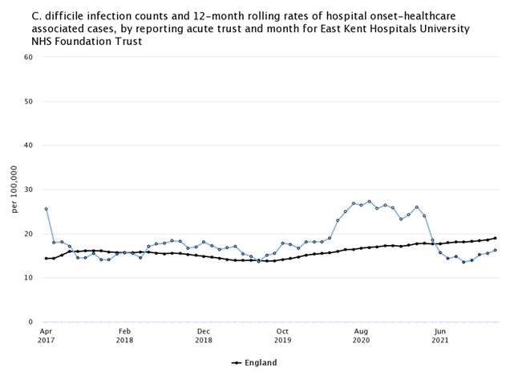

  - Staphylococcus aureus Infections (MRSA and MSSA) bloodstream infections

    - MRSA

MRSA bloodstream infections should be extremely rare events and avoidable healthcare onset cases should be regarded with zero tolerance. During 2021-2022 EKHUFT reported three cases. An investigation is conducted for any case and any lessons shared at the IPCC.

    - MSSA

Meticillin sensitive Staphylococcus aureus (MSSA) bloodstream infections are common in both community and hospital settings. Healthcare associated infections are commonly related to vascular access catheters or surgical site infection. There is no externally set objective for MSSA bloodstream infections.

The number of hospital attributed bacteraemias is higher for 2021-2022 compared with the previous year. Sixty one cases to the end of March 2022 compared with 50 for the previous year (figure 6). The rate of hospital onset cases is 14.8 cases per 100,000 bed days compared with the England rate of 11.3 cases per 100 000 bed days (March 2022 published data).

Hospital acquired cases are investigated by root cause analysis with an associated action plan where learning is identified.

Figure 6:
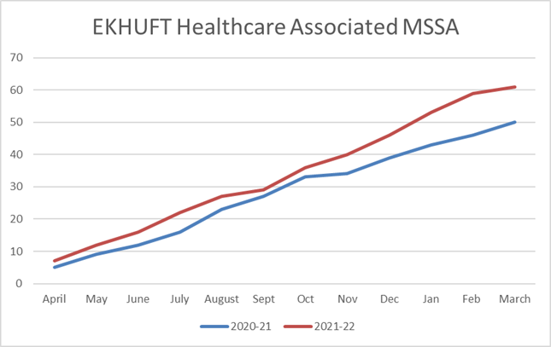

  - Gram Negative Bloodstream Infections

There is a national commitment to reduce the number of avoidable healthcare associated Gram-negative bloodstream infections by 25% by the end of 2021-22 and the full 50% by 2023-24 compared with 2015-2016.

With the publication of the new national thresholds for these infections, these are now presented separately (figures 7 to 9) and using the revised calculation on which these thresholds are based (described as ‘Healthcare Associated’). This calculation includes Community Onset – Healthcare Associated (COHA) cases as well as Hospital Onset – Healthcare Associated (HOHA) in a manner similar to the Cdiff data. Consequently, these numbers are higher than the committee have previously seen. All comparisons with the previous reporting year need to be treated with caution because of the impact of Covid-19, in particular the very large increases in the number of critical care patients.

The data for P. aeruginosa have exceeded the threshold for the full year by three cases, although the actual number of cases is identical to the previous year. For Klebsiella spp. there has been a small reduction in the number of cases (circa 10%) compared with the previous year and the total is below the external threshold. For E coli the number of cases is similar to the previous year and under the external threshold.

Figure 7:
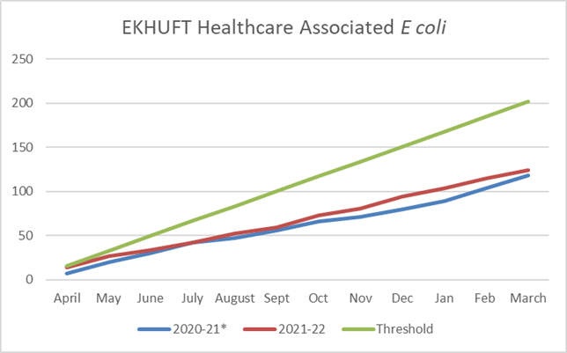

Figure 8:

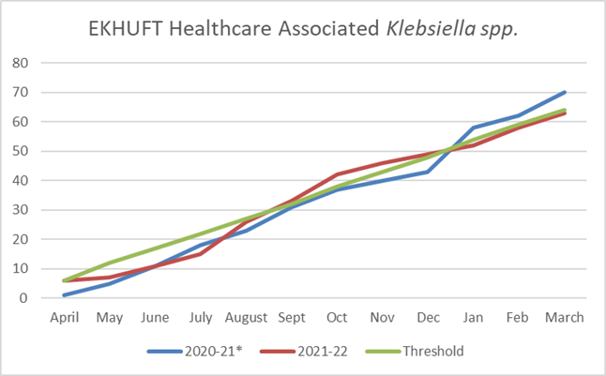

Figure 9:

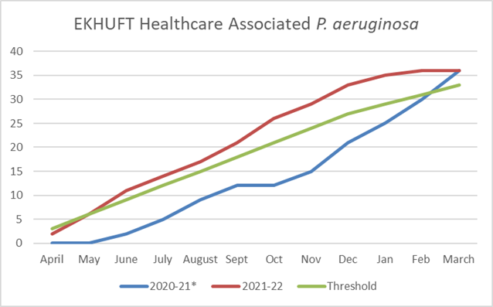

  - Carbapenemase Producing Organisms (CPO)

CPO are of concern as organisms producing Carbapenamases (enzymes that confer antimicrobial resistance) are resistant to many of the antimicrobials of last resort. In some areas of the UK, CPO have become endemic and once established in a healthcare facility, they can be extremely difficult to eradicate. Management of CPO follows published guidance from UKHSA. For EKHUFT where CPO are not endemic this is based on targeted screening of certain patient groups. Although this screening has identified sporadic cases, no cluster or outbreaks have been identified. Vigilance remains high. New guidance on the management of CPO is expected

- Antimicrobial Stewardship Group (ASG)

Currently the Antimicrobial Stewardship Team consists of Dr Stephen Glass (Consultant Medical Microbiologist) 10 hours per week and Doreen Flower (Advanced Pharmacist - AMS) 1 Full Time Equivalent (FTE). AMS ward rounds/referrals are conducted by other Consultant Microbiologists as needed. (Amy Dalton (Advanced Pharmacist – Antimicrobial Stewardship) 0.7 FTE (will be on maternity leave from December 2021 to January 2023)). It has not been possible to date to successfully appoint to the new post of Consultant Pharmacist, Antimicrobial Stewardship to date. A third attempt to recruit is in train.

Antimicrobial stewardship rounds occur on 1-2 sites 2-3 times a week depending on how time and resource allows. These rounds focus on reviewing restricted antibiotics such as clindamycin, meropenem, fluoroquinolones and third generation cephalosporins. The pharmacists on all sites are asked to highlight any antibiotics prescribed outside guidelines or those reaching 10 days duration, for review by the medical team with referral to microbiology where necessary. As of October 2020, the clinical pharmacists now have formal pathways in place to escalate any issues to a senior pharmacist for advice. They can further escalate to an AMS pharmacist if required.
In November 2020, in order to reduce antibiotic usage and prevent issues with Clostridioides difficile infections as seen during the first wave of COVID-19, the AMS team implemented the use of procalcitonin (PCT) testing for all suspected or confirmed community-acquired COVID-19 cases admitted to hospital and prescribed antibiotics for COVID-19 pneumonitis. A negative PCT result of <0.25ng/ml indicates that a bacterial co-infection is very unlikely and antibiotics are not recommended.

The following information is presented using data collected from the REFINE database. In order to compare data across different timeframes and between different trusts, the data is presented as Defined Daily Doses (DDDs)/1000 admissions. Whilst the antibiotic consumption data is updated every month, the admission data is updated every 2 months. In the data sets below, the figures are correct up until February 2022 with March 2022 calculated using February admission data as a proxy. The data point for March 2022 may be subject to change in later versions of this report.
Total consumption of antibiotics is monitored under the NHS Standard Contract. The data is reported as Defined Daily Dose per 1000 admissions (using the dictionary of medicines and devices nomenclature to allow benchmarking) with the aim to reduce total antimicrobial consumption by 1% against 2018 baseline data for 2019-2020 and 2% for 2020-21. Due to COVID-19, the target of 2% reduction has been carried over for 2021-2022, with a further 1% required yearly thereafter. The trust met the target for 2019-2020, however the increased usage of antibiotics during the COVID-19 pandemic means that the trust is some way off meeting the target for 2020/21 and is starting from a higher level at the beginning of 2021-2022 (Figure 10).

Figure 10:

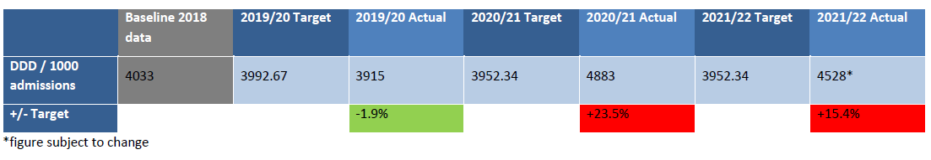

Antimicrobial Stewardship Audits

AMS audits have been conducted monthly with data collected by the clinical pharmacists and clinical pharmacy technicians. Due to the clinical pharmacy team reverting to business continuity plans to deal with the second wave of the COVID-19 pandemic, AMS audits were suspended in November 2020 but were restarted in May 2021 and collected by the clinical pharmacists covering the ward areas. Results are reported to the Antimicrobial Stewardship Group and IPCC.
The AMS team is currently working with the Trust’s Patient Tracking List (PTL) team to set up a new AMS audit PTL system (different to the AMS patient PTL system). This will be used for the monthly AMS audit data collection and display of results for both ward areas and consultants. Results will include antibiotic guideline compliance, documentation of antibiotic indications and documentation of penicillin allergy status. Wards and care groups will be able to see their results in a timely manner, enabling them to take ownership of their own improvement plans where necessary.

The activities of the Antimicrobial Stewardship Team during 2021-2022 are shown in Table 1.

Table 1: Overview of AMS Workstreams for 2020-2021

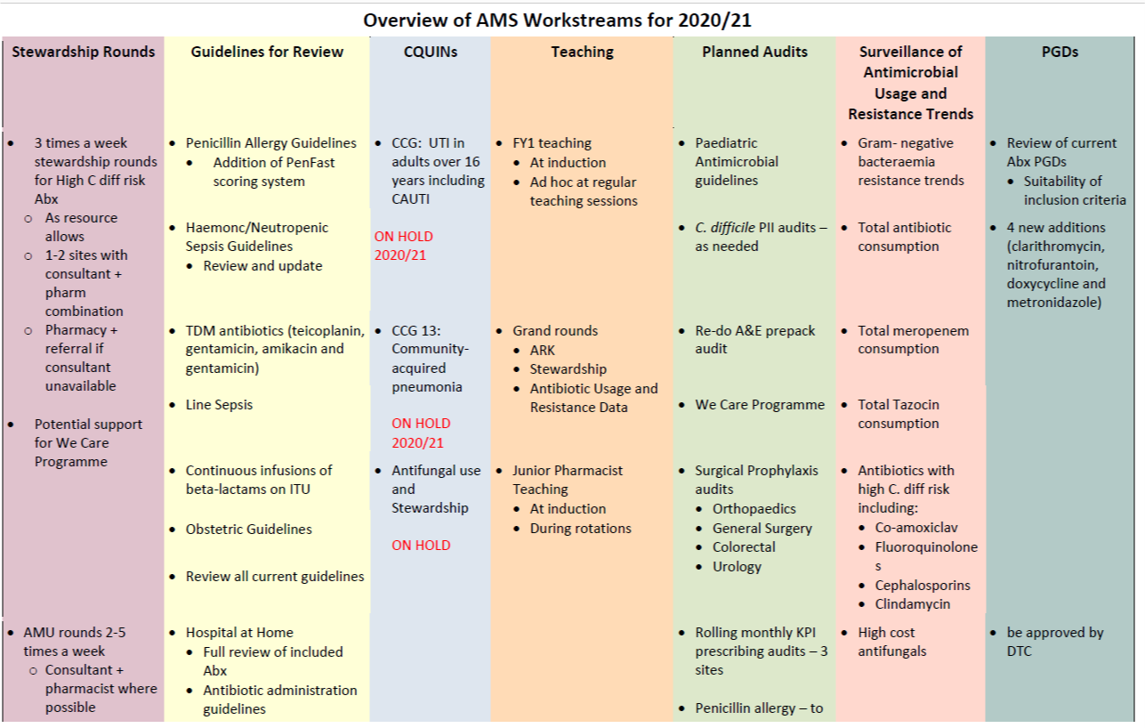

- Trauma and Orthopaedic Surveillance of Surgical Site Infection

Surveillance of surgical site infection (SSI) following orthopaedic surgery is included in the mandatory healthcare-associated infection surveillance system.

All NHS Trusts where orthopaedic surgical procedures are performed are expected to carry out a minimum of three months surveillance in at least one of the three orthopaedic categories:

- Total hip replacements

- Knee replacements

- Hip hemiarthroplasties

EKHUFT undertake continuous surveillance in all 3 categories (rather than limiting participation to the mandatory single quarter per year). This process is managed by the orthopaedic team with IPC support. All data for the year 2021-2022 have been submitted to the surveillance system. There is a time lag in receiving reports back with national comparators. Hospitals that are outliers in comparison to the national data set, based on the previous four quarters of data are notified formally by the UKHSA national surveillance team. At the time of writing EKHUFT has received no outlier notifications for the year 2021-2022.

- Conclusions

The Covid-19 pandemic, as noted at the beginning of this report, has continued to impact upon the Trust and IPC service during 2021-2022. There have been some improvements in year, including reductions in C. difficile and E coli as well as much improved outcomes from CQC inspections compared with the previous year, although all comparisons should be made with caution, given the impact of the pandemic. Challenges remain, including the ongoing response to Covid-19 and the increase in MSSA bacteraemias and the breaching of the external threshold for P. aeruginosa bacteraemias.

For 2022-2023 the focus of the IPCT and AMS activities is described in the IPC Annual Work Plan and includes the following issues:

- Governance and assurance review
- Team and service development
- Infection reduction priorities
- Education and link practitioner review
- Antimicrobial stewardship
- Developments is surveillance, audit and epidemiology
- Review of compliance with the expected review of the “Code of practice on the prevention and control of infections 2015”

Appendix 1 - The Covid-19 Infection Prevention and Control Board Assurance Framework at March 2022

Infection Prevention and Control board assurance framework
The IPC BAF is required to be updated and reviewed by the Trust Board on a monthly basis during the Covid-19 pandemic.

This version of the BAF is a completely revised update, based on the version published by NHSE/I on 26 December 2021. The previous iteration presented to the Trust Board in November 2021 has been archived and will be available as a record of the iterations to that date.

Note: guidance changes related to the NHS approach to ‘living with Covid-19 are expected but may be delayed by the current UK wide surge of Omicron BA.2

Changes to the BAF this month:

Section 1.
- Risk based decisions made regarding patient placement that balances IPC risks and other risks e.g. corridor care in ED (by IPC and operational and clinical managers)
- Review of patient moves in progress, reviewing the need to maintain optimal IPC and optimal speciality-based care and treatment and minimise unnecessary moves
- Kent & Medway agreed position on closing Covid-19 outbreaks after 10 days of no new cases (no evidence of onward transmission agreed by Gold and implemented

Section 4.
- An update on national visiting guidance has been promised and is awaited. Current visiting risk assessments have been reviewed and re-published for clarity

Section 10
- Change in national guidance that removes distinction between vaccinated and unvaccinated staff when deemed a contact – implemented, updated K&M risk assessment now implemented

Infection prevention and control board assurance framework

1. Systems to manage and monitor the prevention and control of infection. These systems use risk assessments and consider the susceptibility
of service users and any risks their environment and other users may pose to them
Key lines of enquiry |  | Evidence | Gaps in assurance | Mitigating actions
Systems and processes are in place to ensure that:  - a respiratory season/winter plan is in place:  - that includes point of care testing (POCT) methods for seasonal respiratory viruses to support patient triage/placement and safe management according to local needs, prevalence, and care services  - to enable appropriate segregation of cases depending on the pathogen.  - plan for and manage increasing case numbers where they occur.  - a multidisciplinary team approach is adopted with hospital leadership, estates & facilities, IPC Teams and clinical staff to assess and plan for creation of adequate isolation rooms/units as part of the Trusts winter plan.  - health and care settings continue to apply COVID-19 secure workplace requirements as far as practicable, and that any workplace risk(s) are mitigated for everyone.  - Organisational /employers risk assessments in the context of managing seasonal respiratory infectious agents are:  - based on the measures as prioritised in the hierarchy of controls. including evaluation of the ventilation in the area, operational capacity, and prevalence of infection/new variants of concern in the local area.  - applied in order and include elimination; substitution, engineering, administration and PPE/RPE.  - communicated to staff.  - safe systems of working; including managing the risk associated with  infectious agents through the completion of risk assessments have been approved through local governance procedures, for example Integrated Care Systems. |  | The Trust Covid-19 response escalation plans include the need to test for other respiratory viruses, including POCT for influenza and Respiratory Syncytial Virus (RSV).  Cases of confirmed Covid-19 are managed in Covid-19 areas (Blue) and confirmed cases of other seasonal respiratory viruses are managed in single rooms according to specialty/clinical need.  Risk based decisions made regarding patient placement that balances IPC risks and other risks e.g. corridor care in ED (by IPC and operational and clinical managers  The Trust has maintained all workplace requirements as instituted previously, including, but not limited to, social distancing, appropriate PPE, hand hygiene, enhanced cleaning and alterations to work patterns (including work from home requirements and staggered breaks).  Existing risk assessments for individual staff are all in the process of being updated.  Risk assessments for staff as contacts of Covid-19 cases are agreed on a Kent and Medway-wide basis. Other risk assessments have been approved within the organisation.

- if the organisation has adopted practices that differ from those recommended/stated in the national guidance a risk assessment has been completed and it has been approved through local governance procedures, for example Integrated Care Systems.  - risk assessments are carried out in all areas by a competent person with the skills, knowledge, and experience to be able to recognise the hazards associated with respiratory infectious agents.  - if an unacceptable risk of transmission remains following the risk assessment, the extended use of Respiratory Protective Equipment (RPE) for patient care in specific situations should be considered.  - ensure that patients are not transferred unnecessarily between care areas unless, there is a change in their infectious status, clinical need, or availability of services.  - the Trust Chief Executive, the Medical Director or the Chief Nurse has oversight of daily sitrep.in relation to COVID-19, other seasonal respiratory infections, and hospital onset cases  - there are check and challenge opportunities by the executive/senior leadership teams of IPC practice in both clinical and non-clinical areas.  - resources are in place to implement and measure adherence to good IPC practice. This must include all care areas and all staff (permanent, agency and external contractors).  - the application of IPC practices within this guidance is monitored, e.g.:  - hand hygiene.  - PPE donning and doffing training.  - cleaning and decontamination.  - the IPC Board Assurance Framework is reviewed, and evidence of assessments are made available and discussed at Trust board.  - the Trust Board has oversight of ongoing outbreaks and action plans.  - the Trust is not reliant on a particular mask type and ensure that a range of predominantly UK Make FFP3 masks are available to users as required. | The trust has maintained compliance with current iteration of the national guidance and has not derogated any matters.  Environmental risk assessments done in response to previous surges of Covid-19 are being reviewed in light of changing epidemiology of the Omicron variant.  RPE has been made available to all staff in any area, not limited to ‘Blue’ areas and if specified in individual risk assessments.  Review of patient moves in progress, reviewing the need to maintain optimal IPC and optimal speciality-based care and treatment and minimise unnecessary moves  IPC are monitoring and reviewing patient movements and any impact on transmission.  CEO or exec sign off for data submissions, DIPC signs off IIMARCH forms for outbreaks, Daily Sitrep analysis shared with senior staff  Gemba and other senior leader engagement activities continue. Execs and senior leaders frequently in clinical and non-clinical areas.  All necessary resources are in place  IPC audits are conducted in all clinical areas and the results are monitored by the IPC Committee and the IPC Team. Additional audits are conducted by the IPC Team when indicated (e.g. outbreak situations)  IPC BAF is reviewed at every Board meeting  The DIPC reports to the Quality and Safety Committee and The Trust Board and provides updates on outbreaks and, where relevant, trust-wide actions.  Kent & Medway agreed position on closing Covid-19 outbreaks after 10 days of no new cases (no evidence of onward transmission agreed by Gold and implemented  The trust has access to a range of FFP3 with sufficient stocks, monitored at Gold. | Not all areas have had an environmental risk assessment based on previous Covid-19 epidemiology | Data on previous risk assessment completeness being reviewed to inform further work

2. Provide and maintain a clean and appropriate environment in managed premises that facilitates the prevention and control of i nfections
Key lines of enquiry | Evidence | Gaps in assurance | Mitigating actions
Systems and processes are in place to ensure that:  - the Trust has a plan in place for the implementation of the National Standards of Healthcare Cleanliness and this plan is monitored at board level.  - the organisation has systems and processes in place to identify and communicate changes in the functionality of areas/rooms  - cleaning standards and frequencies are monitored in clinical and non- clinical areas with actions in place to resolve issues in maintaining a clean environment.  - increased frequency of cleaning should be incorporated into the environmental decontamination schedules for patient isolation rooms and cohort areas.  - Where patients with respiratory infections are cared for : cleaning and decontamination are carried out with neutral detergent or a combined solution followed by a chlorine-based disinfectant, in the form of a solution at a minimum strength of 1,000ppm available chlorine as per national guidance.  - if an alternative disinfectant is used, the local infection prevention and control team (IPCT) are consulted on this to ensure that this is effective against enveloped viruses.  - manufacturers’ guidance and recommended product ‘contact time’ is followed for all cleaning/disinfectant solutions/products.  - a minimum of twice daily cleaning of:  - patient isolation rooms.  - cohort areas.  - Donning & doffing areas  - ‘Frequently touched’ surfaces e.g., door/toilet handles, patient call bells, over bed tables and bed rails.  - where there may be higher environmental contamination rates, including:  - toilets/commodes particularly if patients have diarrhoea. | The Trust Board has approved the business case for implementation of 2021 National Standards of Healthcare Cleanliness and 2gether Support solutions have developed an implementation plan to achieve full compliance by the October 2022 deadline for Trusts. This will include mechanisms to identify and communicated changes in functionality of rooms/areas  Cleaning issues are escalated through existing processes and to the IPC Team if required. Cleaning escalations are discussed at the IPC Committee  Cleaning schedules and methods for isolation areas are as per policy. EKHUFT uses Tristel Fuse™ which is a Chlorine Dioxide based environmental disinfectant approved by the IPCT.  Products are used as per protocol (incorporating manufacturers’ instructions).  In addition enhanced technologies (UV and Hydrogen Peroxide Vapour) are deployed as per IPC protocol.  Cleaning frequencies, protocols and procedures meet these requirements

- A terminal/deep clean of inpatient rooms is carried out:  - following resolutions of symptoms and removal of precautions.  - when vacated following discharge or transfer (this includes removal and disposal/or laundering of all curtains and bed screens);  - following an AGP if room vacated (clearance of infectious particles after an AGP is dependent on the ventilation and air change within the room).  - reusable non-invasive care equipment is decontaminated:  - between each use.  - after blood and/or body fluid contamination  - at regular predefined intervals as part of an equipment cleaning protocol  - before inspection, servicing, or repair equipment.  - Compliance with regular cleaning regimes is monitored including that of reusable patient care equipment.  - As part of the Hierarchy of controls assessment: ventilation systems, particularly in, patient care areas (natural or mechanical) meet national recommendations for minimum air changes refer to country specific guidance.  - In patient Care Health Building Note 04-01: Adult in-patient facilities.  - the assessment is carried out in conjunction with organisational estates teams and or specialist advice from ventilation group and or the organisations, authorised engineer.  - a systematic review of ventilation and risk assessment is undertaken to support location of patient care areas for respiratory pathways  - where possible air is diluted by natural ventilation by opening windows and doors where appropriate  - where a clinical space has very low air changes and it is not possible to increase dilution effectively, alternative technologies are considered with Estates/ventilation group.  - when considering screens/partitions in reception/ waiting areas, consult with estates/facilities teams, to ensure that air flow is not affected, and cleaning schedules are in place. | Terminal cleans (including enhanced technologies deployed where appropriate) are done, as described across, according to Trust IPC policy as described in the ‘What Clean do You Need’ posters.  This is business as usual and included in the decontamination policy  Cleaning is monitored by 2gether and as part of IPC audits and reported to the IPC Committee  Much of the EKHUFT clinical estate is older property without mechanical ventilation (other than specialist systems as described in HTM 03-01, specialist ventilation for healthcare building).  As described above, previous assessments of ventilation have focussed on areas for known or suspected Covid-19 cases (Blue). The Omicron variant has significantly different epidemiology with cases in any clinical setting.  Alternative technologies under consideration but experience from other organisations is that there is no advantage to their deployment.  IPC and estates/facilities discuss all physical changes to estate, incorporating impact on air flow where relevant. | Described above | Described above

3. Ensure appropriate antimicrobial use to optimise patient outcomes and to reduce the risk of adverse events and antimicrobial resistance
Key lines of enquiry | Evidence | Gaps in assurance | Mitigating actions
Systems and process are in place to ensure that:  - arrangements for antimicrobial stewardship are maintained  - previous antimicrobial history is considered  - the use of antimicrobials is managed and monitored:  - to reduce inappropriate prescribing.  - to ensure patients with infections are treated promptly with correct antibiotic.  - mandatory reporting requirements are adhered to, and boards continue to maintain oversight.  - risk assessments and mitigations are in place to avoid unintended consequences from other pathogens. | The Antimicrobial Stewardship Group (ASG) meets monthly and monitors and implements the ASG work plan. | The Antimicrobial Stewardship resource is small and fragile (person dependent)  Further work is needed to increase the scope and cover of the ASG programme | A Consultant Pharmacist (AMS) is being recruited  A proposal for further work under the auspices of the We Care programme will form part of the work plan for 2022/2023
4. Provide suitable accurate information on infections to service users, their visitors and any person concerned with providing further support or
nursing/ medical care in a timely fashion.
Key lines of enquiry | Evidence | Gaps in assurance | Mitigating actions
Systems and processes are in place to ensure that:  - visits from patient’s relatives and/or carers (formal/informal) should be encouraged and supported whilst maintaining the safety and wellbeing of patients, staff and visitors  - national guidance on visiting patients in a care setting is implemented.  - restrictive visiting may be considered appropriate during outbreaks within inpatient areas This is an organisational decision following a risk assessment.  - there is clearly displayed, written information available to prompt patients’ visitors and staff to comply with handwashing, wearing of facemask/face covering and physical distancing.  - if visitors are attending a care area with infectious patients, they should be made aware of any infection risks and offered appropriate PPE. This would routinely be an FRSM. | Trust visiting policy reflects this guidance as described across (all bullet points in this section) - agreed by Gold command  An update on national visiting guidance has been published and the trust visiting guidance updated accordingly  Front of house ‘meet and greet’ processes are being reviewed by the COO team and site leadership teams to establish a sustainable approach.

- visitors with respiratory symptoms should not be permitted to enter a care area. However, if the visit is considered essential for compassionate (end of life) or other care reasons (e.g., parent/child) a risk assessment may be undertaken, and mitigations put in place to support visiting wherever possible.  - visitors are not present during AGPs on infectious patients unless they are considered essential following a risk assessment e.g., carer/parent/guardian.  - Implementation of the Supporting excellence in infection prevention and control behaviours Implementation Toolkit has been adopted C1116- supporting-excellence-in-ipc-behaviours-imp-toolkit.pdf (england.nhs.uk) | Relevant aspects of the toolkit implemented as part of the communications approach and approved by Gold Command | Not all elements in the toolkit in use | Further review of toolkit by IPC to establish if any elements will add further value
5. Ensure prompt identification of people who have or are at risk of developing an infection so that they receive timely and appropriate treatment
to reduce the risk of transmitting infection to other people
Key lines of enquiry | Evidence | Gaps in assurance | Mitigating actions
Systems and processes are in place to ensure that:  - signage is displayed prior to and on entry to all health and care settings instructing patients with respiratory symptoms to inform receiving reception staff, immediately on their arrival.  - infection status of the patient is communicated to the receiving organization, department or transferring services, when a possible or confirmed seasonal respiratory infection needs to be transferred.  - staff are aware of agreed template for screening questions to ask.  - screening for COVID-19 is undertaken prior to attendance wherever possible to enable early recognition and to clinically assess patients prior to any patient attending a healthcare environment.  - front door areas have appropriate triaging arrangements in place to cohort patients with possible or confirmed COVID-19/ other respiratory infection symptoms and segregation of cases to minimise the risk of cross-infection as per national guidance.  - triage is undertaken by clinical staff who are trained and competent in the clinical case definition and patient is allocated appropriate pathway as soon as possible.  - there is evidence of compliance with routine patient testing protocols in line with trust approved hierarchies of control risk assessment and approved. | Signage in place at entry points to hospital sites, using national toolkit graphics and information  Included in transfer protocols, including those patients deemed medically fit for discharge  Standard screening questions in place for admission/triage/transfer across all protocols – on Trust intranet Covid-19 pages and IPC policies (for other respiratory viruses)  In place as per existing protocols (as above) as per national guidance.  See above  Routine testing protocol compliance constantly monitored via the PTL

- patients with suspected or confirmed respiratory infection are provided with a surgical facemask (Type II or Type IIR) to be worn in multi-bedded bays and communal areas if this can be tolerated.  - patients with respiratory symptoms are assessed in a segregated area, ideally a single room, and away from other patients pending their test result.  - patients with excessive cough and sputum production are prioritised for placement in single rooms whilst awaiting testing.  - patients at risk of severe outcomes of respiratory infection receive protective IPC measures depending on their medical condition and treatment whilst receiving healthcare e.g., priority for single room isolation and risk for their  families and carers accompanying them for treatments/procedures must be  considered.  - where treatment is not urgent consider delaying this until resolution of symptoms providing this does not impact negatively on patient outcomes.  - face masks/coverings are worn by staff and patients in all health and care facilities.  - where infectious respiratory patients are cared for physical distancing remains at 2 metres distance.  - patients, visitors, and staff can maintain 1 metre or greater social & physical distancing in all patient care areas; ideally segregation should be with separate spaces, but there is potential to use screens, e.g., to protect reception staff.  - patients that test negative but display or go on to develop symptoms of COVID-19 are segregated and promptly re-tested and contacts traced promptly.  - isolation, testing and instigation of contact tracing is achieved for all patients with new-onset symptoms, until proven negative.  - patients that attend for routine appointments who display symptoms of COVID-19 are managed appropriately. | All patients are currently supplied with and encouraged to wear a surgical face mask as described (not limited to these criteria)  As per existing IPC policies and Covid-19 specific protocols already in place  This is business as usual and supported by existing IPC policies and management  Patients who were previously classified as Clinically Extremely Vulnerable https://www.gov.uk/government/publications/covid-19-guidance-for-people-whose-immune-system-means-they-are-at-higher-risk/covid-19-guidance-for-people-whose-immune-system-means-they-are-at-higher-risk or who their clinician considers high risk are prioritised for single room isolation across all pathways  Included in protocols for all elective activity  Revised guidance from the joint Royal Colleges reinforces the current Trist approach to delaying elective surgery in the context of Covid-19 infection.  Trust policy and enforced by all managers and leaders  No derogations from 2 metre distancing in place unless barriers used as mitigation (across all pathways)  At this stage we have not moved to 1-metre distancing as this was recommended and was being considered just prior to Omicron – will be reviewed post current surge  As per existing protocols  As per existing protocols  As per existing protocols, well established
6. Systems to ensure that all care workers (including contractors and volunteers) are aware of and discharge their responsibilities in the process
of preventing and controlling infection
Key lines of enquiry | Evidence | Gaps in assurance | Mitigating actions
Systems and processes are in place to ensure that:

- appropriate infection prevention education is provided for staff, patients, and visitors.  - training in IPC measures is provided to all staff, including: the correct use of PPE including an initial face fit test/and fit check each time when wearing a filtering face piece (FFP3) respirator and the correct technique for putting on and removing (donning/doffing) PPE safely.  - all staff providing patient care and working within the clinical environment are trained in the selection and use of PPE appropriate for the clinical situation and on how to safely put it on and remove it;  - adherence to national guidance on the use of PPE is regularly audited with actions in place to mitigate any identified risk.  - gloves are worn when exposure to blood and/or other body fluids, non- intact skin or mucous membranes is anticipated or in line with SICP’s and TBP’s.  - the use of hand air dryers should be avoided in all clinical areas. Hands should be dried with soft, absorbent, disposable paper towels from a dispenser which is located close to the sink but beyond the risk of splash contamination as per national guidance.  - staff maintaining physical and social distancing of 1 metre or greater wherever possible in the workplace  - staff understand the requirements for uniform laundering where this is not provided for onsite.  - all staff understand the symptoms of COVID-19 and take appropriate action if they or a member of their household display any of the symptoms (even if experiencing mild symptoms) in line with national guidance.  - to monitor compliance and reporting for asymptomatic staff testing  - there is a rapid and continued response to ongoing surveillance of rates of infection transmission within the local population and for hospital/organisation onset cases (staff and patients/individuals).  - positive cases identified after admission who fit the criteria for investigation should trigger a case investigation. Two or more positive cases linked in time and place trigger an outbreak investigation and are reported. | Education for staff is described in mandatory training requirements. Patients and visitors have patient information and communications materials as required.  FFP3 training as part of fit testing protocols. IPC measures as part of mandatory training, ad-hoc supplemented by IPC (e.g. outbreaks, on request)  As above  Included in regular IPC audits, monitored by the IPC Committee  This is business as usual supported by existing policies, protocols and training.  Hot air dryers not in use in clinical areas.  Paper towels as per guidance.  No derogation from 2 metre distancing where possible (as described above)  Scrubs are worn on all Covid wards and several other wards and clinical areas by clinical and facilities staff.  Scrubs are laundered by the Trust and staff are advised not to take them off-site  Staff launder their own uniforms. Guidance has been published through the Covid intranet page.  All staff advised to travel to and from work in their own clothes and change on site  Staff changing and shower facilities provided on all acute sites  Full information and support available on Covid intranet pages, Kent and Medway wide risk assessment in place and supported by Occupational Health and approved by Gold  Epidemiology and modelling reported to Gold on at least a weekly basis for information and action as advised by DIPC  Managed as per national protocols and reported to the national system and local partners (CCG/ICS and Health Protection Team)

7. Provide or secure adequate isolation facilities
Key lines of enquiry | Evidence | Gaps in assurance | Mitigating actions
Systems and processes are in place to ensure:  - that clear advice is provided, and monitoring is carried out of inpatients compliance with wearing face masks (particularly when moving around the ward or healthcare facility) providing it can be tolerated and is not detrimental to their (physical or mental) care needs.  - separation in space and/or time is maintained between patients with and without suspected respiratory infection by appointment or clinic scheduling to reduce waiting times in reception areas and avoid mixing of infectious and non-infectious patients.  - patients who are known or suspected to be positive with a respiratory pathogen including COVID-19 where their treatment cannot be deferred, their care is provided from services able to operate in a way which minimise the risk of spread of the virus to other patients/individuals.  - patients are appropriately placed i.e., infectious patients in isolation or cohorts.  - ongoing regular assessments of physical distancing and bed spacing, considering potential increases in staff to patient ratios and equipment needs (dependent on clinical care requirements).  - standard infection control precautions (SIPC’s) are used at point of care for patients who have been screened, triaged, and tested and have a negative result  - the principles of SICPs and TBPs continued to be applied when caring for the deceased | Clear advice in place and regularly reinforced by leaders at site huddles and by IPC team  Remains in place as previously established for Covid-19 surges, includes other seasonal respiratory viruses  Covid-19 patients have specific ‘Blue’ pathways, well established. Other respiratory viruses managed using existing IPC policies all available on intranet  As per protocols, business as usual and Covid-19 specific  Dealt with as part of business as usual and with IPC input on request or in light of issues/incidents  Business as usual supported by existing IPC policies and protocols  Business as usual supported by specific IPC policy
8. Secure adequate access to laboratory support as appropriate
Key lines of enquiry | Evidence | Gaps in assurance | Mitigating actions
There are systems and processes in place to ensure:  - testing is undertaken by competent and trained individuals.  - patient testing for all respiratory viruses testing is undertaken promptly and in line with national guidance;  - staff testing protocols are in place | Testing undertaken by registered biomedical scientists with documented competencies  Methods validated prior to diagnostic testing  National testing protocols remain in place as previously described including for non-Covid seasonal viruses in symptomatic patients  Staff testing protocols in place supervised and supported by Occupational Health

- there is regular monitoring and reporting of the testing turnaround times, with  focus on the time taken from the patient to time result is available.  - there is regular monitoring and reporting that identified cases have been tested and reported in line with the testing protocols (correctly recorded data).  - screening for other potential infections takes place.  - that all emergency patients are tested for COVID-19 and other respiratory infections as appropriate on admission.  - that those inpatients who go on to develop symptoms of respiratory  infection/COVID-19 after admission are retested at the point symptoms arise.  - that all emergency admissions who test negative on admission are retested for COVID-19 on day 3 of admission, and again between 5-7 days post admission.  - that sites with high nosocomial rates should consider testing COVID-19 negative patients daily.  - that those being discharged to a care home are tested for COVID-19, 48 hours prior to discharge (unless they have tested positive within the previous 90 days), and result is communicated to receiving organisation prior to discharge.  - those patients being discharged to a care facility within their 14-day isolation period are discharged to a designated care setting, where they should complete their remaining isolation as per national guidance  - there is an assessment of the need for a negative PCR and 3 days self- isolation before certain elective procedures on selected low risk patients who are fully vaccinated, asymptomatic, and not a contact of case suspected/confirmed case of COVID-19 within the last 10 days. Instead, these patients can take a lateral flow test (LFT) on the day of the procedure as per national guidance. | Testing turnaround times reported to Gold weekly  Constantly monitored via the PTL system  As per protocol and part of business as usual  All ED patients and other emergency patients are POCT or LFT (SDEC) tested  Part of clinical protocols  Monitored by the PTL system with testing prompts on electronic whiteboards and PTL  Enhanced testing used when advised by IPC Team  As per national protocol – in place  As per national protocol – in place  Currently maintaining 3 day self-isolation and PCR approach. Alternative considered by the restore and recovery group but recommended no change to Gold at this time.  Revised elective surgical pathway in line with recent guidance agreed by Gold with caveats around PCR testing
9. Have and adhere to policies designed for the individual’s care and provider organisations that will help to prevent and control infections
Key lines of enquiry | Evidence | Gaps in assurance | Mitigating actions
Systems and processes are in place to ensure that  - the application of IPC practices are monitored and that resources are in place to implement and measure adherence to good IPC practice. This must | IPC audits in all care groups, reported to IPC Committee monthly

include all care areas and all staff (permanent, agency and external contractors).  - staff are supported in adhering to all IPC policies, including those for other alert organisms.  - safe spaces for staff break areas/changing facilities are provided.  - robust policies and procedures are in place for the identification of and management of outbreaks of infection. This includes the documented recording of an outbreak.  - all clinical waste and linen/laundry related to confirmed or suspected COVID- 19 cases is handled, stored and managed in accordance with current national guidance.  - PPE stock is appropriately stored and accessible to staff who require it. | IPC team and microbiology/virology support staff in managing all alert organisms. Policies/SOPs in place for all organisms specified in the “hygiene code”  Outbreak policy updated in 2021 and followed – Covid-19 outbreaks recorded on national database using IIMARCH format  Treated as infected linen as per protocol  Managed locally and supported by IPC
10. Have a system in place to manage the occupational health needs and obligations of staff in relation to infection
Key lines of enquiry | Evidence | Gaps in assurance | Mitigating actions
Systems and processes are in place to ensure that:  - staff seek advice when required from their IPCT/occupational health department/GP or employer as per their local policy.  - bank, agency, and locum staff follow the same deployment advice as permanent staff.  - staff who are fully vaccinated against COVID-19 and are a close contact of a case of COVID-19 are enabled to return to work without the need to self- isolate (see Staff isolation: approach following updated government guidance)  - staff understand and are adequately trained in safe systems of working, including donning, and doffing of PPE.  - a fit testing programme is in place for those who may need to wear respiratory protection.  - where there has been a breach in infection control procedures staff are reviewed by occupational health. Who will:  - lead on the implementation of systems to monitor for illness and absence. | Occupational Health service available to all staff and staff reminded and encouraged to seek support  Agreed Kent and Medway wide approach implemented and on Covid intranet pages  Change in national guidance that removes distinction between vaccinated and unvaccinated staff when deemed a contact – implemented, updated K&M risk assessment now implemented  Covered in previous section  Fit testing programme in place and widely advertised and information on intranet  Occupational Health team review all staff cases of Covid-19 and advise if deemed work related and support staff as required

- facilitate access of staff to antiviral treatment where necessary and implement a vaccination programme for the healthcare workforce  - lead on the implementation of systems to monitor staff illness, absence and vaccination against seasonal influenza and COVID-19  - encourage staff vaccine uptake.  - staff who have had and recovered from or have received vaccination for a specific respiratory pathogen continue to follow the infection control precautions, including PPE, as outlined in national guidance.  - a risk assessment is carried for health and social care staff including pregnant and specific ethnic minority groups who may be at high risk of complications from respiratory infections such as influenza and severe illness from COVID-19.  - A discussion is had with employees who are in the at-risk groups, including those who are pregnant and specific ethnic minority groups;  - that advice is available to all health and social care staff, including specific advice to those at risk from complications.  - Bank, agency, and locum staff who fall into these categories should follow the same deployment advice as permanent staff .  - A risk assessment is required for health and social care staff at high risk of complications, including pregnant staff.  - vaccination and testing policies are in place as advised by occupational health/public health.  - staff required to wear FFP3 reusable respirators undergo training that is compliant with HSE guidance and a record of this training is maintained and held centrally/ESR records.  - staff who carry out fit test training are trained and competent to do so.  - all staff required to wear an FFP3 respirator have been fit tested for the model being used and this should be repeated each time a different model is used.  - all staff required to wear an FFP3 respirator should be fit tested to use at least two different masks  - a record of the fit test and result is given to and kept by the trainee and centrally within the organisation.  - those who fail a fit test, there is a record given to and held by employee and centrally within the organisation of repeated testing on alternative respirators and hoods. | See above and supported by microbiology/virology  Staff illness and absence (Covid related and total) as well as vaccine uptake monitored and reported to Gold at least weekly  Included in business as usual and Covid-19 specific requirements  Individual risk assessments for all staff, taking into account all of the criteria described are in place and being updated with booster vaccination status  As part of the above RA process  As above with OH support where needed  OH policies and processes in place  Covered in above (repeated point)  Policies in place and approved by Gold or existing policy  Training contracted to an accredited training organisation and conducted to HSE standards  As above (accredited trainers)  As per policy and above  Not fully implemented as staff previously tested only tested on 1 type of mask and supply of those masks is stable  Records exist and alternative respirators and hoods area available | Records are held locally not centrally (although reported by contractor back to the trust)  Not all staff tested on more than one mask  Records are held locally not centrally (as above) | Revising arrangements for managing fit testing contract/service to include recording  Included in review described above  Included in review described above

- that where fit testing fails, suitable alternative equipment is provided. Reusable respirators can be used by individuals if they comply with HSE recommendations and should be decontaminated and maintained according to the manufacturer’s instructions.  - members of staff who fail to be adequately fit tested a discussion should be had, regarding re deployment opportunities and options commensurate with the staff members skills and experience and in line with nationally agreed algorithm.  - a documented record of this discussion should be available for the staff member and held centrally within the organisation, as part of employment record including Occupational health.  - boards have a system in place that demonstrates how, regarding fit testing, the organisation maintains staff safety and provides safe care across all care settings. This system should include a centrally held record of results which is regularly reviewed by the board.  - consistency in staff allocation should be maintained, reducing movement of staff and the crossover of care pathways between planned/elective care pathways and urgent/emergency care pathways as per national guidance.  - health and care settings are COVID-19 secure workplaces as far as practical, that is, that any workplace risk(s) are mitigated maximally for everyone.  - staff absence and well-being are monitored and staff who are self -isolating are supported and able to access testing.  - staff who test positive have adequate information and support to aid their recovery and return to work. | For failed fit testing, alternative is use of PAPR hoods  Managed locally and supported by occupational health (but PAPR hood option is always available as fit test not required).  Managed locally, occupational health support available as required – Covid-19 individual risk assessments are held centrally and include where FFP3 is agreed as personal mitigation.  A fit testing service is in place as described and available across the organisation. Not currently reported to Board or held centrally  IPC advise on a case by case basis if staff need to work across care pathways. Avoided where possible and mitigated if necessary  Covered in earlier section (repeated point)  Covered in earlier section (repeated point)  Covered in earlier section (repeated point) | Records are held locally not centrally (other than Covid-19 RA)  Records are not held centrally or reported to Board regularly, managers are responsible for ensuring staff are fit tested | To be included in review of fit testing contract and arrangements  To be included in review of fit testing and to come to Board via Health and Safety Committee.

