Successful implementation of low tech AAC

through targeted communication partner guidance and training

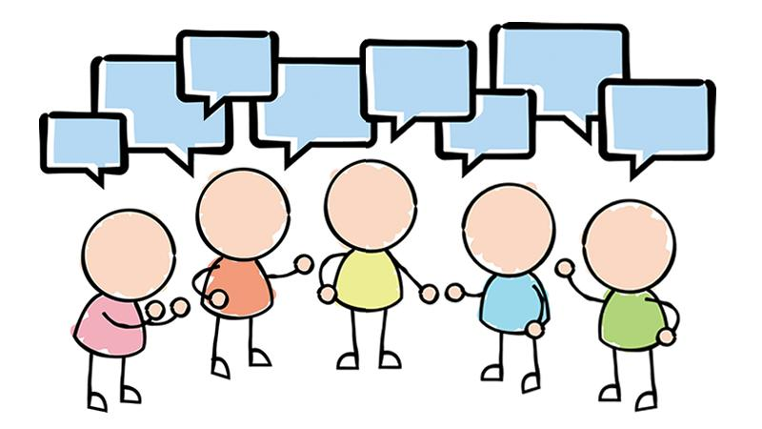

Introduction

With the right strategies in place and practice using them, low tech AAC can be an extremely valuable means of communication for a wide range of individuals and situations.

Successful interactions using any AAC (particularly low tech), are extremely reliant on the abilities of the communication partner.
Training undertaken at the beginning of the process can really help embed the skills needed to make it an effective means of communication. This can also limit any frustrations for everyone involved.
Communicating using AAC is very different from using natural speech. Using AAC to communicate can break up the flow of conversation, and may be misunderstood.
It takes support from communication partners, who have the right skills and tools to help them get the most out of communication. This can lead to a more rewarding and fulfilling interaction for both parties.

This resource is aimed at those therapists who are introducing low tech AAC with their clients. It focuses on bespoke guidance and training for the communication partner, as this is critical when implementing any form of low tech AAC and has been created using a wide range of sources.

References for these and further reading are at the back.

CONTENTS

Topic | Printable Resource | Page
Who do I train? – Where do I start |  | 1
Circles of communication partners + resources to refer to |  | 2
General tips for communication partners |  | 3
Strategies to help train communication partners | Top tips for communication partners | 4
Tips for using different types of low tech AAC |  | 7
Pointing |  | 7
- Pointing - direct | Yes/ no cards | 7
- Eye pointing – ETRAN | How to use my ETRAN frame with me | 8
- Eye pointing – Speakbook |  | 9
- Partner Assisted Scanning | How to use my alphabet chart with me using partner assisted scanning | 10
- Auditory Scanning | Auditory scan chart phrase list | 11
 | Pragmatic based phrase book | 12
 | How to use auditory scanning with me | 12
Dealing with different situations |  | 13
- Managing misunderstandings guidelines |  | 13
- Environmental Considerations |  | 13
- Situational Considerations | Communication phrase sheet | 14
- Acquaintances and unfamiliar communication partners |  | 15
Communication cards- useful advice |  | 15
 | Communication Cards A5/A6 | 16
 | Communication passports | 16
 | Guidelines for Vocabulary Gathering | 16
References and resources |  | 17

WHO DO I TRAIN - WHERE DO I START?
A good place is to consider who the person needs to communicate with and then tailor your advice and training to the people identified.
In their Social Networks approach, Blackstone and Hunt-Berg use a ‘circles of communication partners’ model to describe the types of people who may communicate with the individual.

Your Client
1: lifelong communication partners. This includes family members and others with whom an individual resides or is related. For older individuals, “family” may mean a parent, spouse and/or children, as well as a domestic partner or the residents in a group home.
2: Close friends/ relatives. This represents individuals with whom someone spends leisure time, shares mutual interests, plays and confides.. Adults’ second circles incorporate relatives, people they enjoy spending time with, as well as friends from their past with whom they keep in touch. There is a degree of closeness and familiarity to these relationships.

3: Acquaintances. This circle includes people with whom an individual is acquainted but does not socialize on a regular basis. Examples are schoolmates, colleagues, bus drivers, shopkeepers, co-workers and community helpers.

4: Paid workers. These are people who are generally being paid during the times they are interacting with the person. They may include therapists, physicians, teachers, instructional assistants, personal assistants, babysitters, job coaches and so on. Even though some paid workers may become friends, as long as they are being paid they are listed in this circle.
5: Unfamiliar partners. The fifth circle represents “everyone else.” When filling out this circle, informants do not identify specific individuals. Rather, they are instructed to think of categories of individuals who are potential interactants. Examples include shopkeepers, waiters, public transport workers, people in a local coffee shop , community helpers and so on.

What support and resources should I use with which circle of communication partners?
Circle partners | Resources that may be useful – this is a guide. The different resources can be used with any suitable individual
1 | General Tips for communication partners  Tips for using different types of low tech (whichever is relevant for the individual)  Pointing  Eye pointing  ETRAN  Speakbook  Partner Assisted Scanning  Auditory Scanning  *Vocabulary gathering guidelines  *Managing misunderstandings guidelines  *Environmental Considerations  *Situational Considerations  *Acquaintances and unfamiliar communication partners  *Communication Cards  *Communication passports  *it is envisaged that those in this circle will help prepare the user and associated resources for their use. For example making up bespoke communication cards, preparing for a family gathering etc.
2 | General Tips for communication partners  Tips for using different types of low tech AAC (whichever is relevant for the individual)  Pointing  Eye pointing – ETRAN  Eye pointing – Speakbook  Partner Assisted Scanning  Auditory Scanning  Managing misunderstandings guidelines  Acquaintances and unfamiliar communication partners  Communication Cards
3 | Communication Cards  Relevant how to guides for particular AAC tools (ETRAN, partner assisted scanning, auditory scanning)  Communication passports
4 | General Tips for communication partners  Tips for using different types of low tech (whichever is relevant for the individual)  Pointing  Eye pointing  ETRAN  Speakbook  Partner Assisted Scanning  Auditory Scanning  Managing misunderstandings guidelines
5 | Communication Cards  Communication passports
GENERAL TIPS FOR COMMUNICATION PARTNERS
These tips may be cut and pasted to make more relevant for specific people:
- If relevant, ensure the individual is wearing the right glasses and hearing aids and these are working.

- Once a clear method of communicating yes and no are established, share this with all communication partners who may come into contact with the AAC user. This will ensure consistency across environments and people, and any confusion is avoided.

- Keep conversations short initially as it will take you both time to get used to a different way of communicating.

- Some individuals prefer to spell out full sentences, but others would prefer you to guess after a few letters (agree this before starting).

- Guessing by familiar partners makes communication more efficient and less effortful.

- Pause frequently to give the individual time to respond, point or signal.

- Try and resist ‘filling the silence’ whilst the individual is spelling.

- The partner can keep conversation on track, and check the right letter has been selected by saying each letter or word the individual spells out.

- The partner should try and predict “space” or “end of word.”, if the individual has no means to do so themselves.

- When the individual is spelling out a long word or phrase, it might be helpful for the partner to write down each letter and hold up the paper (or whiteboard) for both individual and partner to see.

- Try not to use a lot of wh- and yes/no questions. These can put you in control of choosing the topic and make the user just a responder.

- Watch for signs of fatigue and take regular breaks.

- Communication using AAC does take extra time. It can sometimes be helpful to set aside time daily at a convenient time for uninterrupted conversation, so the individual does not feel rushed. This can foster social, rather than needs based communication.

Here is a top tips sheet that can be customised and printed for communication partners:

STRATEGIES TO HELP TRAIN COMMUNICATION PARTNERS
The imPAACT Program described by Kent-Walsh and Binger (2013) offers some helpful guidelines.
These are aimed at communicators working with children and so have been adapted for the literate adult population.

They observed that Professionals often: | They suggest;
Focus on what is ‘wrong’ with the partner | Focus on Individual outcomes during instructional session with partners.
Try to change too many partner behaviours at once | Identify the partner techniques that will result in the desired individual skills
Try to change too many individual behaviours at once | Select individual and partner skills that change quickly and are easy to identify and quantify
Try to change individual and/or partner behaviours in too many settings or situations at once | Practice the selected partner techniques with the individual before teaching it to the partner
Fail to link changes in partner behaviours to identifiable, measurable changes in the individual | Start small; expand after achieving initial success

The authors suggest asking yourself the following 3 questions:

1. What is the partner currently doing—or not doing—that is failing to facilitate communication?
2. What exactly could the partner be doing instead that would be more facilitative?
3. What exact client behaviours would result from these changes?

The following steps have been identified in the literature as being those most useful when training communication partners.
Feel free to adapt these to suit your particular situation
Initial observations | Observe communication partners’ spontaneous use of current communication methods with the individual using AAC in their usual environment.  Introduce any new strategies to communication partners and the individual.  Discuss reasons around this with reference to their existing strengths and weaknesses
Strategy description | Describe the targeted strategies.  Instructors discuss the impact of implementing the targeted strategy with communication partners and with individuals who use AAC
Strategy demonstration | Demonstrate use of the targeted strategies with the individual  Explain what you are doing and why to the communication partner
Observed practice and feedback | Communication partners practice implementing the targeted strategies whilst being observed.  Give any prompts and feedback as needed
Independent practice and feedback | Communication partners practice implementing the targeted strategy in multiple situations within the natural environment.  Encourage them to keep note of how they are getting on with this.
Review | Document and review the communication partners’ competence of the targeted strategies  Review and discuss in comparison to previous communication methods  Gain and discuss any feedback from the communication partners implementation of the targeted strategy, and also from the individual themselves.

Case example:
This could be observing the individual and their spouse communicating using an alphabet chart with partner assisted scanning. You notice that the communication partner (spouse) tends to ask a lot of yes / no questions and asks more than one thing at a time. This makes it difficult for the individual to respond as they don’t know where to start and the communication partner does not leave enough of a gap for them to reply.

There are several behaviours here which need addressing:
- Asking a lot of yes/no questions. There may be situations where this is needed, but it is not how a normal conversation flows. It makes it very one sided.
- Asking too many things at once
- Not giving the individual enough time to respond and to what.

- You might choose to practice communication with the partner using the AAC technique you have advised with the individual.
- Explain that only asking yes no questions is not always helpful.
- You might demonstrate asking one thing or make one statement at time, and then pause and wait for them to respond and hold up the chart for them to begin their response.
- Encourage the communication partner to practice the strategy with you to see how it feels to communicate in a different way.
- Finish by observing them at a review session to see if there has been any changes.

If you are implementing more than one method, then discuss and practice the different situations where each would be of benefit. For example, a personal care based speakbook with carers who are time limited and an alphabet chart using partner assisted scanning with a spouse.
Ensure strategies are shared with all who will use them. Consider giving personalised instructions for use so anyone can pick up the resource and use it.
See each relevant section earlier in this resource for customisable instructions
Also consider selecting the most relevant tips from this resource to also add to the instructions.

When introducing any AAC, encourage the communication partner to practice using with the individual, using activities to develop social conversation rather than just needs based topics, as this can get repetitive.
Some examples could be: discussing forthcoming visitors, talk about things seen on the TV or heard on the radio, chat about something read or seen in a paper or magazine etc.

Remember, communication using AAC is very different than natural speech and takes commitment and practice from those involved if it is to be successful.
TIPS FOR USING DIFFERENT TYPES OF LOW TECH AAC

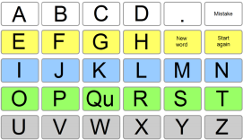
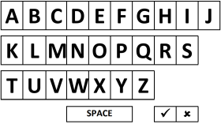
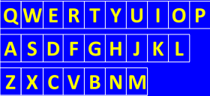
POINTING

Even when a person is pointing to an alphabet chart, there are things the communication partner can do to help the conversation:
- Pay attention! It is easy to miss what is being spelt, especially when the individual is spelling quite fast.
- If you need to, write down what is being spelt as it is happening with a pen and paper or whiteboard

EYE POINTING
For those individuals with established good vision and clear eye movements, eye pointing can be used to access several different types of eye pointing communication aids.

YES/NO
Try and establish both Yes AND No for when not easily understood and cannot nod or shake head. Try and avoid using blinking as this is a natural movement and may be misinterpreted.
It is possible to use one movement for YES only with those exhibiting very limited movement.
Use residual motor abilities which can be repeated consistently.
Alternate lip or mouth movements could be used or eye movements, for example look up for yes and down for no.
Consider fatigue and whether 2 different systems need to be in place. For example thumb movements most of the time, with eye movements when tired.
Yes no cards can be put in place so there is no ambiguity between partners for the client to look at to signal yes and no. This can be useful when there are a number of care staff involved with a client.
Here is a link to a colour coded yes no card which can be printed and laminated for use:
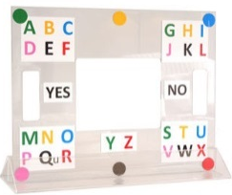
E-TRAN FRAME (EYE TRANSFER)

- The frame is held by the communication partner whilst standing in front of the individual so they can see the individual through the hole.
- The individual looks at the corner where the letter they wish to pick is positioned.
- The communication partner then confirms this is where they think the individual is looking
- If correct, the individual then looks to the corresponding colour square which is the same as that letter which are spread around the edges of the board.
- The communication partner confirms the selected letter (and writes down if need be) then moves on to the next letter.
- If agreed beforehand, and appropriate they can pre-empt the word the user is building up. This could be as quick as after just one letter if the context is known.
- Over time this process becomes more familiar for both parties and can be a fast and effective method of communication
Here is a link to customisable instructions for communication partners

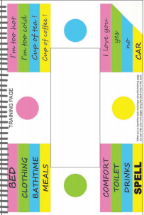
SPEAKBOOK

Used in the same way as an E-TRAN, but with personalised messages instead.
These can be categorised into different areas on each separate page.
They need to be made for each individual so takes some time to gather the information needed to populate and make up the pages.
They are good for communicating regular messages e.g. with carers or if spelling is difficult for the individual.
There is also a version for those who are colourblind which uses shapes.

Here is a video on how the Speakbook is used: https://vimeo.com/25812980

PARTNER ASSISTED SCANNING
- The communication partner presents a message list or alphabet chart to the individual, holding it in a position they can clearly see.
- Ensure you know the individuals response to yes and no
- With agreement from the individual, rather than pointing to each item in turn, the partner points to a category of messages or a row on the alphabet chart, pausing to allow the individual to scan and signal a selection.
- After a category or row is selected, the partner then points to each item in the category or letter in that row until one is selected.
- It is not necessary for the individual to signal a no for each item they do not want as this is time consuming and fatiguing.
- This system requires good memory and attentional abilities from the individual (and also the communication partner!).
- The communication partner may benefit from having a notebook or whiteboard and pen to write letters down as they are being spelt to keep track.

Useful messages to have on either message or alphabet charts could be:
- New word | - Please wait for me to finish
- Mistake, | - That’s wrong
- Yes, No, | - Start again
- I don’t know | - I’m uncomfortable
- guess the rest of the word | - I need the bathroom

Here is a video on how to use partner assisted scanning:
https://www.youtube.com/watch?v=d8KLjuJ2tIw

Follow this link for instructions you can customise for communication partners
AUDITORY SCANNING
If the individual is unable to see the chart, then the partner can read out the categories/word or phrase lists or letters of the alphabet. This is called Auditory Scanning.
Use of Auditory scanning is slow, but can be the only option for those unable to access alternatives when their vision is very poor and prohibits the use of other methods.
Use of categories, sub categories and yes/ no questioning can therefore help to set the scene with these individuals before considering spelling words.
This technique can be cognitively demanding for the individual, so adequate rests should be taken.
These categories and sub categories can be set with the individual and their communication partners using a structured format or premade resource which can be adapted or populated.
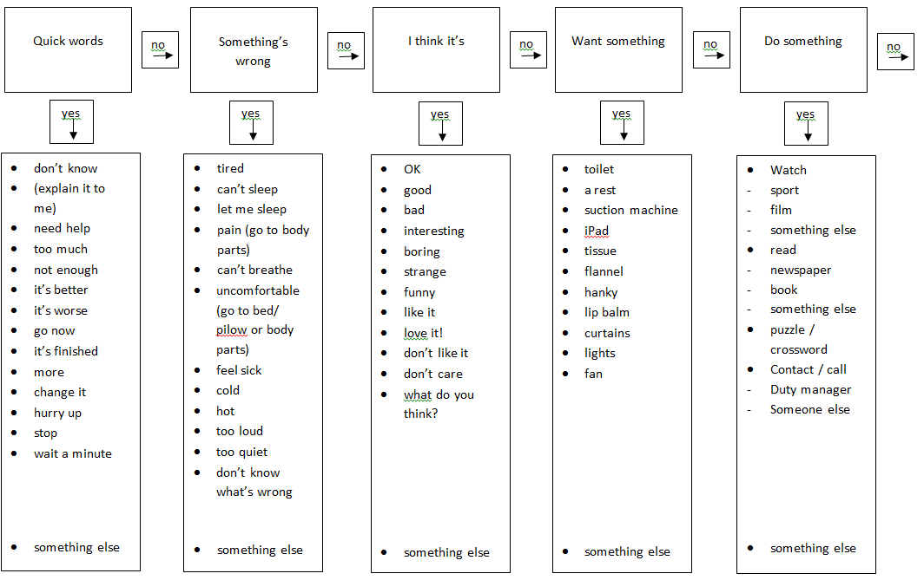
Here are some examples of Auditory scanning resources:

Here is a link to a copy of this example which can be customised (taken from https://acecentre.org.uk/resources/):
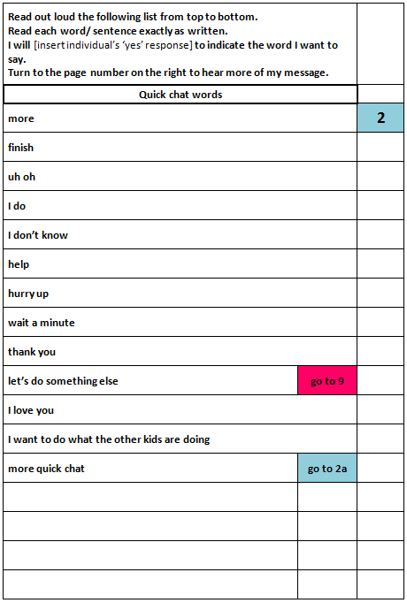
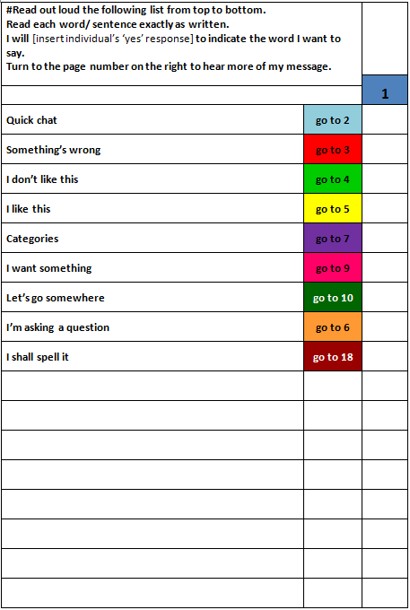

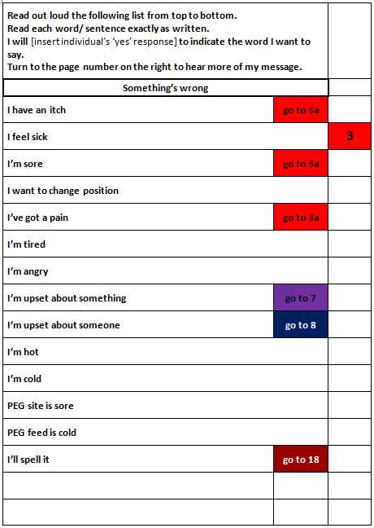

Here is a link to a copy of this example which can be customised (taken from https://acecentre.org.uk/resources/):
It may be helpful to use a framework for gathering relevant and appropriate vocabulary for your client. Ask someone who knows the client well to complete this with them. Please refer also to the guidelines for vocabulary gathering document. (see link on page 12)

Follow this link for instructions for communication partners when using simple alphabet auditory scanning:
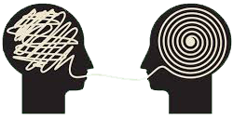
MANAGING MISUNDERSTANDINGS
– Some Guidelines:

Make sure you let each other know during the conversation whether or not you understand each other, before anyone gets lost.
For example, nod your head or say what you think the individual means so they can confirm your understanding or clarify.
If you don’t understand, don’t pretend you do!
- Start by guessing what the individual meant (especially if you know the topic or area of conversation already).
- Try and establish who or what you are talking about
- Ask if it is something that has happened (in the past) or something in the future
- If you don’t get it after a few guesses, ask the individual to start again.

ENVIRONMENTAL CONSIDERATIONS
Different environments require different skills from both the individual using AAC and the conversation partner.
Users report that one to one conversations with a familiar partner in a quiet space are easiest.
As well as this, the partner usually knows how to communicate with the individual and is able to predict and keep track of the conversation. The AAC user feels at ease and the conversation is balanced.
Clients and their communication partners may benefit from some advice on managing difficult environments
For example group gatherings – individuals can find it difficult to keep up with the conversation and make their points known
Strategies: communication partner could brief those attending in advance about how the individual communicates, and ways they may be included in the conversation:
- regular pauses at a suitable point to ask the individual if they want to say something and allowing them to spell it out.
- prepare some ‘news’ they wish to share before the date or topics they wish to chat about.
This type of situation can still be overwhelming and fatiguing for an individual, so this must be considered.
SITUATIONAL CONSIDERATIONS
It may be useful to have different strategies for different situations.
For example someone who is using an alphabet chart to communicate novel messages may wish to have a needs based list for when carers visit.
The interaction the user has is likely to be different with carers than with a visiting friend. It is likely that a lot of the same words or phrases may be used, so having these to hand and not needed to spell them out each time can save time and energy.
This could comprise a simple numbered or colour coded list of tasks or requests
For example
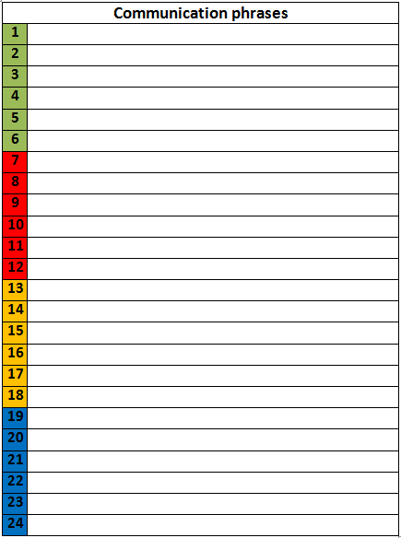

Follow this link for a phrase chart you can customise:
You may wish to refer to the guidelines for vocabulary gathering on p16 for ideas on content
ACQUAINTANCES AND UNFAMILIAR COMMUNICATION PARTNERS
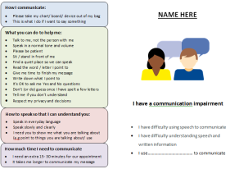
Most people know little about AAC and have difficulty learning how to carry on a conversation with the individual. The following may be helpful for those that are very familiar to help the individual feel prepared for encountering situations with this group of people.
Communication Card

A communication card tells people what to do when communicating with you.
Here is some useful advice from Communication Disabilities Access Canada © 2013
- Keep your instructions short and simple.
- Focus on telling people what you want them to do when communicating with you.
- It may be useful to have different cards for different places.
- Keep your communication instruction card in a place where you can easily show it to people.
How you communicate. For example:
- “Yes” and “No”
- I want to say something
- Please read my instructions
- Please take my chart/ board out of my bag
- This is what I do if I want to say something
- My speech may be unclear at times
What the person you are communicating to can do. For example:
- Read the word / letter I point to
- Sit / stand in front of me
- Give me time to finish my message
- Write down what I point to
- It’s OK to ask me Yes and No questions
- Don’t (or do) guess once I have spelt a few letters
- Tell me if you don’t understand
- Talk to me, not the person with me
- Speak in a normal tone and volume
- Give me opportunities to communicate
- Respect my privacy and decisions
- I can make my own decisions
- Please be patient

How to speak so that you can understand. For example:
- Speak in everyday language
- Speak slowly
- Speak clearly
- Please explain
- I need you to show me what you are talking about
How much time you need to communicate. For example:
- I need an extra 15- 30 minutes for our appointment
- It takes me longer to communicate my message
Advice taken from:
https://www.cdacanada.com/resources/information-for-people-who-have-disabilities-that-affect-communication/resources/things-to-do/

Here is a link to a communication card which must be customised to briefly explain how an individual communicates.
It is designed to be printed, folded in half and laminated. There are 2 sizes – A5 and A6:
GUIDELINES FOR VOCABULARY GATHERING

COMMUNICATION PASSPORT
There may be times when more information is needed for unfamiliar communication partners. For example, during a hospital admission or during respite.
The communication passport can be helpful in giving extra useful information about the individual who uses AAC. It can be printed and written on or customised before printing.

This resource has been created by Call Scotland:
https://www.communicationpassports.org.uk/Creating-Passports/Templates/

REFERENCES AND RESOURCES

Ace Centre (2016), Getting Started with AAC: Designing and using alphabet charts, [online][accessed on 07/04/2019]
http://aacbooks.net/book1/
Ace Centre (2016), Getting Started with AAC: Access to low tech symbol based resources when pointing is difficult, [online][accessed on 07/04/2019]
http://aacbooks.net/book3/
Ace Centre (2017), Getting Started with AAC: Using Low Tech Symbol Based Systems with Children, [online][accessed on 09/04/2019]
http://aacbooks.net/book2/
Beukelman. D, and Mirenda. P, (2013) Augmentative and Alternative Communication; Supporting Children and Adults with Complex Communication Needs, 4th ed., Baltimore, Brooks
Binger C and Kent-Walsh J, (2012), Selecting Skills To Teach Communication Partners: Where Do I Start?, Perspectives on Augmentative & Alternative Communication, vol. 21 (4) p. 127-135
Blackstone. S (1998), Auditory Scanning, Augmentative Communication News, 11, ( 4,5), Monterey, Unknown publisher [online] [accessed on 18th November 2018]
http://www.augcominc.com/newsletters/index.cfm/newsletter_20.pdf
Blackstone, S. W, and Hunt Berg, M. (2002), Social Networks: An Assessment and Intervention Planning Inventory for Individuals with Complex Communication Needs and Their Communication Partners, Monterey, CA: Augmentative Communication.
Chailey Communication Aid Service, no date, Low tech communication strategies guide [online] [accessed on 04/04/2019]
https://www.sussexcommunity.nhs.uk/downloads/services/chcs/guide-lowtech-commstrategies.pdf
Culp D, Beukelman D.R, Fager S.K, (2007), Brainstem Impairment in Beukelman D.R, Garrett K.L, Yorkstone K.M, (2007) Augmentative Communication Strategies for Adults with Acute or Chronic Medical Conditions, Baltimore, Brooks.
Douglas S, (2012), Teaching Paraeducators to Support the Communication of Individuals Who Use Augmentative and Alternative Communication: A Literature Review, Current Issues in Education, Vol 15 (1), p1-12
Garrett K.K, Happ, M.B, Costello J, Fried-Oken. M.B, in Beukelman D.R, Garrett K.L, Yorkstone K.M, (2007) Augmentative Communication Strategies for Adults with Acute or Chronic Medical Conditions, Baltimore, Brooks.
Kent-Walsh J, and Binger C (2013), Fundamentals of the ImPAACT Program, Perspectives on Augmentative and Alternative Communication, Special Interest Group 12, Vol 22, 1, p52-62
Kent-Walsh. J, & McNaughton.D, (2005), Communication Partner Instruction in AAC: Present Practices and Future Directions, Augmentative and Alternative Communication, Vol 21 (3), pp 195-204
Thiessen. A, and Beukelman. D.R (2013), Training Communication Partners of Adults Who Rely on AAC: Co-Construction of Meaning, Perspectives on Augmentative and Alternative Communication, Special Interest Group 12, Vol 22, 1, p 17-21

