# East Kent Hospitals logo Transforming our Trust –

Our Improvement Plan summary

2023-2025

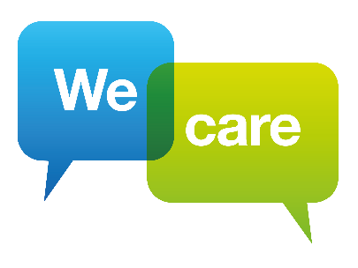

# Introduction

**Every day we care for more than 1,000 people, from helping to bring a new born baby into the world to caring for a patient at the end of life, and at all the stages in between.**

**In everything we do, we want to make our staff, patients and their families feel cared for, safe, respected, included and confident we are making a difference, and provide the best possible care and treatment to every one of our patients.**

We have many excellent services and dedicated, hard-working staff but we know we are not always providing the right standard of care to every patient, every day.

The importance of providing safe, kind and compassionate care, team working and listening and acting on what our staff, patients and families are telling us may be obvious but we have seen in all too clearly, the impact when this does not happen.

We remain determined to learn from Dr Kirkup’s report Reading the Signals which highlighted long-standing failures to provide safe services, high standards of clinical behaviour, team working and open and honest organisational behaviour.

To do this, we have set ourselves stretching, ambitious targets for what we want to achieve, together we will:

**Reduce harm and deliver safe services** by developing and fostering a safety culture in which all of us respond openly and learn when things go wrong, where we involve patients and families and do everything we can to improve the conditions where our staff work and patients are treated.

**Put patient, family and community voices** at the heart of everything we do. We will be open and honest when things go wrong, we will constantly seek their feedback and design services with them, and make sure they are listened to, involved and their concerns are acted upon.

Treat our patients and each other with **care and compassion** at all levels across the organization, and create teams that **work well together, trust, and respect each other and where people feel included.**

We will treat our patients and each other with care and compassion at all levels across the organisation and create teams that work well together, trust and respect each other and where people feel included.

We will work with our partners to **improve patient outcomes and reduce health inequality** and continuously improve by being **a centre of research excellence.**

We will strive constantly to reach national standards for access and outcomes in **planned and emergency care** and seek to deliver care in the most **cost-effective** way possible.

We are using a nationally-recognised quality improvement programme together with a nationally renowned Culture and Leadership Programme, both of which have been shown to improve care for patients and the experience of staff in other NHS organisations.

We will also carry out detailed work with our clinical teams on the future improvements needed within their services to respond to patient and staff feedback and begin the work on the long-term future strategy of the Trust.

Achieving this change will take time. There is a great deal of work we need to do at every level of our organisation to provide the consistent standard of care we want for all of our patients and to improve how it feels to work here for our staff.

We also recognise the importance of acknowledging the milestones and progress that is made along the way, as together we work to transform our Trust.

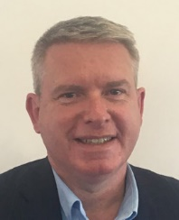

**Stewart Baird**

**Acting Chairman**

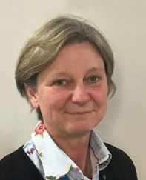

**Tracey Fletcher**

**Chief Executive**

# Our plan on a page

## Our vision is to deliver great healthcare from great people.

Our strategic themes are Quality and Safety, Patients, People, Partnerships, Sustainability and Research.

Our strategic objectives are driven by our response to Dr Kirkup’s report Reading the Signals; the importance of meeting national standards for planned, cancer and emergency care and the need to be financially sustainable by providing better care and reducing waste.

Everything we do is underpinned by our values: People feel cared for, safe, respected and confident we are making a difference.

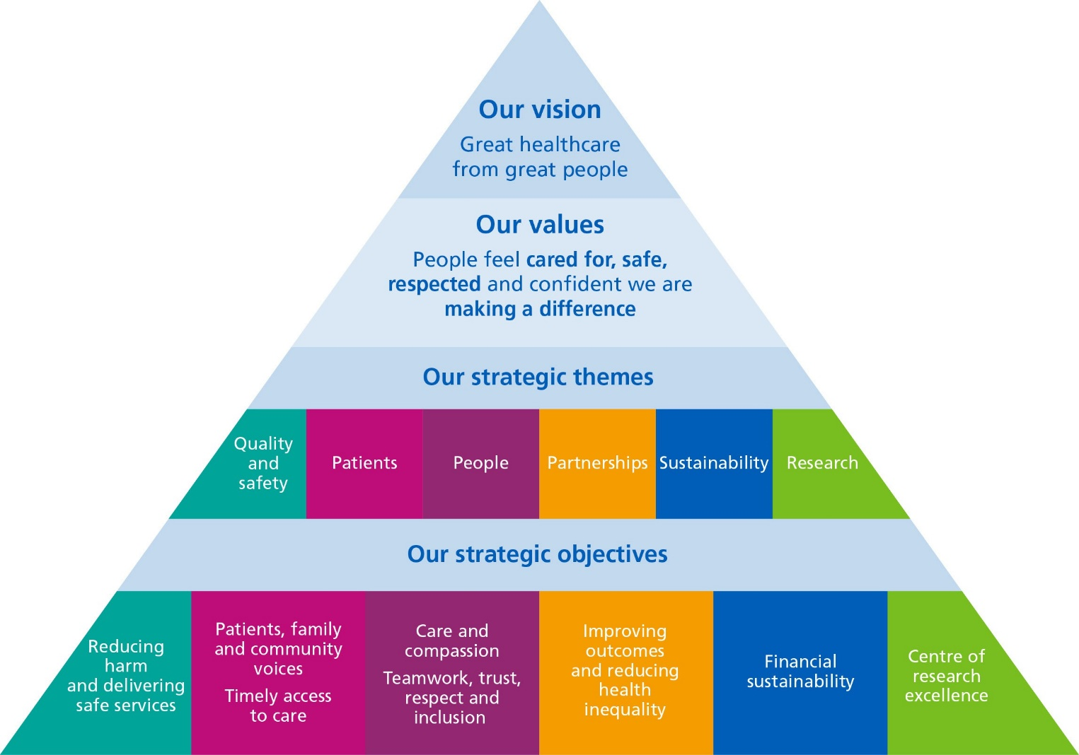

We will discuss our progress against key performance indicators, and the difference it is making, in public at our public board meetings which anyone can join, visit [www.ekhuft.nhs.uk](http://www.ekhuft.nhs.uk/)

**Quality and safety**

## Reducing harm and delivering safe services

We will do this by developing and fostering a safety culture in which all of us respond openly and learn when things go wrong, where we involve patients and families and do everything we can to improve the conditions where our staff work and patients are treated.

We want to:

* Have effective systems and processes for responding to and learning from patient safety incidents.
* Involve patients and families in investigations and answer their questions.
* Continuously seek ways to improve the physical environment for staff and patients.

## Our ambition is:

* To be in the top 20% of Trusts with the lowest mortality.
* To have zero avoidable harms graded moderate or above.

## Our targets for 2024/25 are:

* To reduce the numbers of moderate and above harms from falls by 10%
* To reduce moderate and above harms related to pressure ulcers by 10%

## How we will measure success:

* Patients in east Kent will have a longer life expectancy (mortality)
* There will be fewer cases of moderate harm and above due to care
* There will be fewer falls with harm
* Fewer patients will have hospital acquired pressure damage
* Fewer patients will need to be admitted to ITU as a result of deteriorating
* Investigations will be completed more quickly and safeguarding concerns addressed
* Serious Incidents will be completed on time and there will be fewer repeat incidents
* Patients report improvements in the inpatient survey
* We will be open and explain when something has gone wrong (Duty of candour)

# Patients

## Patients, Family & Community Voices

We will put patient, family and community voices at the heart of everything we do. We will be open and honest when things go wrong, we will constantly seek their feedback and design services with them, and make sure they are listened to, involved and their concerns are acted upon.

## We want:

* Patients to feel listened to, involved and their concerns acted upon.
* To always be honest and transparent in communicating with patients and admit when we get things wrong.
* Services to be designed with patients.

## Our ambition is:

* To achieve an overall score of 96% in the Friends and Family Test

## Our target for 2024/25 is:

* Improvement in the Friends and Family response rate to 30%

## How we will measure success:

* Complaints about staff attitude, communication and patients not feeling listened to reduce.
* More patients feel involved in their care in inpatient survey
* More Participation Partners are involved in committees, interviews and action groups
* Tangible changes made as a result of feedback
* We will be open and explain when something has gone wrong (Duty of candour)

# Patients

## Timely access for patients

* We will do this by striving constantly to meet national standards for access and outcomes in planned and emergency care

## We want:

* Timely access for all of our patients to planned and unplanned care.

## Our ambition is:

* For 95% of patients to be seen and treated or discharged from the emergency department within 4hrs
* For 85% of patients to receive cancer treatment with 62 days
* For no patient to wait more than 18 weeks for planned treatment

Our targets for 2024/25 are:

* To increase the number of the sickness patients (type 1) waiting no more than 4 hours in the emergency department to be consistently more than 50%
* To reduce the number of patients waiting more than 12 hours in the emergency department to less than 8%
* To have no patients waiting longer than 65 weeks for planned care and long waits for diagnostics reduced to 22%
* For 80% of patients to receive a decision on whether or not they have cancer within 28 days and for 75% of patients to receive cancer treatment with 62 days

## How we will measure success:

* Cancer patients will be seen, diagnosed and treated more quickly
* More tests will be carried out at Buckland Community Diagnostic Centre
* GPs will be able to refer patients directly for tests
* No patients wait more than 65 weeks for planned care by March 2024
* Fewer patients will wait 52 weeks for planned care
* Patients won’t have unnecessary follow up appointments
* More virtual appointments will be offered where that’s best for patients

# People

## Care and Compassion & Teamwork, trust, respect and inclusion

We will treat our patients and each other with care and compassion and create teams that work well together, trust and respect each other and where people feel included.

## We want to:

* Treat each other with care and compassion and work in teams where people feel valued, respected and included.
* Have teams that work together in a way that delivers better outcomes for patients.
* Have effective, embedded ways of listening to and involving staff.
* Be a diverse and inclusive employer.

## Our ambition is:

* To be in the top 25% of Trusts in the country for the National Staff Survey staff engagement score.

## Our aim for 2024/25 is:

* Demonstrable improvement of the culture of the organisation
* More than 50% of staff complete the staff survey
* Our Staff Survey Staff Engagement Score to increase to quartile 3 from quartile 4 nationally

## How we will measure success:

* More staff will give feedback in the quarterly pulse survey.
* Staff will report feeling more involved and more staff will recommend the Trust as a place to work.
* Staff sickness, vacancy and turnover rates will reduce.
* Fewer staff will leave the Trust, across all staff groups.
* The vacancy rate in hard to recruit areas will reduce.
* We will meet targets for international nursing and clinical support worker recruitment.
* Medical job planning will be complete.

# Partnerships

## Improving outcomes and reducing health inequalities

We will work collaboratively with our partners to improve the health and outcomes of the local population and reduce health inequality. We will develop our organisation by creating a stable leadership which is open to challenge and is supported by strong governance

## We want to:

* Have effective stable leadership which is open to challenge.
* Have effective governance processes from ward to Board.
* Make partnership working embedded and effective.

## Our ambition is:

* To be recognised as a well-led and high performing organisation.

## Our aims for 2024/25 are:

* Develop an organisational strategy for our clinical pathways

## How we will measure success:

* We will have a draft strategy completed by March 2025
* Through joint work and involvement with our partners in the East Kent Health Care Partnership, provider collaboratives and NHS Kent and Medway.

# Sustainability

## Financial Sustainability

We will deliver high-quality, safe care, which is cost-effective and reduces waste.

## We want to:

* Deliver great care for patients within the resources we are given

## Our ambition is:

* To have no overspend by the end of March 2026.

## Our aim for 2024/25 is:

* To develop and deliver the second year of the agreed three-year financial plan.
* To deliver the agreed cost improvement plan
* The deliver the agreed expenditure

How we will measure success:

* We will focus on quality improvement to reduce cost
* We will involve staff in making decisions about efficiencies
* We will make month on month improvement in our run rate
* We will reduce spend on premium pay
* We will adopt best practice in financial efficiency