# INFECTION PREVENTION AND CONTROL ANNUAL REPORT

**APRIL 2024 – MARCH 2025**

## Contents

|  |  |  |
| --- | --- | --- |
|  | **Section** | **Page Number** |
| 1. | Introduction | 3 |
| 2. | Executive Summary - The Year 2024/2025 | 3 |
| 3. | The Infection Prevention and Control Team | 4 |
| 4. | Infection Prevention and Control committee and reporting structure | 5 |
| 5. | The Care Quality Commission (CQC) | 6 |
| 6. | Education and Training | 6 |
| 7. | Audit | 7 |
| 8. | Hospital hygiene and the Healthcare Environment | 9 |
| 9. | Incidents/Outbreaks of Healthcare-Associated Infection | 11 |
| 10. | Surveillance and Epidemiology including  *Clostridioides difficile*  *Staphylococcus aureus* (MSSA and MRSA) bloodstream infections  Gram Negative bloodstream infections  Carbapenemase Producing Organisms (CPO) | 12 |
| 11. | Antimicrobial Stewardship | 17 |
| 12. | Decontamination | 23 |
| 13 | Surgical Site Infection Surveillance | 23 |
| 14. | Conclusion | 25 |
|  |  |  |

## 1. Introduction

The Director of Infection Prevention and Control (DIPC) is required to produce an Annual Report on the state of healthcare associated infection (HCAI) in the organisation for which s/he is responsible and release it publicly according to the *Code of Practice on the prevention and control of infections and related guidance* (The Health and Social Care Act 2008). The Annual Report is aligned to the ten compliance criteria as outlined in the Code of Practice. This report covers the period from 1 April 2024 to 31 March 2025.

The Annual Report is produced for the Chief Executive and Trust Board of Directors, and describes infection prevention and control activity during the year, including progress made against the work plan and objectives identified in the infection prevention and control annual programme, and against any external objectives.

Healthcare associated infections (HCAIs) can cause harm, and can lead to suboptimal patient experiences. This report also provides assurance to patients, public and all staff of the work undertaken throughout the year, including celebrating the successes and highlighting the challenges.



## 2. Executive Summary – The Year 2024/2025

The Chief Nursing and Midwifery Officer is the accountable board member for infection prevention and control (IPC), and undertakes the role of Director of Infection Prevention and Control (DIPC). The Trust also has a deputy DIPC who is responsible for managing the IPC team across all hospital sites.

The DIPC continued to report to the Quality and Safety Committee and periodically to the Trust Board on the status of infection prevention and control throughout this reporting year, and presented the updated ‘infection prevention and control board assurance framework’ and associated work streams.

The IPC and Antimicrobial Stewardship Committee (IPCAMS) has a function to fulfil the requirements of the statutory IPC obligations, and formally reports to the Quality and Safety Committee.

Overall, 2024/2025 was extremely busy with a wide variety of IPC activity, in meeting key standards and regulatory requirements. Below is a summary of activity and achievements:

* Reduction in healthcare associated *Clostridioides difficile (C. diff)* infections with 105 cases against a threshold of 145.
* Reduction in E. coli healthcare associated infections with 147 cases against a threshold of 160.
* 2 MRSA bacteraemia reported for this period which was a 75% reduction from the previous year. MRSA bacteraemia has no threshold with a ‘Zero Tolerance’.
* Norovirus outbreaks affecting a large number of patients at both WHH and QEQM. The outbreak resulted in a number of beds and wards being closed.
* IPC audits of the environment, equipment and clinical procedures continued throughout the year, and there were notable improvements with scores based on previous yearly audit programmes.
* Hand hygiene audit of compliance was 91.7% overall for the Trust.
* IPC education and training continued throughout the year, and the IPC link worker programme delivered a programme of training focusing on themes and learning from investigations.
* Improved focus on Infection prevention and control aspects in the ward accreditation
* Fit testing for the use of FFP3 respirators in undertaken by a dedicated person within the IPC team, and over 600 staff members were tested.
* Successful launch and implementation of the CLEAN campaign through joint working with 2Gether Solutions.

Surgical site infection surveillance (SSIS) is carried out for repair of neck of femur fracture, hip and knee replacements. The SSI Steering Group met regularly throughout the year, and the group holds responsibility for overseeing the progress of the agreed improvement plan. In addition, as well as identifying learning outcomes from deep dive investigations into T&O SSI incidents, the group successfully implemented a number of key improvements, this included standardisation of wound dressings, education on tissue viability and patient information for wound management.

Antimicrobial stewardship (AMS) is led by a consultant pharmacist, two advanced pharmacists and a medical microbiologist who is the AMS lead. The AMS pharmacy team audited antimicrobial prescribing across all care groups, and have made a significant difference with the reduction of inappropriate prescribing. The AMS team also work closely with the IPC team on post infection reviews to identify and share learning.

## 3. The Infection Prevention and Control Team (IPCT)

The Chief Executive holds overall responsibility for infection prevention and control, with the management and co-ordination delegated to the DIPC. The DIPC works closely with the deputy DIPC who provides the day to day strategic and operational management of the IPC service.

The IPC team provides specialist advice, support, education and training to all sites across the Trust. Each site has a dedicated team in place with occasional cross site cover to ensure delivery of service. In addition, the IPC nursing team work on a seven-day rota to provide on-site cover 365 days per year. The IPC team also provide the Trust wide fit testing service, and have a surveillance nurse leading on Surgical site infection surveillance.

Working alongside the IPC team are medical microbiology and virology consultants. There is no specific named IPC lead microbiologist, but all microbiologists support the team and implementation of this role is being actively pursued. There is also a Trust consultant pharmacist leading on antimicrobial stewardship 3 days a week, with 2 part time antimicrobial stewardship pharmacists supporting, and 1 consultant microbiologist has this as part of their portfolio.

## 4. Infection Prevention and Control Committee and Reporting Structure

The structure includes Care Group Infection Prevention and Control meetings, chaired by the Care Group Director, supported by the Infection prevention and control lead. These site groups are operationally focused and bring together clinical and non-clinical colleagues to discuss challenges and successes and share the learning from investigations. Each of these groups along with groups for decontamination, water safety, ventilation safety and antimicrobial stewardship report to a new quarterly Infection Prevention and Control and Antimicrobial Stewardship Committee (IPCAS).

The IPCAS Committee takes a strategic perspective and gathers themes and learning from across the Trust and is a vehicle for wider sharing, including with colleagues from external bodies such as the Kent and Medway Integrated Care Board (ICB) and the United Kingdom Health Security Agency (UKHSA). The IPCAS Committee reports to the Board via the Quality and Safety Committee and directly through the DIPC in accordance with the Code of Practice on the Prevention and Control of Infections (Health and Social Care Act 2008). The structure is shown below.

### IPC Reporting Structure

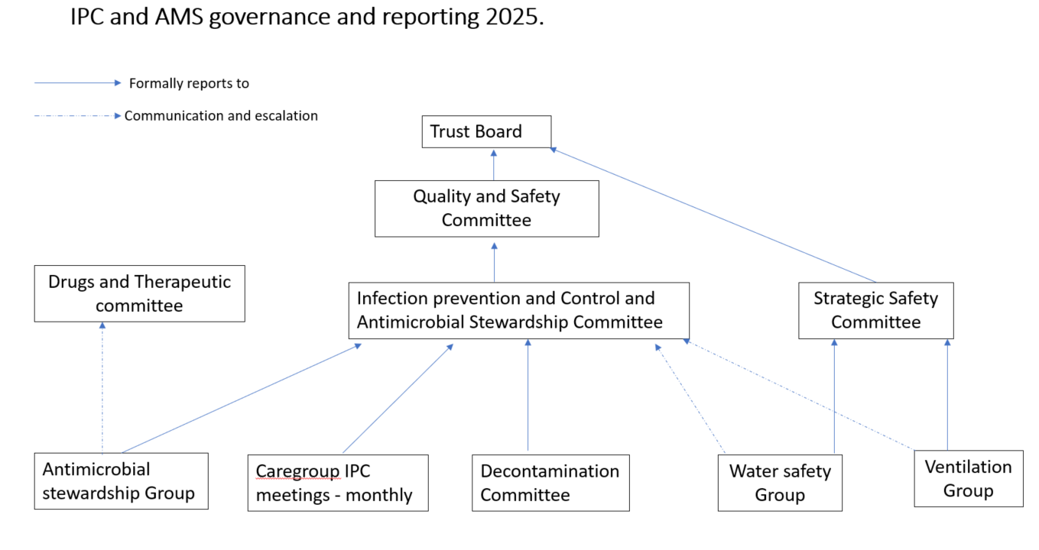

## 5. The Care Quality Commission (CQC)

There were no IPC specific or focussed CQC inspections in 2024/25. A CQC inspection took place within maternity which identified good IPC practice, and recognised the environmental challenges within the service, and the mitigations in place to address them.

## 6. Education and Training

The *Code of Practice* requires that all staff undertake mandatory infection prevention and control training on a regular basis. The specific requirement is:

*‘that relevant staff, contractors and other persons whose normal duties are directly or indirectly concerned with patients care receive suitable and sufficient training, information and supervision on the measures required to prevent and control risks of infection’.*

The IPC team worked continuously to review and update the trust IPC training, which remained a combination of face to face and virtual learning as well as practical hand hygiene training.

At the end of this reporting period (March 2025) compliance with IPC mandatory training requirements was 92.9% (see table below):

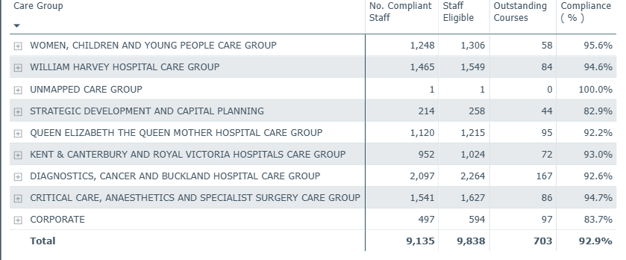

## 7. Audit

The annual audits are undertaken by the IPC team, and where possible, jointly with support from estates, facilities and clinical colleagues. Actions are managed by the care groups and issues escalated through this committee. Below is the comparison between 2023/24 and 2024/25 – there is a notable improvement in the environmental scores between the years, following a significant focus on environmental improvements.

The clinical practice results identify ongoing areas for improvement, and these are included in the IPC TWIP.

For the reporting year 2023-2024 the following audits continued:

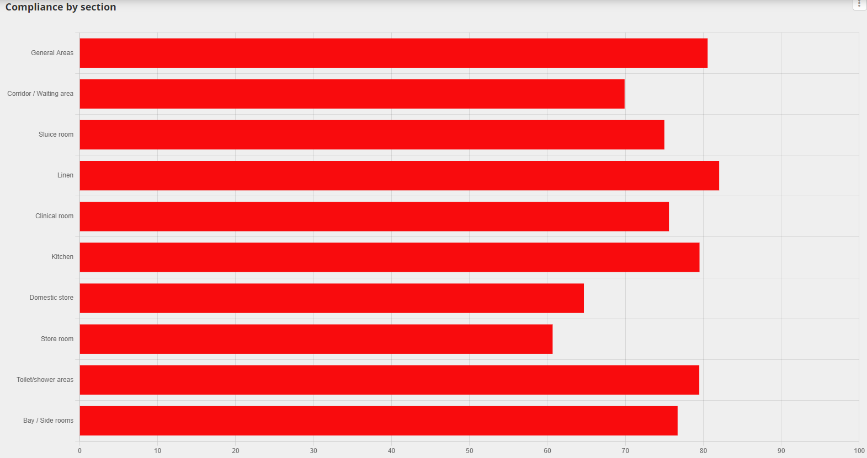

Trust wide environmental audits for 2024/25:

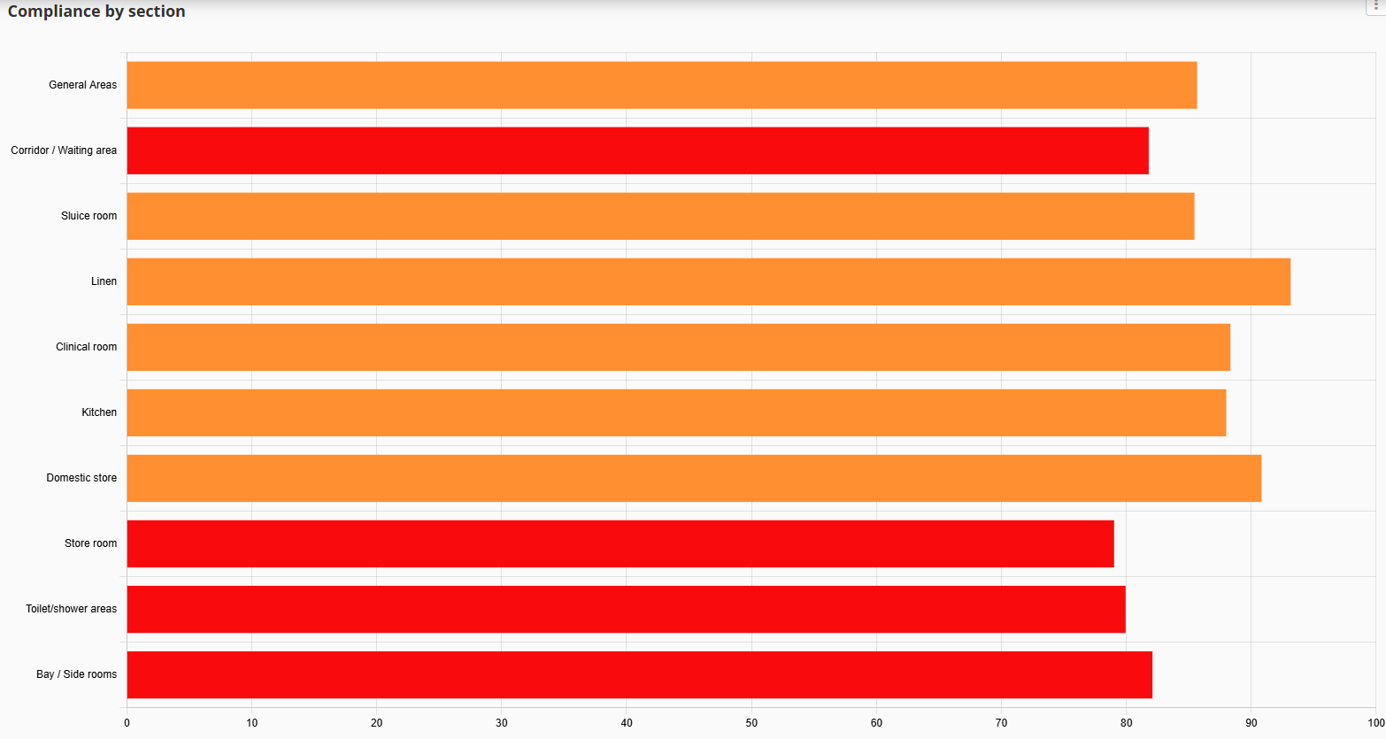

Annual clinical practice audit on MEG for 2023/24:

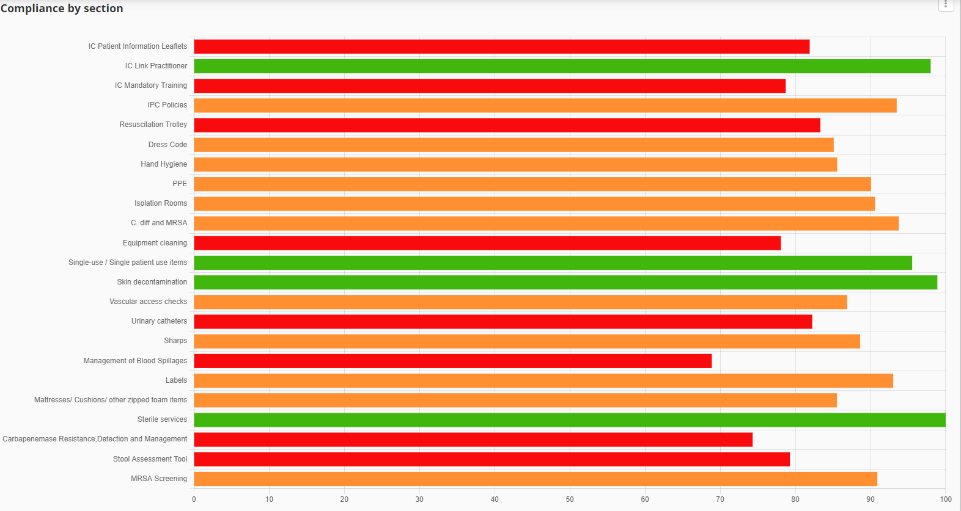

Annual Clinical practice audit on MEG for 2024/25:

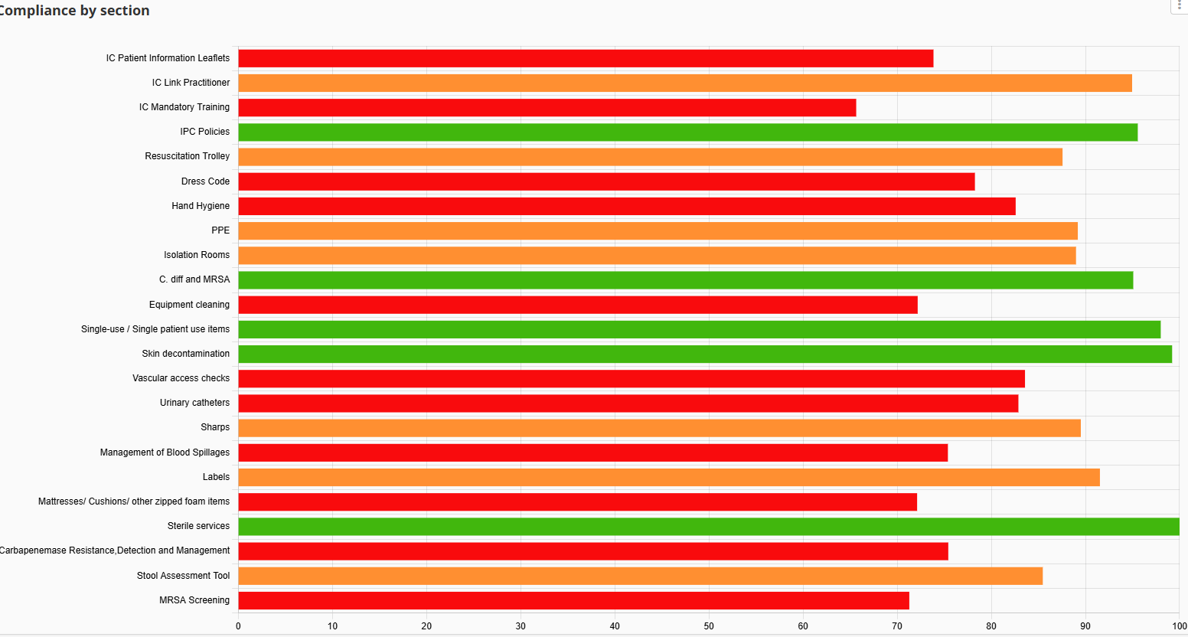

The link worker programme continued throughout 2024/25 within the Trust, with support and training focussing on hand hygiene, *Clostridioides difficile* recognition and UTI reduction tools. The link worker programme was developed based on themes from learning following healthcare associated infection reviews.

## 8. Hospital Hygiene and the Healthcare Environment

The IPC Team have continued to monitor standards of cleanliness within the Trust and promote good practice in conjunction with the Hospital and 2gether Support Solutions Facilities Managers through participation in the following activities:

* Patient-led Assessment of the Care Environment (PLACE).
* Environmental audits of cleanliness and the healthcare environment.
* Advising contractors/contract management on cleaning and domestic issues.
* Day to day advice/intervention/escalation to facilities management as appropriate, with regard to cleaning issues.
* Advising, with engineering colleagues from 2gether Support Solutions, through the site based and trust wide Water Safety Groups on the safe management of water supplies, to prevent risks associated with Legionella and, in augmented care settings, *Pseudomonas aeruginosa*.
* Attending joint cleaning audit training to ensure parity of audit standards.
* Advising, with engineering colleagues from 2gether Support Solutions, through the Trust wide Ventilation Safety Groups

During 2024-2025 the IPC team has continued to work with 2gether colleagues to review and manage cleanliness standards across the organisation. The Trust has, with a small number of exceptions, a very old estate and a very significant backlog of maintenance and need for refurbishment of clinical environments. This creates a major challenge to effective cleanliness as a large amount of the estate is beyond the scope of cleaning and therefore does not support good IPC practice or lead to a good patient experience. The DIPC and DDIPC work with the trust and 2gether to prioritise the very limited capital investment available, taking into consideration the range of patient and safety risks, not limited to IPC risks. These challenges are reflected in the trust’s corporate risk register. 2024-2025 has seen a significant joint trust and 2gether focus on cleaning standards with stakeholder groups engaged in both strategic and operational planning to drive increased standards of cleanliness. This has led to a review of the cleaning standards in place, commencing initially with looking at all published cleaning arrangements and reviewing accountability and understanding of the detail surrounding those arrangements.

All 50 cleaning elements listed in the New Cleaning Standards have been reviewed in relation to whether the element has an estates, facilities or clinical responsibility, traced back to review of relevant IPC/Trust policies and then the method and frequency of clean has been appraised and agreed by all parties. Whilst this piece of work had been done previously at a high-level during mobilisation of the standards, the detailed evaluation of “local protocol arrangements” had not yet been fully formalised. Particular focus has been paid to areas that provide risk in relation to potential infection such as vents, grilles, sluices and related equipment, commodes, but there has also been a robust review of items such as mobility aids, all types of trolley (crash, linen, drugs), lighting and so on, with any element that may have had any ambiguity surrounded the context of the item being split into a subsection of the standards to ensure absolute clarity. It is important not to underestimate the volume and detail of the work that has been needed to ensure all elements are agreed and clear for staff across all services.

The ongoing work between IPC and 2gether has led to the CLEAN 2 campaign being planned in for 2025, working jointly with 2gether to ensure clinical and 2gether staff have this clarity on their own responsibility for cleaning but also to ensure there is work carried out co-operatively on cleaning standards. Work has also focused on providing information for staff on how to log concerns, report estates issues, record items that are condemned and request the right type of cleaning for their areas – these items have been focused on based on feedback from staff.

All areas of the Hospital are audited in accordance with the national cleaning standards requirements. All staff are BICS trained auditors and have been trained independently by the Chair of the British Cleaning Council is partnership with representatives from IPC. The average scores from the audits are highlighted below:

Throughout the year, as issues are identified, action plans are put in place, these action plans are reviewed, discussed at local committees and then any escalations are taken to the IPC committee.

## 9. Incidents/Outbreaks of Healthcare Associated Infection

Throughout the year there was a significant number of COVID-19 and Influenza outbreaks, mainly contained within individual wards, however the impact on patient flow at all the sites had been significant. A Hospital wide outbreak of Norovirus in QEQM in January 2025 closed many wards to admission, requiring novel ways of utilising the remaining estate, Norovirus continued to circulate and impacting patient flow. In 2025/26, a review of testing procedures will take place summer 2025, in order to ensure we have adequate rapid testing facilities and capabilities for 2025/26 winter, as this was a key learning output from the outbreaks.

The Trust identified cases of Candidozyma Auris, from patients identified as contacts at Guys hospital renal transplant units. Internal guidelines and policies were amended, and will be reviewed again throughout 2025/26 owing to a change in national guidance due to a national increase in cases and outbreaks.

There were 5 Tuberculosis positive results that required risk assessment and contact tracing, in all cases, those identified as at risk were either notified by letter and followed up by the community Tuberculosis team, or our occupational health team. There were no onward transmission cases identified.

## 10. Surveillance and Epidemiology

### Reportable Infections

Thresholds for *Clostridioides difficile* and Gram-negative bloodstream infections (see below for details) were published for the year 2024/25, Trust performance against these thresholds and data for those infections where no threshold has been set are given below.

### 10.1 Clostridioides difficile (previously known as Clostridium difficile)

All cases of *Clostridioides difficile* identified from samples taken on day 2 of admission (where the day of admission is day 0) are hospital attributable.

These cases are described as Hospital Onset Healthcare Associated (HOHA). In addition, any patient discharged from hospital in the 28 days prior to a positive test for *C. difficile* are also hospital attributable. These cases are described as Community Onset Healthcare Associated (COHA). These two categories are combined in figure 4 showing performance compared with 2023-2024 and a linear trajectory to the externally set threshold.

Following a significant focus on the reduction of C. diff the total attributable cases in 2024/25 was 105 – which is a 25% decrease on the previous year. In total 241 patients tested positive for C. diff in EKHUFT, highlighting that once again the community burden is very high. 3 key focusses this year were environmental and cleaning improvements, antimicrobial stewardship and a trial of use of Fidaxomicin as first line treatment.

All cases reviewed following PSIRF methodology, with a rapid review initially, followed by SWARM if required, and all cases reviewed by a multidisciplinary panel every 2 months to identify themes, and ensure any learning added to Trust Wide Improvement Programme (TWIP). Themes remain similar to the previous year, but significant improvements have been noted:

|  |  |  |
| --- | --- | --- |
| **Likely Source/Indication** | **2023/24** | **2024/25** |
| Cross infection | 10% | 2.5% |
| Antibiotic associated | 63% | 75% |
| Of those antibiotic associated (percentage of non-compliance) | 26% | 19% |
| Samples that were actually community cases, but delay in sending made attributable to Trust | 9% | 3% |
| Relapse | 11% | 2.5% |

Actions focussed predominantly around antimicrobial stewardship (see section 11), environmental cleaning, and hand hygiene.

## 10.2 *Staphylococcus aureus* Infections (MRSA and MSSA) bloodstream infections

### 10.2.1 MRSA

MRSA bloodstream infections should be extremely rare events, and avoidable healthcare onset cases should be regarded with ‘Zero Tolerance’.

In 2024/2025 Compliance with MRSA screening for non-elective patients varied throughout the year with poor compliance of just 50% reported in May 2024, improving as months went by, with 75% compliance in Feb 25, and 100% in March 25. In this year the Trust reported 2 MRSA bacteraemia cases, a 75% reduction on 2024/25.

Both cases were COHA’s, and were reviewed for good practice and or learning following PSIRF methodology. One case was deemed a contaminant, but learning identified regarding decolonisation of patients with higher risk factors for infection, such as those with a learning disability, and an updated protocol implemented. The second case identified learning in relation to education for patient’s post-surgery, when caring for wounds at home, and the information provided to patients was updated.

### 10.2.2 MSSA

Meticillin sensitive *Staphylococcus aureus* (MSSA) bloodstream infections are common in both community and hospital settings. Healthcare associated infections are commonly related to vascular access catheters or surgical site infection. There is no externally set objective for MSSA bloodstream infections.

No threshold has been set for these infections, however in the last quarter of the year, EKHUFT reported a sharp increase in MSSA cases (87) compared with last year’s cases (72). These were reviewed for learning, and are associated with devices and wounds, actions to help reduce these sources form part of the IPC TWIP for 2025/6.

All HOHA and COHA cases are investigated by the IPC team with associated action plan where learning is identified, the learning for MSSA’s is similar to MRSA, and predominantly wound care and line care focus.

### 10.3 Gram Negative Bloodstream Infections

The [UK 5-year action plan for antimicrobial resistance (AMR) 2024 to 2029](https://www.gov.uk/government/publications/uk-5-year-action-plan-for-antimicrobial-resistance-2024-to-2029) includes a target (1b) to prevent any increase in Gram-negative bloodstream infections in humans from the 2019 to 2020 financial year baseline by 2029.

Results for reduction of gram negative bacteraemias varied this year, E. coli cases reduced, and reported less than the threshold of 160, with 147 cases, however, we are over trajectory for both Klebsiella and pseudomonas. Whilst there are actions continuing to focus on reduction of these cases, the targeted interventions for both E. coli and Klebsiella infections are similar, therefore it is hard to understand why the difference in cases, especially when the E. coli is reducing. Within the IPC TWIP for this year we continue to focus on environmental aspects of care provision and wound and bladder / catheter QI projects.

The data for the three nationally reportable Gram-negative bloodstream infections are given below:

### 10.4 Carbapenemase Producing Organisms (CPO)

CPO are of concern as organisms producing Carbapenemases (enzymes that confer antimicrobial resistance) are resistant to many of the antimicrobials of last resort. In some areas of the UK, CPO have become endemic and once established in a healthcare facility, they can be extremely difficult to eradicate. Management of CPO follows published guidance from UKHSA. For EKHUFT where CPO are not endemic this is based on targeted screening of certain patient groups. Although this screening has identified sporadic cases, no cluster or outbreaks have been identified. Vigilance remains high.

## 11. Antimicrobial Stewardship

### 11.1 Current Antimicrobial Stewardship Team

Consultant Medical Microbiologist (Lead Consultant for AMS) – with <0.2 wte for AMS

Consultant Pharmacist (AMS) – 0.6WTE – in post

Advanced Pharmacist (AMS) based at WHH– 0.64 WTE – in post

Advanced Pharmacist (AMS) based at QEQM– 0.6 WTE- in post from September 2024

Other Consultant Medical Microbiologists and Clinical Fellows are available for advice/ward rounds if needed.

#### 11.1.1 Expectations from clinical staff

Prescribers are asked to refer any patients they are concerned about to the Consultant Microbiologists/Clinical Fellows via the Careflow app. A response can be added to the referral recommending a treatment plan and duration.

Clinical ward pharmacists are asked to review all antibiotic prescriptions to ensure that:

* there is an accurate indication and stop/review date on the Sunrise chart
* they are prescribed as per guidelines, microbiology advice or as per culture and sensitivity results (and they are asked to challenge anything that does not fit these criteria)
* they prompt clinical teams to refer patients to Microbiology via Careflow if duration of treatment is at 10 days or more or if the antibiotic choice is a restricted antibiotic / not as per guidelines or microbiology advice

#### 11.1.2 Main aims of the AMS Team for 2024-25

* Reduce inappropriate antimicrobial prescribing; total consumption, broad spectrum and high *Clostridioides difficile* risk antibiotics (in particular: co-amoxiclav, piperacillin/tazobactam, fluoroquinolones, clindamycin, carbapenems and 3rd generation cephalosporins)
* Work pro-actively to prevent increasing antimicrobial resistance and healthcare associated infections e.g. *C. difficile*.

The pharmacy AMS team produced a monthly highlight report summarising activities conducted during 2024 whilst ASG was occurring quarterly. ASG has now been moved to monthly meetings with a split agenda.

#### 11.1.3 Data

Unless stated otherwise, the graphs and tables presented in this report uses data collected from the RxInfo database. In order to compare data across different timeframes, the data is presented as Defined Daily Doses (DDDs/1000 admissions).

It should be noted that since April 2020, admissions for the Emergency Department (ED) is not complete. The effect this has on the data presented, is not known.

FP10s have been included in the usage data. ED use a lot of FP10 prescriptions to facilitate discharge. To not include them would potentially skew the data and not give a true representation of the prescribing patterns within ED.

#### 11.1.4 Standard Contract 2024/25

The consumption of antibiotics in the Watch and Reserve categories of the AWaRe list is monitored under the NHS Standard Contract. All the ‘High *C. difficile* risk antibiotics’ monitored by the AMS team in the list above fall under the Watch and Reserve categories. A full list of WHO AWaRe (Access, Watch and Reserve) category antibiotics can be found at the following link: <https://www.who.int/publications/i/item/2021-aware-classification>

In previous years, the contract has included a provision requiring Trusts to use all reasonable endeavours to reduce their broad-spectrum (UK Watch and Reserve category) antibiotic usage by a specific percentage each year, in accordance with the overall target reduction set out in the UK five-year action plan for antimicrobial resistance 2019 to 2024. This is now coming to an end and the Contract provisions need to be revised.

As the new Action Plan had not been published in time for the start of the 2024/25 Standard Contract, there were no specific percentage targets for annual reduction in 2024/25, but is expected to be reviewed for the 2025/26 contract.

The new National Action Plan (NAP) for 2024-29 has a theme related to AMS and 2 objectives to achieve by 2029:

1. Reduce the total antibiotic usage in humans by 5% on 2019 baseline data
2. Achieve 70% of antibiotic usage to be from ACCESS group

Co-amoxiclav is the most used Watch and Reserve antibiotic in the trust, followed by clarithromycin, ciprofloxacin, levofloxacin and Tazocin® (piperacillin/tazobactam). Use of co-amoxiclav has tripled across the trust between 2014 and 2024 and from 2023-24 we see a probable plateau in the trend, however there is still an excess of Co-amoxiclav usage (these are standardised data).

Figure 1: Consumption of Top 10 Watch and Reserve Antibiotics by drug in DDDs/1000 total admissions for 2014-2024 (**including FP10s)**

Figure 2 represents the Co-amoxiclav usage per specialty. Please note: WHH AMU and QEQM AMU B is included in Emergency Medicine data point. Remainder of QEQM AMU is included in Acute Medicine data.

Figure 2: Consumption of Watch and Reserve Antibiotics by Top 5 local directorate in DDDs/1000 total admissions for 2014-2024 (**including FP10s**)

Emergency Medicine is the biggest user of Watch and Reserve antibiotics (figure 2). ED uses three times as many antibiotics as the second highest user (Specialty Medicine) and more than the rest of the Top 5 combined, however it should be noted that the admissions data for ED from 2020 onwards is not complete.

Antibiotic usage has been steadily increasing in ED and across the trust since 2014, with co-amoxiclav and clarithromycin forming the largest portion.

ED and AMU AMS Key Performance Indicator audits were redefined for September and October 2024 to capture more information on which specialties are starting antibiotics in ED, for which indications and their compliance to guidelines.

September data has been presented at ED clinical governance meetings and discussions have been started on how to address poor compliance to guidelines in this area.

Figure 3 represents the Co-amoxiclav usage per in ED. Please note: WHH AMU and QEQM AMU B is included in Emergency Medicine data point. Remainder of QEQM AMU is included in Acute Medicine data. This information is intrinsic to the how the systems have been set up.

Figure 3: Consumption of Top 5 Watch and Reserve Antibiotics in ED **(including FP10s) (excluding AMU units, but including UTCs)**

#### 11.1.4 AMS Team audits/projects conducted

* KPI audits were defined with a link to risk of CDI and conducted during 2024-25 in each different ward regularly. KPI results have been discussed at different specialties.
* Tazocin usage monitoring started in 2024 due to an increase of its demand. This usage and the KPI results confirm the Trust has opportunities in improving following guidelines.
* Junior doctors were asked to participate in a snapshot of the IVTOS quality improvement project as an element of embedding AMS to their practice.

#### 11.1.5. Next audits and AMS projects

The KPI audits will continue less frequently whilst AMS team focusses in developing the junior workforce in pharmacy embedding AMS in their practice and escalate unoptimized use of antimicrobials to the AMS team.

#### 11.1.6. Highlights

Next figure shows the highlights for AMS team during the establishing of the team post pandemic.

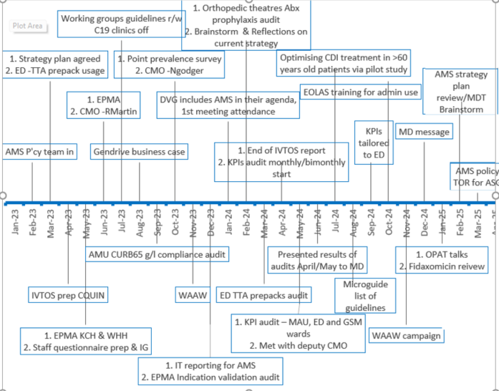

## 12. Decontamination

### 12.1 Sterile Supplies (CSSD)

The Trust has a Decontamination Committee that is chaired by the Deputy DIPC as the designated decontamination lead for the Trust. Instrument reprocessing is outsourced to In House Sterile Services (IHSS) and the contract is managed through agreed key performance indicators. In 2024/25 the turnaround performance was above 95%, with quality performance above 98%, and issues identified related to potential contamination of sets. A number of sets were switched to tins to reduce the risk of contamination and it was agreed to focus on orthopaedic instruments which has seen a reduction in cancellations of surgery.

The deputy DIPC and deputy decontamination lead undertook an annual review of IHSS Aylesham branch in March 25. Full compliance with decontamination practices was identified, having reviewed their annual independent audit results which had identified non-conformities in other IHSS services, but not those that reprocess EKHUFT instruments. Local audits and reports from their independent authorising engineer and Andersen Caledonian were also reviewed, and any non-conformities had been rectified, and therefore no concerns were found.

IHSS continue to work alongside EKHUFT, and aim to further increase the amount of tins they can reprocess, and continue to review the paper used on their shelving for ongoing improvements. The unidentified contaminants have now significantly reduced, and monitoring remains in place through the contractual agreements

### 12.2 Endoscope reprocessing

The EKHUFT authorising engineer for decontamination undertook the annual review of endoscopy units and overall general compliance was found, with some actions required relating to evidencing of ventilation and water reports. However two decontamination rooms (KCH urology and endoscopy) do not meet full best practice standards as they are built in one room, but they do meet the basic HTM requirements, through implementation of good dirty – clean flow utilising PPE and cleaning processes.

## 13. Surgical Site Surveillance

Surveillance of surgical site infection (SSI) following orthopaedic surgery is included in the mandatory healthcare-associated infection surveillance system.

All NHS Trusts where orthopaedic surgical procedures are performed are expected to carry out a minimum of three months surveillance in at least one of the three orthopaedic categories:

* Total hip replacements
* Knee replacements
* Hip hemiarthroplasties

EKHUFT undertake continuous surveillance in all three categories (rather than limiting participation to the mandatory single quarter per year).

Every quarter, surgical site infection surveillance (SSIS) is carried for the following UKHSA orthopaedic procedures: Repair of NOF fracture, Hip and Knee replacements. These procedures are carried out in Queen Elizabeth Queen Mother (QEQM) Hospital, William Harvey Hospital (WHH) and the Elective Orthopaedic Centre (EOC) at Kent & Canterbury Hospital (KCH).

In addition, an internal trust-wide SSIS was carried out for elective and emergency caesarean sections between August and October, 2024. SSI rates were obtained using the patient-reported SSI method – patients whose wound complaints met a nationally defined criteria for patient-reported SSI.

The table below illustrates the confirmed orthopaedic SSIs rates attributed to each hospital site since April 2024:

### SSI (Inpatient & Readmission Data)

National average in bracket ()

|  |  |  |  |  |
| --- | --- | --- | --- | --- |
| **Quarter** | **EOC** | | **QEQM** | **WHH** |
| **Knee Replacement** | **Hip Replacement** | **Repair of NOF** | **Repair of NOF** |
| **Apr – Jun 2024** | 0% (0.2%) | 1.8% (0.3%) | 0% (0.9%) | 2% (0.9%) |
| **Jul – Sept 2024** | 1.4% (0.2%) | 0.9% (0.3%) | 1.5% (0.9%) | 0% (0.9%) |
| **Oct – Dec 2024** | 0% (0.2%) | 0.9% (0.3%) | 1.6% (0.9%) | 0% (0.9%) |
| **Jan- March 2025** | 0.6% (0.2%) | 1.6 % (0.3%) | 5.2% (0.9%) | 0% (0.9%) |

### Caesarean Section SSI (August – October 2024)

**Quarter trust-wide average – 17%**

|  |  |  |  |
| --- | --- | --- | --- |
|  | **WHH** | **QEQM** | **Trust-Wide** |
| August | 11.4% | 18.6% | 14.9% |
| September | 24.2% | 18.8% | 21.9% |
| October | 14.8% | 14.3% | 14.5% |
| **Total Average** | **16.8%** | **17.2%** | **17.1%** |

Several key improvements were implemented during 2024–25, including:

* **Standardisation of dressings** used for patients undergoing Total Hip Replacement (THR) and Total Knee Replacement (TKR) surgeries.
* **Wound management training sessions** delivered by the Tissue Viability and Infection Prevention and Control teams.
* **SSI-related training and awareness activities** conducted across all three hospital sites.
* **Wound care leaflets** provided to patients upon discharge.
* **Patient information leaflets** developed for those undergoing THR and TKR; the leaflet for NOF patients is in the final stages of approval.
* **Theatre teams’ adoption of AfPP audit tools** to enhance perioperative practice.
* **Establishment of a pre-operative washing process** for patients undergoing NOF repair, with corresponding documentation in place.
* **Commissioning and use of antimicrobial sutures** across all three sites.

## 14. Conclusion

There has been a strong and sustained focus on IPC and antimicrobial stewardship during the last twelve months and there has been significant progress, despite the context of extreme operational pressures, and challenging outbreaks of Norovirus at both the William Harvey and Queen Elizabeth Queen Mother hospitals. The Trusts aging estate continues to cause significant impact on the ability of the staff to be able to effectively clean, and manage care in a safe environment, and this remains a key focus going forward with the CLEAN campaign. The IPC and antimicrobial stewardship teams are established and work continuously to improve practice and outcomes for patients and staff.

In the last year we have:

* Maintained a fully established team, with the exception of one team member (band 6 IPC charge nurse) leaving for promotion, however, there was a successful recruitment into this position.
* Reviewed the IPC training needs and education for all trust staff.
* Successful continued the IPC Link Practitioner programme.
* Implemented care group/site lead IPC meetings focusing on operational issues associated with IPC.
* Continued to implement the standards of the National Infection Prevention and Control Manual (NIPCM).
* Revised the governance structure for the water safety and ventilation safety groups.
* Revised the IPC Business Continuity Plans.
* Reviewed the scope and quality of the surveillance of HCAI and continued a programme of improvement work.
* Continued to work collaboratively with system partners to develop a Kent and Medway IPC Strategy.

We have achieved success in the following areas:

* The IPC team remained fully established.
* The Trust was below the external threshold for *C diff* infections reporting 105 against a threshold of 145.
* The Trust was below threshold for *E.coli* bloodstream infections (BSI).
* Meticillin Resistant Staphylococcus aureus (MRSA) BSI was lower this year compared to previous year with 2 cases being reported against 8 in the previous year.
* Continued to implement robust processes for surgical site infection surveillance in Trauma and orthopaedics – Total hip, total knee replacements and fractured neck of femur repairs.
* Reduced SSI’s relating to fracture neck of femur repairs.
* Introduced SSI surveillance on caesarean sections.
* Fit testing for the use of FFP3 respirators is undertaken by a dedicated person within the IPC team, and over 600 staff members were tested.

The remaining challenges and areas of focus include:

* The Trust exceeded thresholds for all other gram-negative blood stream infections (Pseudomonas and Klebsiella).
* MSSA BSI were at 87 compared to 72 in the previous year.
* Overall the state of our estate and physical infrastructure remains very challenging and does not support good IPC practice.

Focus for coming year:

* Review the clinical skills training for staff with a focus on ANTT (line related), and urinary catheter care.
* Relaunch of the CLEAN Together campaign to focus on environmental and decluttering issues:

‘C’ Clutter and cupboards.

‘L’ Linen and laundry

‘E’ -Environmental and equipment cleaning

‘A’ All the waste in the right place

‘N’ Nobody should walk by

* Focussed Trust-wide improvement plan on learning identified from current year – Sampling, isolation, and aspects of CLEAN campaign.

### CLEAN Campaign in 2024

