INFECTION PREVENTION AND CONTROL
ANNUAL REPORT

APRIL 2022 – MARCH 2023

Contents

1. Introduction 3
2. The Year 2022 – 2023 and the Pandemic of Covid-19 3
3. The Infection Prevention and Control Team (IPCT) 4
4. Infection Prevention and Control Committee and Reporting Structure 5
5. The Care Quality Commission (CQC) 6
6. Education and Training 6
7. Audit 6
8. Hospital Hygiene and the Healthcare Environment 7
9. Incidents/Outbreaks of Healthcare-Associated Infection 7
9.1 Seasonal viral infections 7
10. Surveillance and Epidemiology 7
10.1 Clostridioides difficile (previously known as Clostridium difficile) 8
10.2 Staphylococcus aureus Infections (MRSA and MSSA) bloodstream infections 9
10.3 Gram Negative Bloodstream Infections 10
10.4 Carbapenemase Producing Organisms (CPO) 11
11. Antimicrobial Stewardship 12
11.1 Current Antimicrobial Stewardship Team 12
11.2 11.2 Aims of the AMS Team 12
11.3 11.3 Data 12
11.4 11.4 Standard Contract 2022/23 13
11.5 11.4 AMS Team Emergency Department Project 15
11.6 11.5 AMS Audits 16
11.7 11.6 AMS Ward rounds/AMS PTL Portal 16
12. Decontamination 17
12.1 12.1Sterile Supplies (CSSD) 17
12.2 12.2 Endoscope reprocessing 17
12.3 12.3 Decontamination Audits 17
13. Surgical Site Surveillance 17
14. Conclusions 18

East Kent Hospitals University NHS Foundation Trust

INFECTION PREVENTION AND CONTROL ANNUAL REPORT

April 2022 – March 2023

Introduction

The Director of Infection Prevention and Control (DIPC) is required to produce an Annual Report on the state of healthcare associated infection (HCAI) in the organisation for which s/he is responsible and release it publicly according to the Code of Practice on the prevention and control of infections and related guidance (The Health and Social Care Act 2008). The Annual Report is produced for the Chief Executive and Trust Board of Directors and describes Infection Prevention and Control activity during the year, including progress made against the work plan and objectives identified in the Infection Prevention and Control Annual Programme and against any external objectives.

The Year 2022 – 2023 and the Pandemic of Covid-19

This report covers the period from April 2022 to the end of March 2023. This year has been characterised by the slow progression towards business as usual in infection prevention and control. However, at the start of this reporting year we were experiencing what became the second highest rise in numbers of cases of Covid-19 in our hospitals, reaching a peak of 235 in early April 2022. This was a greater number than during the first wave in 2020 but considerably lower than the peak of the second wave in early 2021 (figures 1 and 2 below). This peak in cases and the continuing, but gradually reducing subsequent waves of peaks and troughs for the rest of the year were primarily driven by the sub-variants of the Omicron variant of SARS-CoV-2. These variants were circulating widely with the removal of all societal restrictions and, importantly, most of the cases detected in the hospitals were incidental findings, unrelated to the reason for the patient’s admission to hospital, whether that reason was elective or non-elective in nature. Another welcome aspect of this changing epidemiology has been that the morbidity and mortality associated with Covid-19 is now and has been for much of this reporting year, very much lower than in earlier phases of the pandemic. The pattern of cases and the numbers of inpatients positive for SARS-CoV-2 has continued to very gradually reduce for the remainder of 2022-2023 with the number of inpatients at the end of March 2023 at circa fifty. Thankfully, in the months following this reporting year, those numbers have dwindled further into single figures. Despite these overall reductions, Covid-19 continued to present a significant operational challenge to the trust and to the IPC team throughout the year. The placing of patients both cases and contacts of Covid-19, in the context of significant operational pressures on patient flow, particularly in the emergency care pathways, remained very difficult. These challenges required daily support from the IPC team to the hospital site managers and leadership teams and continued to detract from the IPC team’s ability to address the wider IPC challenges and goals. This was especially true during a very difficult and challenging winter period where the return of seasonal Influenza and, mainly but not exclusively in children, Respiratory Syncytial Virus (RSV) after being largely absent in the two previous winters, led to huge pressures on our ability to place patients in the most appropriate place for their IPC and clinical needs. Throughout this year the IPC team have continued to support the trust response to the pandemic, which is technically not over, albeit the World Health Organisation have decided in the months since this reporting period to step down the Global Health Emergency status of the pandemic. In terms of NHS and trust policy this year has seen the continuing of a gradual return to business as usual in how we manage Covid-19 from an IPC perspective. By the end of March 2023, there were almost no Covid-19 specific measures in place, with the exception of some testing requirements associated with transfers to residential care settings, all other testing being only on a clinical basis, i.e. almost no asymptomatic screening of patients or staff. Covid-19 is now managed following the guidance in the National Infection Control Manual for England, which was published in 2022 and immediately adopted as policy in our trust. The Covid-19 specific Board Assurance Framework (BAF) was archived and replaced with a generic BAF. The Director of Infection Prevention and Control continued to report to the Quality and Safety Committee and periodically to the Trust Board on the status of the Covod-19 pandemic response throughout this reporting year. Despite the continuing impact of Covid-19 for much of the year, the IPC team were able to complete the elements of the IPC Work Plan that were within their gift and the majority of the plan was successfully achieved.

Figure 1. Cases of Covid-19 detected by EKHUFT

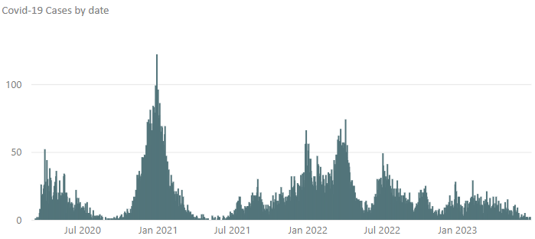

Figure 2. Covid-19 inpatients by date EKHUFT
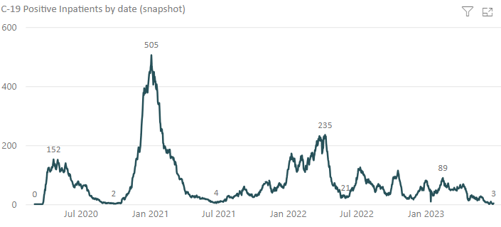

The Infection Prevention and Control Team (IPCT)

The IPCT are the medical, scientific and nursing specialists responsible for undertaking the work described, in the IPC annual programme. Information regarding the Antimicrobial Stewardship Team and resource is given further down under ‘Antimicrobial Stewardship’. There has been some improvement in the IPC resource during this year, primarily through the recruitment and retention of team members to substantive roles at Agenda for Change bands 6 and 7 on all three inpatient hospital sites. Some of these colleagues are new to the specialty and are being supported to develop their specialist skills and knowledge in IPC while utilising their transferable skills from their previous clinical and other roles. In addition, a senior colleague has made a very welcome return from period of long-term sickness and these changes mean that, on the whole, the IPC team is fully recruited to and stable at the end of March 2023. The DIPC has announced an intention to retire during 2023-2024 but succession planning has been a feature of the team since 2021 and there is no risk to the service from this change. In order to support the development of surveillance of healthcare associated infections a specific post has been developed and recruited to, that of a specialist surveillance nurse, see below under ‘Surgical Site Surveillance’ for more details.

Infection Prevention and Control Committee and Reporting Structure

As highlighted in the previous annual report for 2021-2022 a review of the IPC committee and reporting structure has been undertaken during this year and the outcome of that review has been implemented in the final quarter of 2022-2023. The objectives of this review were to strengthen the site-based IPC relationships, which anticipated the wider trust restructure which will follow, and to improve the opportunities for engagement, learning and sharing. The revised structure includes site-based Infection Control Groups on each inpatient hospital site, with links to the two smaller ambulatory facilities in Dover and Folkstone. These site groups are operationally focused and bring together clinical and non-clinical colleagues on each site to discuss challenges and successes and share the learning from investigations. Each of these groups along with groups for decontamination, water safety, ventilation safety and antimicrobial stewardship report to a new quarterly Infection Prevention and Control and Antimicrobial Stewardship Committee (IPCAS). The IPCAS Committee takes a strategic perspective and gathers themes and learning from across the trust and is a vehicle for wider sharing, including with colleagues from external bodies such as the Kent and Medway Integrated Care Board (ICB) and the United Kingdom Health Security Agency (UKHSA). The IPCAS Committee reports to the Board via the Quality and Safety Committee and directly through the DIPC as required by the Code of Practice on the Prevention and Control of Infections (Health and Social Care Act 2008). The revised structure is shown below (figure 3).
Figure 3. IPC Reporting Structure
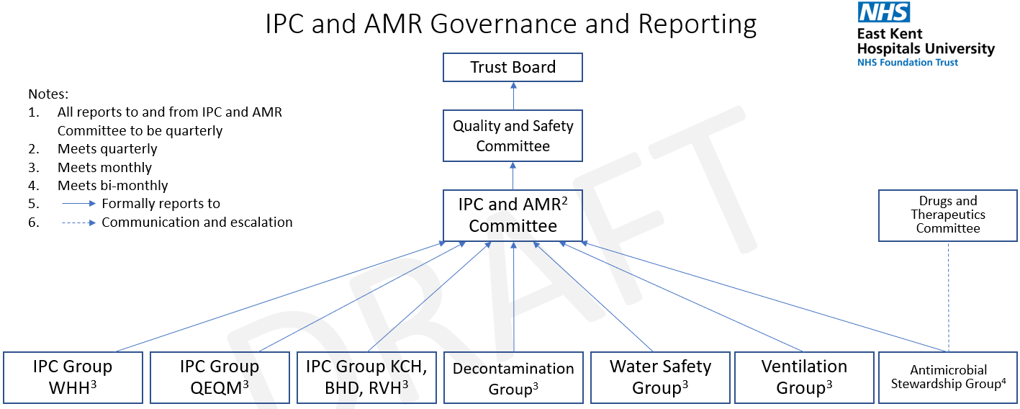

The Care Quality Commission (CQC)

There have been no IPC specific themed CQC inspections during 2022-2023, these are unlikely to be repeated given the reducing impact of the Covid-19 pandemic and these not being part of routine CQC activity. An inspection of maternity services in January identified some disappointing failings in cleanliness and some aspects of basic IPC practice. The trust was issued with a Section 31 notice in relation to this inspection that covered a range of issues including, but not limited to, the cleanliness and IPC issues identified. The IPC team supported the care group in quickly and successfully correcting these failings to the satisfaction of the CQC, whose requirements for monthly reports on the mitigations has been subsequently stepped down.

Education and Training

The Code of Practice requires that all staff undertake mandatory infection prevention and control training on a regular basis. The specific requirement is:

‘that relevant staff, contractors and other persons whose normal duties are directly or indirectly concerned with patients care receive suitable and sufficient training, information and supervision on the measures required to prevent and control risks of infection’.

The IPC team have been working to review and update the trust IPC training portfolio following the reduction in specific Covid-19 training requirements and a return towards business as usual. IPC mandatory training remains as a combination of face to face and virtual learning as well as practical hand hygiene training.
At the end of this reporting period (March 2022) compliance with IPC mandatory training requirements was 91%.

Audit

The audit programme has been reviewed during this year and the hand hygiene audits revised to reflect the return to pre-pandemic personal protective equipment (PPE) use. These audits have also been moved to the new trust audit platform ‘Tendable’. Hand hygiene audit results at the end of March 2023 were 97% overall.

For the reporting year 2022-2023 the following audits have continued:

Audit | Completed | Achievement
Antimicrobial prescribing |  | Please see Antimicrobial Stewardship Report
Infection Prevention | Yearly | Regular audits (every 12 months) of the clinical environments have continued. The completed audit report is sent to the Ward/Department Manager, who is responsible for both formulating and implementing an action plan. The results of these audits are being reported via the Site Infection Prevention and Control Group and escalated as required
“Saving Lives” | Monthly | Monitoring of compliance with the management of invasive devices, e.g. peripheral cannula, central vascular catheter and urinary catheter, insertion and continuing care. The results of these audits are being reported via the Site Infection Prevention and Control Group and escalated as required

Hospital Hygiene and the Healthcare Environment

The IPC Team have continued to monitor standards of cleanliness within the Trust and promote good practice in conjunction with the Hospital and Facilities Managers through participation in the following activities:

- Patient-led Assessment of the Care Environment (PLACE).
- Environmental audits of cleanliness and the healthcare environment.
- Advising contractors/contract management on cleaning and domestic issues.
- Day to day advice/intervention/escalation to facilities management as appropriate, with regard to cleaning issues.
- Advising, with engineering colleagues from 2gether Support Solutions, through the site based and trust wide Water Safety Groups on the safe management of water supplies, to prevent risks associated with Legionella and, in augmented care settings, Pseudomonas aeruginosa.

During 2022 and within this reporting year the trust working with 2gether Support Solutions implemented in full and by the required deadline of October 2022, the 2021 National Standards of Healthcare Cleanliness. The IPC Team continues to work with 2gether colleagues to ensure these standards are in place and to review cleanliness standards across the organisation. The trust has, with a small number of exceptions, a very old estate and a very significant backlog of maintenance and need for refurbishment of clinical environments. This creates a major challenge to effective cleanliness and does not support good IPC practice or a good patient experience. The DIPC and IPC work with the trust and 2gether to prioritise the very limited capital investment available, taking into consideration the range of patient and safety risks, not limited to IPC risks. These challenges are reflected in the trust’s corporate risk register.

Incidents/Outbreaks of Healthcare-Associated Infection

Covid-19 ‘outbreak’ reporting has continued through the year in line with reporting requirements which it is expected will be stood down during 2023-2024.

There have been very few confirmed outbreaks of healthcare associated infections during 2022-2023. A cluster of cases of RSV on a neonatal unit was investigated and managed, no harm was reported to the affected babies. Small outbreaks of seasonal viral infections have been managed according to existing policy and protocols. Individual contact tracing exercises for exposures to infectious diseases such as measles, Chicken Pox and Tuberculosis have been managed in collaboration with clinical teams and colleagues from Occupational Health, the ICB and UKHSA as required. The trust responded to the international outbreak of MPox (previously called Monkeypox) in 2022 with the necessary preparedness in line with national requirements.

Seasonal viral infections

As noted above the winter period in 2022-2023 saw the return for the first time in two years of seasonal winter virus activity. The impact of said activity is described above with regard to seasonal influenza and RSV. There has also been some sporadic Norovirus activity but it has not been widespread or to the extent seen in pre-pandemic winter periods.

Surveillance and Epidemiology

Reportable Infections

Thresholds for Clostridioides difficile and Gram negative bloodstream infections (see below for details) were published for the year 2022-2023 in April 2022.
Trust performance against these thresholds and data for those infections where no threshold has been set are given below.

Clostridioides difficile (previously known as Clostridium difficile)

All cases of C. difficile identified from samples taken on day 2 of admission (where the day of admission is day 0) are hospital attributable.

These cases are described as Hospital Onset Healthcare Associated (HOHA). In addition, any patient discharged from hospital in the 28 days prior to a positive test for C. difficile are also hospital attributable. These cases are described as Community Onset Healthcare Associated (COHA). These two categories are combined in figure 4 showing performance compared with 2021-2022 and a linear trajectory to the externally set threshold.

Figure 4:

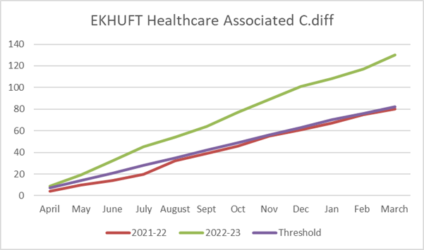

For the full year 2022-2023 the Trust was significantly above the external threshold. This reflects a local and national trend with all of the acute trusts in Kent and Medway and a large majority nationally exceeding the externally set thresholds in 2022-2023. This change in Cdiff epidemiology is not understood locally or nationally. There was no evidence of transmission of Cdiff during 2022-2023 with no cases that were connected epidemiologically having the same molecular type of Cdiff on testing. The three-month rolling average of cases has stayed persistently above the level necessary to achieve the external threshold throughout the year (figure 5).

Figure 5:

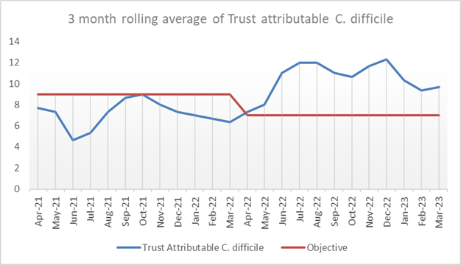

The C. difficile counts and 12 month rolling rates of HOHA and COHA infections published by Public Health England (PHE) to the end of January 2023 (latest data available at March 2023) show that EKHUFT remains slightly above the all England benchmark for HOHA cases than with rates of 20.2 per 100 000 bed days for HOHA (benchmark 20.1, Fig. 6) and remains higher at 12.4 (decreased) per 100,000 bed days for COHA (benchmark 7.0).

Figure 6
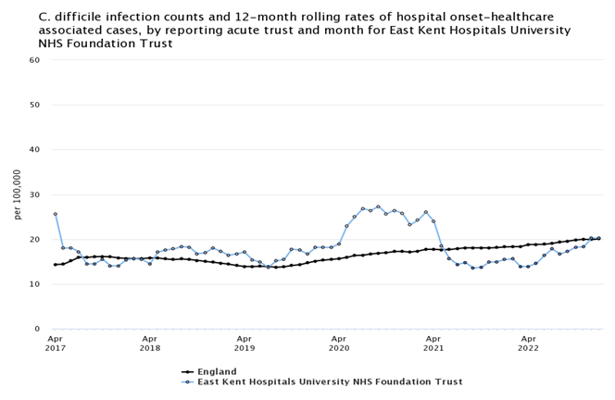

Staphylococcus aureus Infections (MRSA and MSSA) bloodstream infections

MRSA

MRSA bloodstream infections should be extremely rare events and avoidable healthcare onset cases should be regarded with zero tolerance. During 2021-2022 EKHUFT reported one case. An investigation is conducted for any case and any lessons shared at the IPC committees/groups.

    - MSSA

Meticillin sensitive Staphylococcus aureus (MSSA) bloodstream infections are common in both community and hospital settings. Healthcare associated infections are commonly related to vascular access catheters or surgical site infection. There is no externally set objective for MSSA bloodstream infections.

The number of hospital attributed bacteraemias is slightly higher for 2022-2023 compared with the previous year. Sixty six cases to the end of March 2023 compared with 61 for the previous year (figure 7). The rate of hospital onset cases is 14.6 cases per 100,000 bed days compared with the England rate of 11.2 cases per 100 000 bed days (March 2023 published data).

Hospital acquired cases are investigated by root cause analysis with an associated action plan where learning is identified.

Figure 6:

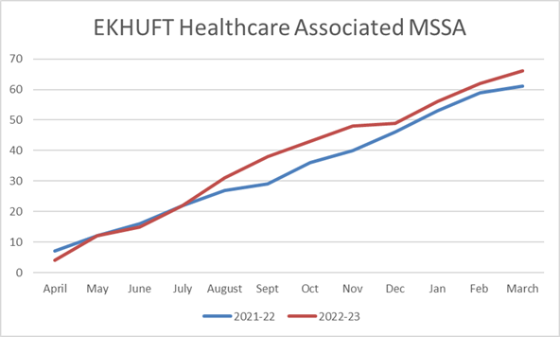

Gram Negative Bloodstream Infections

There is a national commitment to reduce the number of avoidable healthcare associated Gram-negative bloodstream infections by 25% by the end of 2021-22 and the full 50% by 2023-24 compared with 2015-2016.

The data for the three nationally reportable Gram negative bloodstream infections are given below (figures 8 -10)

Cases of E coli have exceeded the external trajectory. The number of cases for March was similar to the same month in 2022. Comparisons need to be made with caution due to the differential effects of the Covid-19 pandemic and the changes in patient presentation compared with the previous year (2021-2022) on which the thresholds were based. There was a major increase in cases in the summer months of 2022 which is difficult to explain but may, speculatively, have been related to the extreme heat seen at that time. There is evidence linking extreme heat conditions to increases in E coli infections.
Klebsiella and Pseudomonas aeruginosa were below the external trajectory for the year.
For Klebsiella spp. EKHUFT is the only acute trust in Kent and Medway to be under the external threshold for the year.

Figure 8:
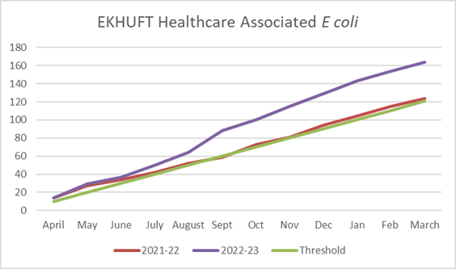

Figure 9:

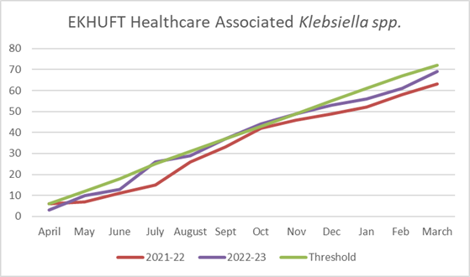

Figure 10:

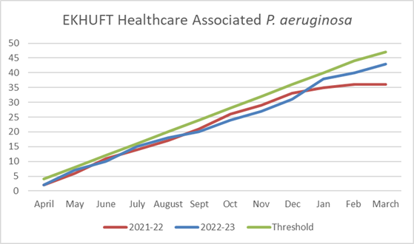

Carbapenemase Producing Organisms (CPO)

CPO are of concern as organisms producing Carbapenamases (enzymes that confer antimicrobial resistance) are resistant to many of the antimicrobials of last resort. In some areas of the UK, CPO have become endemic and once established in a healthcare facility, they can be extremely difficult to eradicate. Management of CPO follows published guidance from UKHSA. For EKHUFT where CPO are not endemic this is based on targeted screening of certain patient groups. Although this screening has identified sporadic cases, no cluster or outbreaks have been identified. Vigilance remains high. New guidance on the management of CPO is still expected but has not been published.

Antimicrobial Stewardship

Current Antimicrobial Stewardship Team

Consultant Medical Microbiologist (Lead Consultant for AMS)
Consultant Pharmacist (AMS) – 0.6WTE – started February 2023
Advanced Pharmacist (AMS) – 0.64 WTE – returned from maternity leave February 2023
Advanced Pharmacist (AMS) – 1.0 WTE. On maternity leave September 2022-October 2023.
Other Consultant Medical Microbiologists and Clinical Fellows are available for advice/ward rounds if needed.
It should be noted that for the period April 22-September 22, there was only 1 AMS pharmacist available. From September 22-February 23, there weren’t any AMS pharmacists available but there was a rotational pharmacist available to support with directorate work e.g. guidelines where needed.
Prescribers are asked to refer any patients they are concerned about to the Consultant Microbiologists/Clinical Fellows via the Careflow app. A response can be added to the referral recommending a treatment plan and duration.
Clinical ward pharmacists are asked to review all antibiotic prescriptions and ensure that:
- there is an accurate indication and stop/review date on the Sunrise chart
- they are prescribed as per guidelines, microbiology advice or as per culture and sensitivity results. They are asked to challenge anything that does not fit these criteria and document in Sunrise notes
- prompt clinical teams to refer patients to Microbiology via Careflow if duration of treatment is at 10 days or more or if the antibiotic choice is a restricted antibiotic, not as per guidelines or microbiology advice

Aims of the AMS Team

- Reduce inappropriate antimicrobial prescribing; total consumption, broad spectrum and high Clostridioides difficile risk antibiotics (in particular: co-amoxiclav, piperacillin/tazobactam, fluoroquinolones, clindamycin, carbapenems and 3rd generation cephalosporins)
- Work pro-actively to prevent increasing antimicrobial resistance and healthcare associated infections e.g. C. difficile.
- Provide education and training to prescribers, nurses and pharmacists where needed
- Reduce allergy and other antimicrobial related incidents by 50% by 2025

Data

Unless stated otherwise, the graphs and tables presented in this report uses data collected from the RxInfo database. In order to compare data across different timeframes, the data is presented as Defined Daily Doses (DDDs/1000 admissions).
It should be noted that since April 2020, admissions for the Emergency Department (ED) is not complete. The effect this has on the data presented, is not known.
FP10s have been included in the usage data. ED use a lot of FP10 prescriptions to facilitate discharge. To not include them would potentially skew the data and not give a true representation of the prescribing patterns within ED.

Standard Contract 2022/23
The consumption of antibiotics in the Watch and Reserve categories of the AWaRe list is monitored under the NHS Standard Contract. All the ‘High C. difficile risk antibiotics’ monitored by the AMS team in the list above fall under the Watch and Reserve categories.
The data are reported as Defined Daily Dose (DDD)/1000 admissions (using the dictionary of medicines and devices nomenclature to allow benchmarking) with the original aim to reduce the Watch and Reserve category antibiotics by 4.5% for 2022/23 from the 2018 baseline use data.
Results for 2022/23 are shown below (Table 1). Final admission figures for March 2023 are not known so this figure will be subject to change, with the final figure to be reported by NHS England in June/July 2023.
Table 1.

 | Baseline 2018 data | Target Watch + Reserve DDDs per 1000  admissions for 2022/23 | Actual usage of Watch+Reserve Abx for preceding 12 months up to end of March 2023
DDDs / 1000 admissions | 2580 | 2464 | 2817
% difference in Watch + Reserve DDDs per 1000 admissions from 2018 baseline |  |  | +14%

Co-amoxiclav is the most used Watch and Reserve antibiotic in the trust, followed by clarithromycin, ciprofloxacin, Tazocin® (Piperacillin/Tazobactam) and clindamycin (figure 11)
There has been approximately 130% increase in the use of co-amoxiclav across the trust between 2014 and 2022.

Figure 11: Consumption of Top 10 Watch and Reserve Antibiotics by drug in DDDs/1000 total admissions for FY2022-23 (including FP10s)

Emergency Medicine is the biggest user of Watch and Reserve antibiotics (figure 12). ED uses approximately three times as many antibiotics as the second highest user (Specialty Medicine) and more than the rest of the Top 5 combined.

Antibiotic usage has been steadily increasing in ED and across the trust since 2014, with co-amoxiclav and clarithromycin forming the largest portion.

Figure 12: Consumption of Watch and Reserve Antibiotics by Top 5 local directorates in DDDs/1000 total admissions for 2022-2023 (including FP10s)

Figure 13: Co-amoxiclav use in Emergency Medicine by formulation (2022-23) in DDD / 1000 admissions including FP10s
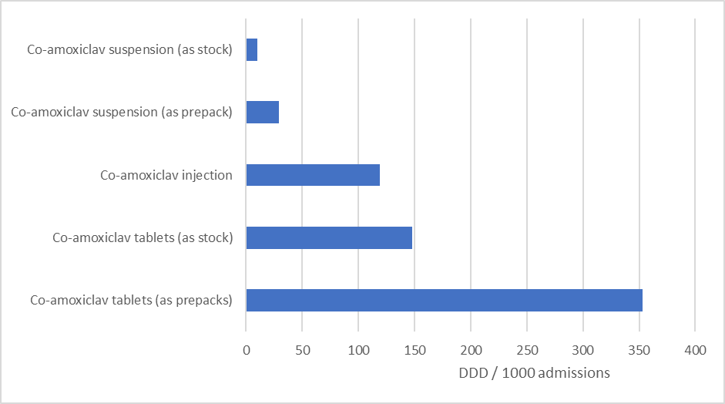

Majority of co-amoxiclav usage in ED is in the form of TTO (to take out/home) prepacks, with usage doubling between 2014 and 2022.

AMS Team Emergency Department Project

In response to the data seen on high antibiotic usage in ED, the AMS pharmacists completed 5 visits to A&E Majors at WHH in March 2023. The TTO prepack registers were checked for co-amoxiclav 625mg tablets, amoxicillin 500mg capsules and ciprofloxacin 250mg tablets.
In addition, 3 drug charts were selected on each visit and antimicrobial prescribing reviewed. Patients were then followed up after 48 hours.

The following issues were highlighted and presented at the Emergency Medicine Clinical Governance and Patient Safety meeting in April 2023:
- There was a discrepancy in stock recorded in the prepack register vs stock in cupboard on 3/5 occasions. Co-amoxiclav was the most common and it wasn’t clear from the register whether the incidents were investigated. This was handed over to the Lead Pharmacist for Acute and Emergency Medicine.

- Documentation of initial prescribing decision – 9/13 patients (69%) didn’t have a clearly documented plan before pharmacist intervention
- Documented Abx plan at follow up after pharmacist intervention – 50% of patients missing duration / date of next review
- Low compliance to Microguide for prescribing of urinary infections/urosepsis and sepsis of unknown origin
- For 5 / 13 patients, we were unable to contact the Doctor
It was hoped that a formal action plan could be discussed and presented at June ASG, however the ED consultants advised that this was not an ED issue and was the responsibility of General and Specialist Medicine and Surgical care groups. Discussion on how to proceed was discussed at ASG in June 2023 and will be discussed further with the Chief Medical Officer in June 2023.

AMS Audits

AMS audits were conducted monthly with data collected by the clinical pharmacists and clinical pharmacy technicians, but were suspended a number of times due to lack of engagement or lack of staff resource. A trust wide AMS audit was last conducted in July 2022 and results distributed via Infection Prevention and Control Committee Meetings. Senior pharmacists were also asked to discuss the results at relevant care group meetings and feedback an action plan to ASG.
As ASG didn’t receive any feedback on how care groups will improve prescribing quality, the audits were put on hold until February 2023 when it could be discussed by the new/returning AMS Pharmacy Team.

The trust implemented a new e-Prescribing system (Sunrise EPMA) in April 2023. It will ensure that an indication and duration is completed on every prescription as a mandatory field.
The AMS team are also working with IT and quality improvement teams to discuss how data from Sunrise EPMA can be used to guide both audits and reporting of antimicrobial usage. A meeting is planned for beginning of July 2023 to discuss an action plan. In order for trust wide audits to restart, the following conditions need to be met:

- Data collected can be viewed by all e.g. via PTL portal (Trust IT system).
- Engagement between ASG and the care groups is in place.

Ad hoc audits are conducted by the AMS Team when a C. difficile Period of Increased Incidence has occurred. Results are then fed back to the IPC team.

AMS Ward rounds/AMS PTL Portal

The AMS PTL portal build was completed in 2022. The data is taken from JAC dispensing system and updated daily to highlight patients dispensed ‘restricted’ antibiotics. The aim is for clinical ward pharmacists to check the portal every day and review any new patients for clinical appropriateness and whether there is a clear plan for treatment. Any patients they are concerned about or cannot sort with the clinical team, can be referred to the AMS team for review via the portal. The clinical ward pharmacists would be asked to complete relevant information as part of the referral.
This is currently being piloted on Cambridge M2 ward. The aim of the pilot is to highlight any issues that need rectifying and determine how many patients need referral per week to the AMS team/microbiology before rolling out across more wards and eventually trust wide.
The AMS team is working with the informatics team to switch over the data feed to the trust’s Sunrise e-Prescribing system. This will ensure more usable, real-time information is available. A planned date for switchover is not yet known.

Currently AMS ward rounds are not occurring but the PTL system is being used by antimicrobial stewardship pharmacists to keep track of fluoroquinolones, carbapenems and clindamycin at least twice a week. Referrals to consultant microbiologists are made when necessary and the patients reviewed by pharmacist and microbiologist. Advice is documented on Sunrise and discussed with the ward team.

Decontamination

Sterile Supplies (CSSD)

Instrument reprocessing is outsourced to In House Sterile Services (IHSS) The Trust Deputy DIPC undertook an informal visit following an increase in reported ‘holes’ in wraps in 2022 relating to a change in process. The DDIPC found that IHSS processes were robust, and that they evidenced their own independent audit compliance, as per national requirements. The contract with IHSS is managed by the service, and decontamination aspects reported through the Decontamination committee, and zero major ‘failure to decontaminate’ issues were reported in the reporting year.

Endoscope reprocessing

Endoscope reprocessing is undertaken and managed locally, all sites where processing is undertaken were audited by the Trust DDIPC and independently by the Trust Authorised Engineer for decontamination. The WHH service did not renew their JAG accreditation (formal external accreditation) this year, owing to the impact the COVID-19 pandemic had over the preceding years, they felt unable to prioritise the required level of documentation and evidence. All sites were deemed to be compliant with essential requirements, with some aspects of flow and training requiring some actions. No service fully met the ‘best practice’ standards.

Decontamination Audits

The results of decontamination audits for 2022-2023 are given below in Table 2.
Table 2 - summary of decontamination audit results

Location | Decontamination Audit Results
WHH Endoscopy | 96%
QEQM Endoscopy | 95%
K&CH Endoscopy | 89%
K&CH Urology | 90%
K&CH Theatres | 93%
Derry Unit RVH | 94%

Surgical Site Surveillance

Surveillance of surgical site infection (SSI) following orthopaedic surgery is included in the mandatory healthcare-associated infection surveillance system.

All NHS Trusts where orthopaedic surgical procedures are performed are expected to carry out a minimum of three months surveillance in at least one of the three orthopaedic categories:

- Total hip replacements

- Knee replacements

- Hip hemiarthroplasties

EKHUFT undertake continuous surveillance in all three categories (rather than limiting participation to the mandatory single quarter per year). This process is managed by the orthopaedic team with IPC support. All data for the year 2022-2023 have been submitted to the surveillance system. There is a time lag in receiving reports back with national comparators. Hospitals that are outliers in comparison to the national data set, based on the previous four quarters of data are notified formally by the UKHSA national surveillance team. The trust has been notified that it is an outlier for low levels of reported infection during 2022-2023. This, along with our own local intelligence suggests that the surveillance methods are not robust, i.e. that the surveillance is not identifying all of the infections that occur. As a result, the IPC team, working with the orthopaedic clinical team and the Surgery and Anaesthetics Care Group are reviewing the audit process to make sure and ensure that it is robust and sensitive. As mentioned previously in this report a surveillance nurse has been employed within the IPC team and, with the support of the IPC Site Lead Nurse for the Kent and Canterbury Hospital site, this colleague is leading this review.

Conclusions

The year 2022- 2023 was mixed with some positive progress and some remaining as well as emerging challenges. In summary we have:

- Completed the establishment of the Infection Prevention and Control and antimicrobial
- stewardship teams including a Consultant Pharmacist for antimicrobial stewardship and a
- specialist nurse for the surveillance of healthcare associated infections.
- Reviewed the infection control training needs and education for all staff.
- Re-established and reviewed the infection control Link Practitioner programme
- Reviewed and reinvigorated the audit programme and integrated hand hygiene audit into the new trust ‘Tendable’ audit platform.
- Contributed to and implemented the Kent and Medway Clostridioides difficile Root Cause Analysis tool.
- Implemented the National Infection Prevention and Control Manual
- Implemented a revised committee and governance structure including antimicrobial stewardship and decontamination.
- Revised the Business Continuity Plans.
- Reviewed the scope and quality of the surveillance of healthcare associated infections and started a programme of improvement work.
- Worked collaboratively with system partners to develop a Kent and Medway Infection Control and Prevention IPC Strategy.

We have achieved success in the following areas:

- The Trust is below the external threshold for Pseudomonas aeruginosa bloodstream
- infections (BSI) which was exceeded in the previous year.
- The Trust is below the external threshold for Klebsiella species for the second year in
- succession.
- A single case of hospital acquired Meticillin Resistant Staphylococcus aureus (MRSA) Blood
- Stream Infections (BSI).
- Stable numbers of Meticillin Sensitive Staphylococcus aureus (MSSA) BSI despite increased
- activity and acuity.

The remaining challenges and areas of focus include:

- In common with most acute trusts locally, regionally, and nationally we have seen a significant increase in Clostridioides difficile infections compared with the previous year. This has led to us exceeding the external trajectory.
- We have exceeded the external trajectory for E coli BSI and further work has started to target the root causes of these infections, including urinary tract infection prevention.
- Regulatory action in maternity services highlighted the need for further work related to cleanliness, the quality of the inanimate environment and some aspects of routine infection control practice, including handwashing between patients.
- Overall the condition of our estate and physical infrastructure remains very challenging and does not support good infection control practice.

