Instructions on how to use the E-TRAN frame (eye transfer) with XXX
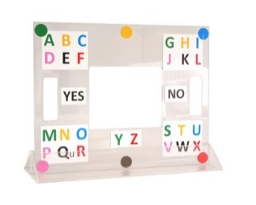

- Agree how XXX will respond “YES” (e.g. by looking directly at you)

- Hold the frame by the handles at a comfortable distance in front of XXX so you can see them through the hole
A B C
D E F

- XXX will look at a block of letters e.g.

- Confirm you have understood where they are looking

- XXX will then look at the colour spot of the letter they want e.g. pink (on the picture above)

- You will then know that they want to select the letter D

- Confirm the letter with XXX (you can write it down to keep track if this helps you)

- XXX will then select the next block of letters, then the colour, etc.

- If XXX agrees beforehand, you can guess/pre-empt the word that he is spelling
Instructions on how to use the E-TRAN frame (eye transfer) with XXX

- PTO for instructions for use

- Quick Tip:
To spell always
- look first at the BLOCK which contains the letter you want
- then look at the COLOUR spot that matches the letter you want

