If you have not used the Apex Pathology WebViewer before, please refer to the Registration Quick Reference Guide for how to sign up.
To access the WebViewer, use the Weblink / App Launcher icon to open the URL and log in, using your ID and password.
Note: your password will be valid indefinitely, no need to update it.
You will be sent an authentication code, which you enter on the screen to allow you to fully access the site. The duration of this code has been set to 8 hours, so once you have logged into the system using this code for 2-factor authentication, you can log in and out easily and will only have to use 2FA again after the 8-hour period has lapsed.
To locate your patient on the front page, do not use the boxes in the top section, but the boxes in the middle area between the 2 green lines (see highlighted box).  Search on patient details (try to use the smallest amount of information as possible, to prevent a mismatch).  Note: (Part of) surname + first name + DOB works best.  Use the Name Swap option if searching for a patient with an ambiguous name e.g. James Patrick, as either of these could be a forename or a surname. | 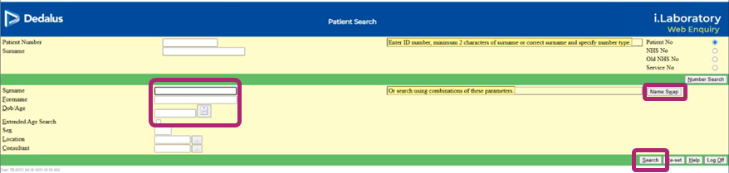
If multiple patients are displayed, choose the correct patient from the list, by clicking on the hyperlink in the ‘number’ column in that row.  Note: if you see multiple records for the same patient, please email the Path IT team ekh-tr.IAMteam@nhs.net to request that they are merged. | 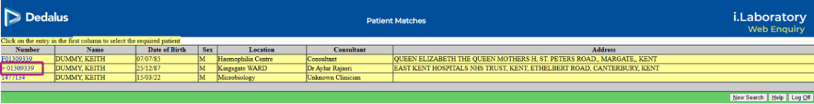
Choose the date range and/ or discipline from the dropdown list, or leave with the defaults. | 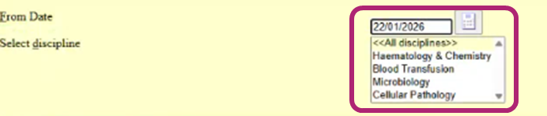
The most recent test results for that patient are shown, in date order. Use the scroll bars to navigate through the results. Status column shows progress of the request.  Note: if an expected result is not listed at all, it may be under another NHS number for that patient (if demographics don’t match, a temporary NHS number is created). Please contact the Path IT team (ekh-tr.IAMteam@nhs.net), who can investigate, and merge the records. | 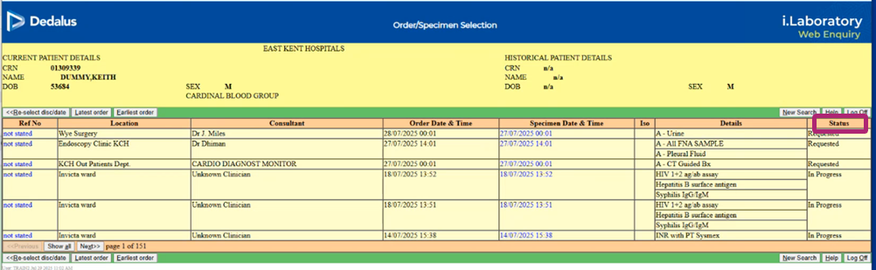
Click on ‘show all’ at the bottom left to show the rest of the results for this patient. Just next to this is a count of the number of pages of results available. | 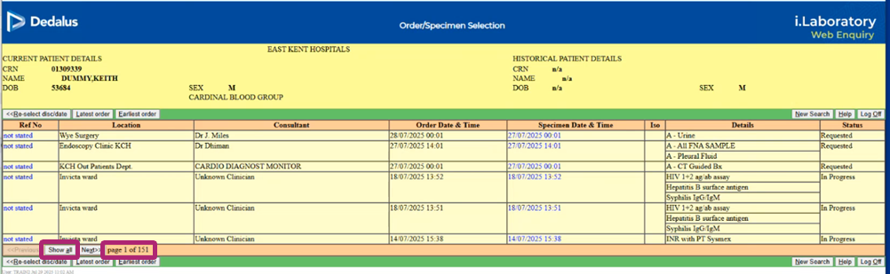
To find a result of a particular type, or from a specific location, you can use the browser’s ‘Find’ function: use the browser menu on the top right and activate ‘Find’, or press CTRL+F to access the Find box. Start to type in the term, and the box will show the number of instances that have been found. You can use the arrows to scroll through to the entry you need. | 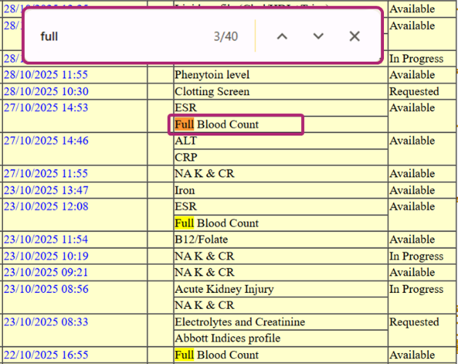
Once you’ve found the result of interest, click on any ‘hyperlinked’ information in that row to open the full report for that sample.  Note: To find an older result, it may be easier to find ANY result of that type (e.g. full blood count), click on it to open the results (even though it’s not the result you need), then click to cumulative view (See below). You can then look for the date of the result that you need. | 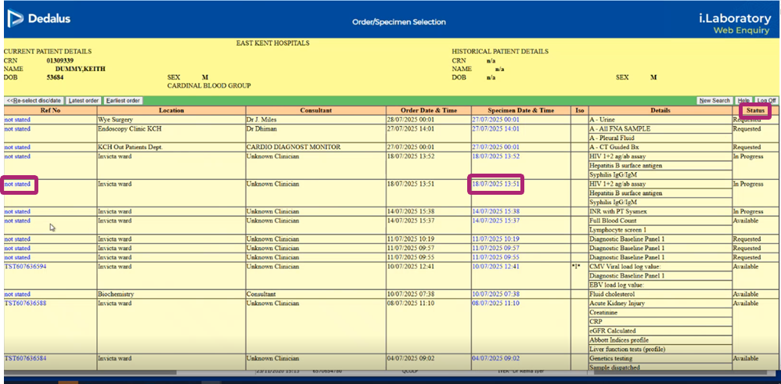
The full report lists the result for each individual test, a reminder of the normal (reference) range, and the status of that individual result.  Note: Results that are out of range have an arrow beside the relevant result, and a highlight colour, depending on the degree of deviation from the reference range. | 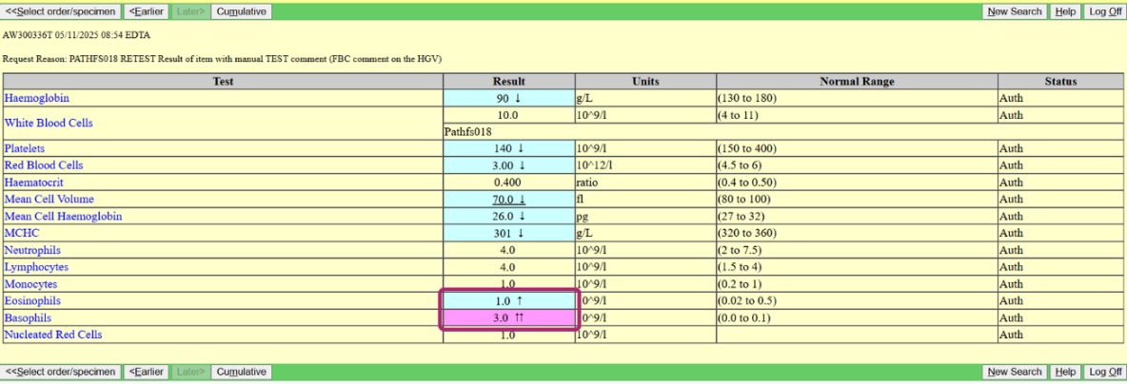
For each test listed, it is possible to click on the hyperlinked test name, to show the cumulative results for that test for that patient as a bar graph. | 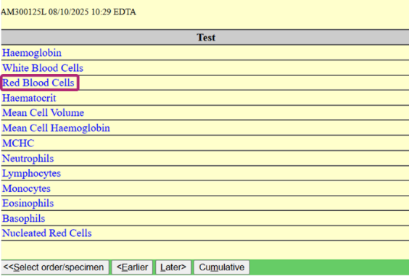
To exit this view, click ‘Select order/ specimen’ at the left of the green menu bar, or use the ‘back’ arrow at the top left of your browser window. | 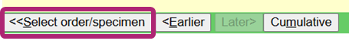
To display the cumulative results as a table, showing all the results from that specimen, click on ‘cumulative’ in the specimen information. | 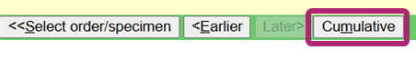
The last 6 results will be displayed, to scroll to earlier results use the buttons at the bottom of the table. | 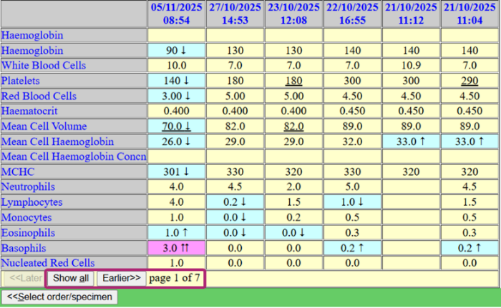
To copy any results, hold down your mouse’s left button and select all the text that you need to copy. Press your right mouse button to copy – this will save formatted data, that can then be pasted into another application. | 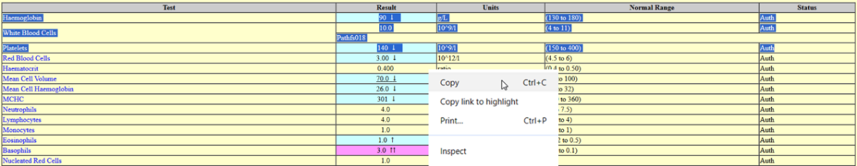
The results can also be pasted into an EMIS comment. | 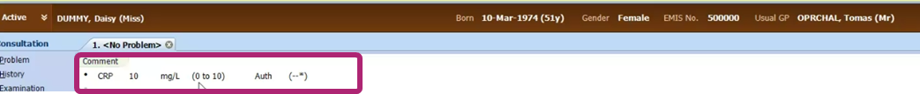
To print the current page, either right click on your mouse or select the print function from your browser. This will open the ‘print preview’ screen, to print to paper of PDF. Alternately you can press CTRL+P on your keyboard. | 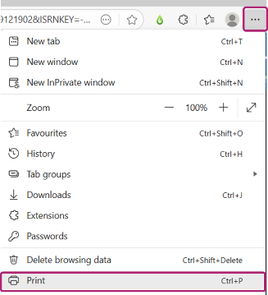

When you have finished, simply close the browser tab to exit the Pathology WebViewer.

