Use the Weblink to open the secure Pathology WebViewer site (this link can also be saved to your browser’s Favourites for future reference).
The steps below are for the 1st time login process, to change your password securely. This must be completed with access to the email address that will be used to log in to the system (as this is verified as part of the process, so initial login cannot be from a colleague’s account, e.g. Practice Manager setting up new colleague’s account).
Once you have logged in and changed the password, please follow instructions in the Pathology WebViewer Quick Reference Guide for regular use.
On the site, you will see the login box (here, it is called Apex Viewer to reflect the lab system, Apex).  Enter your email address, and click ‘log in’ | 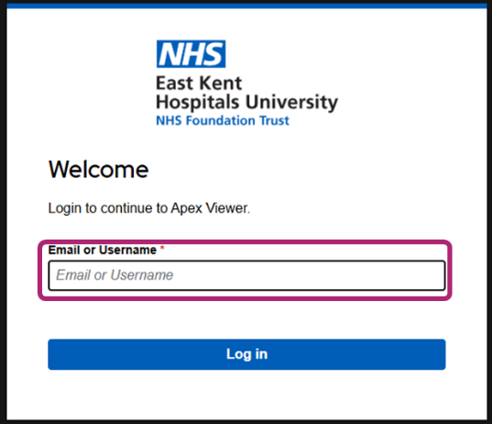
If an account has been created for you, the system recognises your email address which is linked to your account.  The popup box will change to show your email address.  Click on the ‘forgot password?’ button at the bottom. | 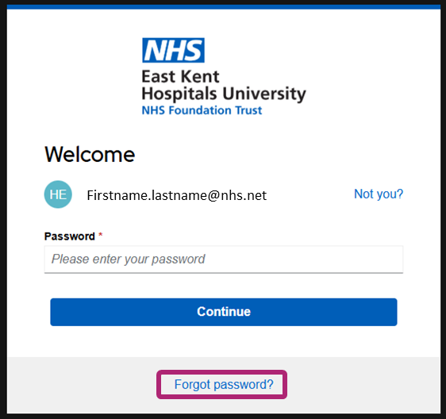
This will take you to the password reset screen.
Fill in the details and press ‘continue’. A popup may appear, with the message ‘email successfully sent’.
An acknowledgement message will appear | 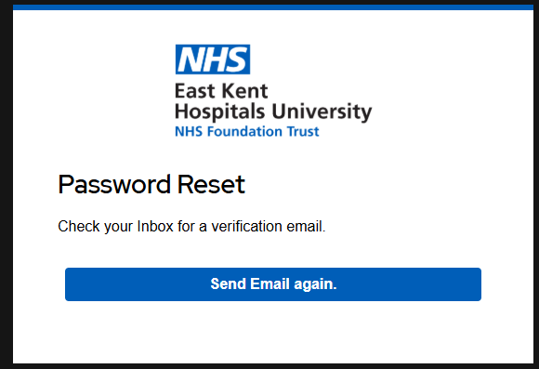
Click on the link in the email you receive, to ‘Reset Password’
When you receive the email, click on the link and enter your details to enter the site. | 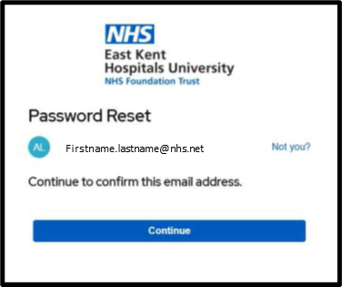
Create your password:
- please use a minimum of 6 characters
- all uppercase
- no consequential characters
- suggested to include a number
The system will advise if the password is the correct strength. | - please use a minimum of 6 characters  - all uppercase  - no consequential characters  - suggested to include a number
Click Continue once you have created the new password . | 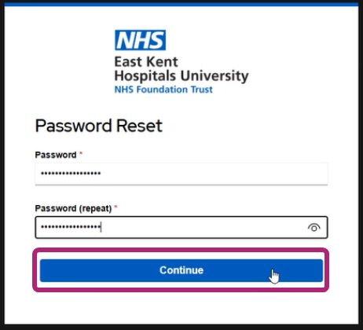
You are now able to log into the WebViewer- type in your work email address
Click Continue once you have entered your new password. | 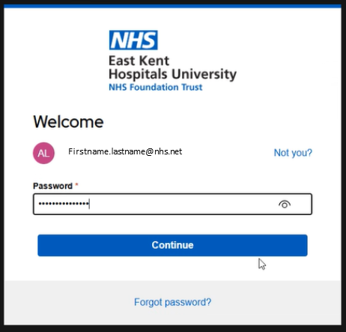
The verification Token will be sent to your work email address.
When the code arrives, copy it and add to the box, then click to verify.

You are now logged into the WebViewer to view Pathology results.
Please follow the instructions in the WebViewer Quick Reference Guide.
If you have any difficulties logging in, please contact the EKHUFT Pathology IT team at ekh-tr.IAMteam@nhs.net
If you don’t receive an email, please complete the relevant part of the RA02b form on the EKHUFT extranet (Apex Viewer).
Unfortunately, because IDs were automatically created, it is possible that even if you had a Dart existing account it is possible that your WebViewer account has not been created, you may need to apply on RA02b.

