

EKHUFT PAEDIATRIC FRACTURE MANAGEMENT
*Not appropriate for VFC – spines, pelvis, hips, head – discuss with Ortho on call. For multiple rib #s – discuss with surgical team
*For suspected hand tendon injuries please refer to East Grinsted via TRIPS for ?plastics
Abbreviations:
# - fracture
VFC – Virtual Fracture Clinic A&E – Accident and Emergency
ASB – Anatomical snuff box ACJ – Acromioclavicular Joint
MC – Metacarpal BAS – Broad arm sling
MT – Metatarsal C&C – Collar and cuff
POP – Plaster of paris T&O – Trauma and Orthopaedics
WB – Weight bearing NWB – Non weight bearing
Useful contacts

WHH VFC: 07929878350 / ekh-tr.VFCWHH@nhs.net
WHH trauma coordinator: 07773152461 (for trauma board patients only)
QEQM VFC: 07929878283 / ekh-tr.VFCQEQM@nhs.net
QEQM trauma coordinator: 07917581606 (for trauma board patients only)
Fracture Clinic Nurse Manager for EKHUFT fracture clinics – Alex Vincent: 07934603535

DIAGNOSIS | INITIAL TREATMENT | MANAGEMENT | CONSIDERATIONS
ACJ / Clavicle #  Minimally displaced/undisplaced  Moderately/significantly displaced | BAS or Polysling  BAS or Polysling | VFC  VFC | Professional sport or art  Consider non accidental injury and document any safeguarding history/concerns
Scapula # | Polysling | VFC – consider early CT if significantly displaced (discuss with Ortho on call) | Check for chest injuries as usually high impact mechanism of injury
Humerus # (Buckle)  Humerus # (Greater tuberosity)  Humerus # (Neck)  Humerus # (Shaft)  Undisplaced Supracondylar #  Displaced supracondylar # /epicondyle displacement – Ortho on call | BAS or Polysing  Double loop C&C  Double look C&C  Above elbow POP  Above elbow POP | Treat as per ACJ/Clavicle advice  VFC  VFC  VFC  VFC  Ortho on call | Neurovascular status  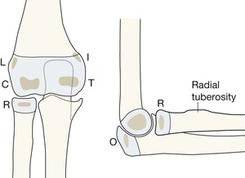CRITOL  (https://radiologykey.com/paediatric-elbow/)  Need true lateral view for radiocapitellar line, neurovascular status and stretch pain assessment
Dislocated shoulder | Reduce and Polysling | VFC | Neurovascular status  Polysling, analgesia and refer to A&E if unable to reduce
Proximal radius #  Head/Neck minimally displaced/undisplaced  Head/neck displaced/comminuted | C&C  C&C | Discharge  Ortho on call | Consider Monteggia # dislocation
Dislocated elbow | Immobilise and analgesia | Ortho on call via A&E | Neurovascular status
Distal Humerus lipohemarthrosis on elbow views with no obvious # | C&C | VFC (if report suggests # or ongoing symptoms)
Olecrannon #  Undisplaced  Displaced | Polysling  Polysling | Ortho on call  Ortho on call | Check extensor mechanism
Combined radius and ulna shaft #  OR  Monteggia/Galeazzi | Above elbow POP  Above elbow POP | Ortho on call  Ortho on call | Monteggia - # proximal ulna and dislocated radial head  Galeazzi - # distal radius and dislocation distal radial/ulna joint
Isolated ulna #  Undisplaced  Displaced | Above elbow POP (wrist splint if ulna styloid only)  Above elbow POP | VFC  Ortho on call | Consider safeguarding – can indicate defence injury
Distal radius #  Torus/Buckle/Undisplaced/Minimally displaced  Displaced radial styloid #  Non angulated greenstick #  Angulated greenstick # | Wrist splint  Wrist splint  Wrist splint  Below elbow POP | Discharge  VFC  Discharge  Ortho on call | Consider VFC referral if buckle/torus of distal radius AND ulna  Assess elbow
Scaphoid  Undisplaced  Displaced  Tender ASB with no # | Below elbow POP  Below elbow POP  Wrist splint | VFC  Ortho on call  Discharge (consider referral to VFC if over 13 years old with tender ASB) | Scaphoid #s unlikely in children under 13 years old or with skeletal immaturity
Carpal #  Triquetral avulsion | Wrist splint  Wrist splint | VFC  Discharge | Consider scapho-lunate widening (Terry Thomas sign) - VFC
1st metacarpal #  Undisplaced – VFC  Displaced – VFC  Bennett’s (Intra-articular base 1st MC) | Thumb splint  Thumb splint  Thumb splint | VFC  VFC  Ortho on call
Proximal thumb #  Undisplaced  Displaced | Thumb splint  Thumb splint | VFC  VFC
Metacarpal # (including Boxer’s #)  Undisplaced  Displaced or rotational deformity  Carpo-metacarpal subluxation/dislocation  Carpo-metacarpal subluxation or dislocation WITH # | Buddy strap and wrist splint  Buddy strap and wrist splint  Buddy strap and wrist splint  Buddy strap and wrist splint | VFC  VFC  Ortho on call  Ortho on call | Ensure a good lateral view is taken  Discuss with Ortho on call if there are bite wounds – may need surgical wash out/antibiotics and screening for BBV’s
Dislocated MCP/IP joints  With no #  Undisplaced #  Volar plate/intra-articular # | Reduce and buddy strap  Reduce and buddy strap  Reduce and buddy strap | VFC  VFC  VFC | Check for laxity  Volar dislocations should be referred to VFC due to likely disrupted extensor tendon
Phalanx #  Undisplaced/extra-articular  Displaced/intra-articular (middle/proximal phalanx)  Distal phalanx #  Displaced/volar plate | Buddy strap  Buddy strap/zimmer splint  Mallet splint  Reduce and buddy strap/mallet splint | Discharge  VFC  VFC  VFC | Record laxity/ROM  Tiny volar plate avulsions can be discharged
Crush terminal phalanx/tuft #  Open  Closed | Wound wash out, dressing, consider antibiotics, mallet splint  Trephine subungual hematoma, dressing, mallet splint | Discharge – Plan UTC/practice nurse wound review  Discharge | Consider QVH East Grinstead TRIPs referral for exposed bone or significant tissue loss  Consider tetanus status
Mallet finger  With #  Without # | Mallet splint  Mallet splint | VFC  VFC | Take lateral X-ray in splint if referring  If there is a wound/cut to extensor tendon – TRIPS referral
Femur # | ABCDE assessment, immobilise analgesia, IV access | Ortho on call (via ED) | High risk for hypovolemia
Patella #  Undisplaced  Displaced | Cricket pad splint +/- walking aid (WB)  Cricket pad splint and walking aid (NWB) | VFC  Ortho on call | Normal variant of bipartite/tripartite
Patellofemoral dislocation | Knee support +/- crutches | Refer to soft tissue knee pathway (including recurrent)
Locked knee | Crutches | Ortho on call
Knee dislocation | Analgesia | Ortho on call via A&E | Check distal pulses
Soft tissue knee injury | Consider knee support and walking aid (MCL injuries to be fitted with cricket pad splint) | Refer to soft tissue knee pathway
Intercondylar tibial avulsion # | Cricket pad splint and walking aid | Ortho on call
Tibial plateau # | Above knee POP or cricket pad splint and walking aid (NWB) | Ortho on call
Tibia  Intra-articular distal tibia #  Displaced/angulated or rotated  Undisplaced/non angulated | Above knee POP  Above knee POP  Walking boot if child ambulant or NWB if child non ambulant | Ortho on call  Ortho on call  VFC | Torus fracture of distal tibial metaphysis (Toddler’s #) or undisplaced spiral distal tibia # with intact fibula in children up to 5 years old – walking boot
Fibula #  Undisplaced Fibula head/neck/shaft  Proximal fibula head avulsion #  Undisplaced distal fibula (Weber A/B/Salter Harris type 2)  Undisplaced distal tibia  Displaced distal fibula with talar shift/Bi-malleolar/Tri-malleolar | Crutches (WB)  Above knee POP  Walking boot +/- walking aid  Below knee POP and crutches  Below knee POP and crutches | Discharge – providing ankle exam normal  VFC  VFC  Ortho on call  Ortho on call via A&E | If medial malleolus tender or syndesmotic widening – below knee POP and crutches  Ensure no talar shift or medial tenderness – below knee POP and crutches  (Salter-Harris-Fracture-Classification.png (2048×1151))  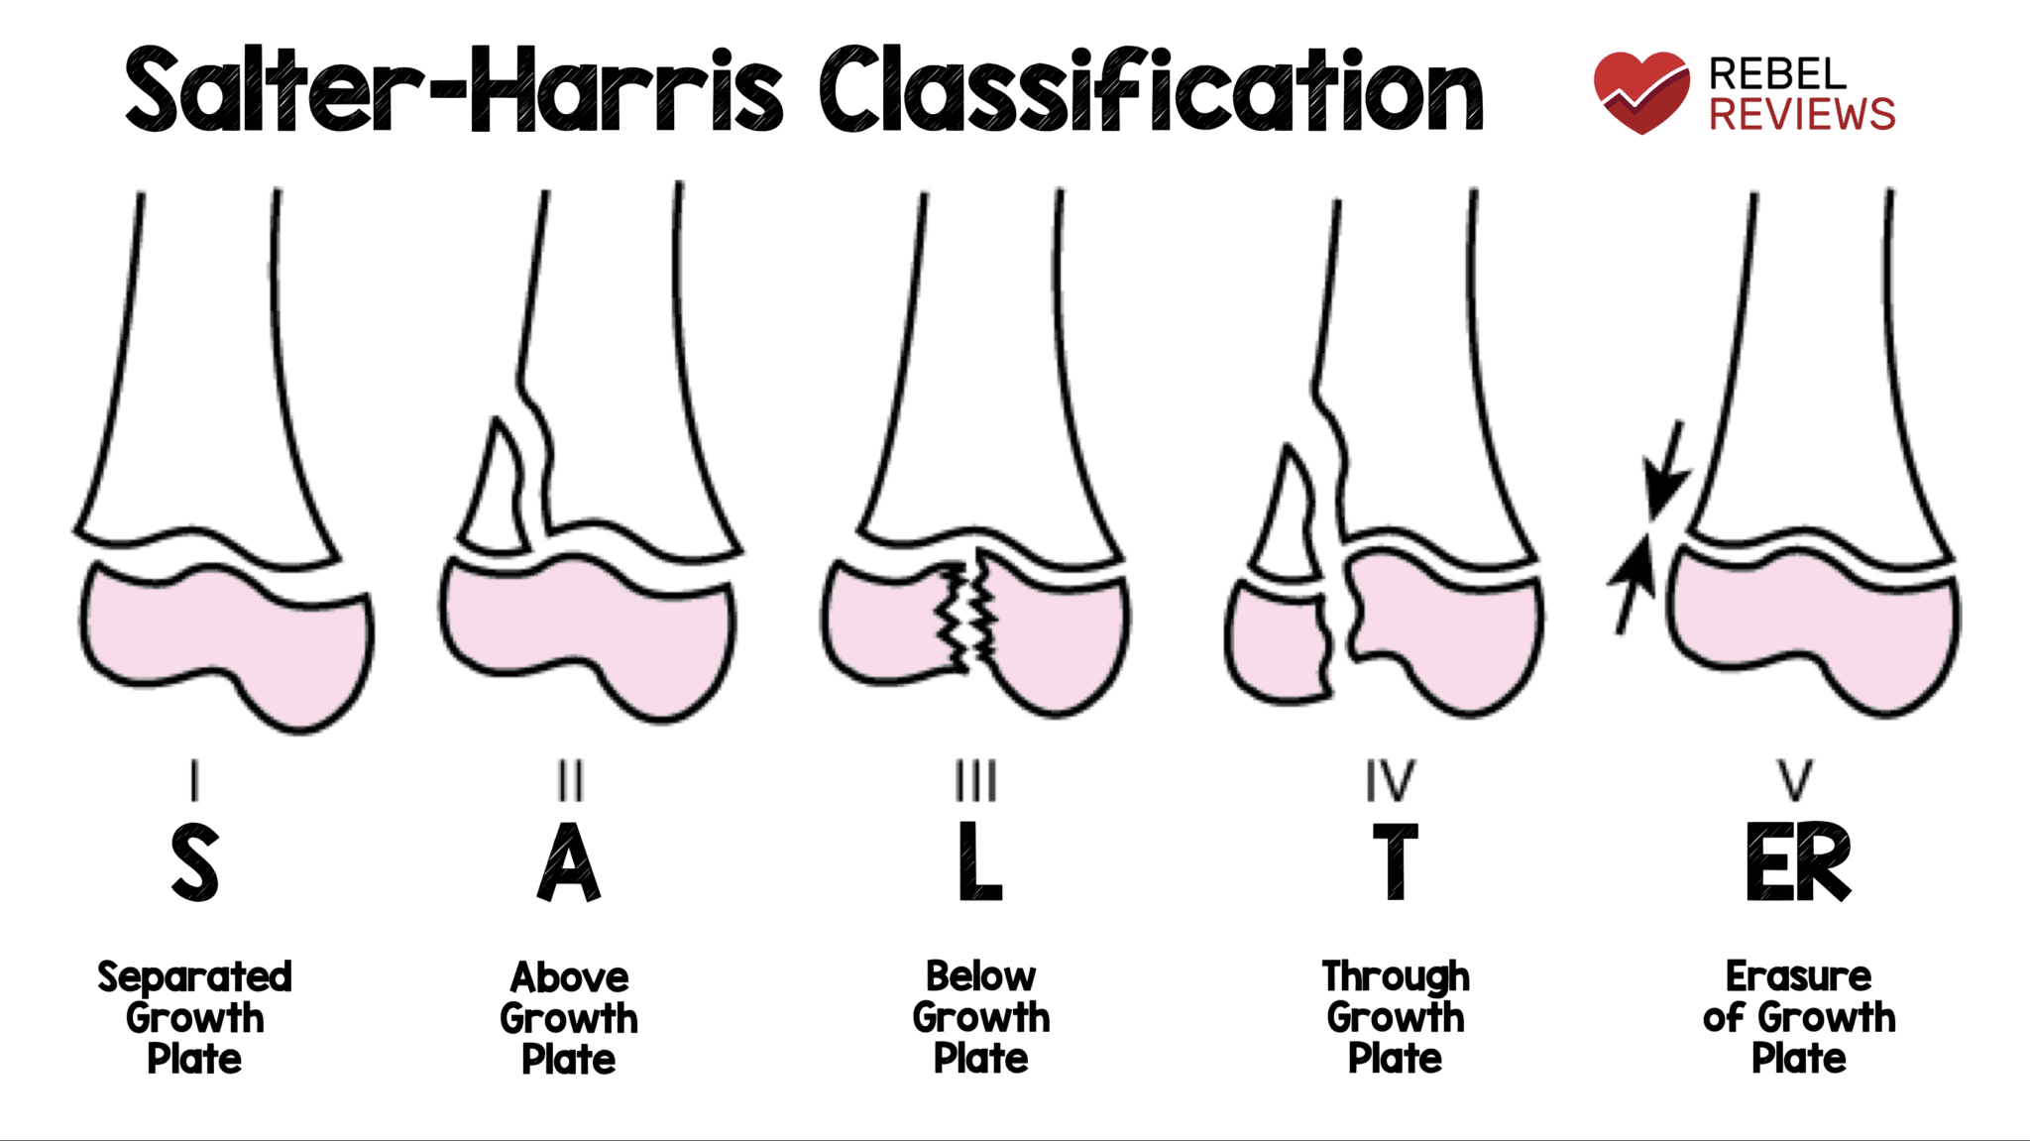
Fibular tip avulsion # | Walking boot/comfortable footwear | VFC
Medial malleolar #  Avulsion  Undisplaced  Displaced | Walking boot  Below knee POP  Below knee POP | VFC  VFC  Ortho on call
Tendo-Achilles rupture | Vacopaed boot/equinis cast | Tendo-Achilles pathway (WHH) or VFC
Talus #  (Talus) Tiny avulsion | Below knee POP, strict elevation and walking aid (NWB)  Walking boot or comfortable shoe | Ortho on call  Discharge
Calcaneum #  Extra-articular avulsion | Below knee POP, strict elevation and walking aid (NWB)  Walking boot or comfortable footwear | Ortho on call  VFC
Navicular #  Tiny avulsion/Undisplaced  Displaced | Walking boot  Below knee POP | VFC  Ortho on call
Tarsal #  Undisplaced  Displaced | Heel bearing shoe or comfortable shoe  Walking boot +/- walking aid | VFC  Ortho on call
Metatarsal #  Undisplaced (including base of 5th MT  Displaced/multiple MTs | Heel bearing shoe or comfortable shoe  Walking shoe | Discharge  VFC | Transverse proximal shaft of 5th MT (Jones’ #) for VFC
Lisfranc | Below knee POP, walking aid and strict elevation (NWB) | Ortho on call | Widened 1st/2nd MT joint  Anti-coagulate unless contraindicated
Greater toe #  Undisplaced/minimally displaced  Displaced/clinical deformity | Heel bearing shoe or comfortable shoe  Heel bearing shoe | Discharge  VFC
Lesser toe phalanx # | Heel bearing shoe or comfortable shoe | Discharge | Reduce if any dislocation/angulation/rotation

