Patient Safety Incident
Response Plan
2025 - 2026

Effective date: August 2025
Interim Review and Update: December 2025
Refresh date: April 2025

Contents
1. Introduction 3
2. Changes since our last Patient Safety Incident Response Plan 3
3. Our Services 4
4. Our Hospitals 4
5. Our Values 5
6. Our Vision 5
7. Our Patient Safety Profile 6
8. Patient safety improvement priorities 8
9. Our Patient Safety Incident Response Plan 9
10. Governance arrangements 14

Introduction
  - This Patient Safety Incident Response (PSIR) Plan sets out how East Kent Hospitals University NHS Foundation Trust (‘the Trust’) intends to respond to patient safety incidents between August 2025 and April 2026. This refreshed plan reflects what we have learnt about the PSIR Framework (PSIRF) requirements and our processes in the last year. It is not a permanent rule that cannot be changed. It will remain flexible and consider the specific circumstances in which the patient safety events occurred and the needs of those affected.
  - The plan describes how the Trust will focus resources on the plan priorities:
      - Compassionate engagement and involvement of those affected by patient safety incidents.
      - Considered and proportionate response to patient safety incidents.
      - Application of a range of system-based approaches to learning from patient safety incidents.
      - Supportive oversight focused on strengthening response system functioning and improvement.
  - This plan should be read in conjunction with the Trust Patient Safety Incident Response Policy (2025) and the Patient Safety Incident Response Framework (NHS England, 2022).

Changes since our last Patient Safety Incident Response Plan
The main changes to the plan since our first plan was implemented in June 2024 are outlined below.
  - Following our Trust, and other Trusts and healthcare providers, highlighting high numbers of patients admitted to hospital with pre-existing pressure damage, we are now working with partners in a system wide group led by the Kent and Medway Integrated Care Board (ICB). In light of this, our planned work within the pressure damage theme related to admitted with pressure ulcers has been superseded by the ICB led work. We continue to actively contribute to this work.
  - Stakeholder events for patient falls, pressure ulcers and nutrition and hydration have informed strengthening of the respective improvement plans. Therefore, pressure ulcers has been discontinued as a theme, remaining as a Trust wide continuous improvement.
  - The dementia work now falls within the mental health workstreams within the Trust.
  - Addition of Safety Standards for Invasive Procedures as an improvement workstream. An internal review of Never Events in 2024, initiated this workstream.
  - Within the delay/failure theme, we previously identified delays or omissions in following up test results (radiology and pathology) as a priority. Our Chief Medical Officer is now leading a group aiming to strengthen the clinical IT systems to enable clinicians to identify and review results and manage onward referrals appropriately. There has been a reduction in delay/failure incidents, however we continue to identify incidents relating to waiting lists. These are now mapped to identify whether a relevant improvement process is in place or is required for the specific speciality e.g. Diabetes and Endocrinology now has an operational improvement plan; a Urology thematic review is underway. We have also implemented a Clinical Harm Review policy to identify potential and actual harm due to delays. This is being used within the cancer pathway and emergency departments. We will undertake a full review of the data relating to delay/failure and delays within Care and Treatment between January and March 2026.
  - Within the medication theme, a review of the electronic prescribing and medication administration (ePMA) system focused on prescribing was completed. The recommendations clarify known issues and have been shared with the Director of Pharmacy and Chief Clinical Information Officer to inform planned updates to the system.
  - In relation to medication administration:
    - PSIIs completed in the last year will inform Learning from Medication Errors policy currently under development.
    - A project has commenced using SEIPS to understand systems issues contribution to missed dose incidents.
  - The national requirement in relation to Deaths in Custody, where health provision is provided by the NHS, has been removed from the plan as the Trust does not provide this service.
  - Safeguarding has been removed as a specific workstream under this plan as this is a statutory (child) and regulatory requirement. Safeguarding staff are members of the PSIRF governance groups and safeguarding, where applicable, is considered within learning responses and investigations.
  - The mechanisms to share learning have been added to the plan.
  - This plan now explicitly aligns with the Trust quality and safety priorities and the annual Quality report timeframes.
  - Our aim is to recruit to two Patient Safety Partner volunteer roles in Quarter 3 2025/26.

Our Services
  - We are a large hospital Trust, with five hospitals and several community clinics serving around 700,000 people in east Kent. We also provide specialist services for a wider population of over a million. We provide several services in the community including home dialysis and the Hospital at Home Team.
  - As a teaching Trust, we play a vital role in the education and training of doctors, nurses, and other healthcare professionals, and are working in partnership with higher education institutions including the Kent and Medway Medical School. We will continue to work with our long-term partners, Canterbury Christchurch University, King’s College University in London and with St George’s Medical School.
  - We value participating in clinical research studies and we consistently recruit high numbers of patients into research trials. Kent and Medway’s Clinical Trials Unit, which opened in 2022, is based in the Queen Elizabeth the Queen Mother Hospital, Margate.

Our Hospitals
  - Kent and Canterbury Hospital Canterbury, provides a range of surgical and medical services. It is a central base for many specialist services in east Kent such as elective orthopaedics, renal, vascular, interventional radiology, urology, dermatology, neurology, stroke and haemophilia services.
  - Queen Elizabeth The Queen Mother Hospital Margate, provides a range of emergency and elective services including comprehensive trauma, obstetrics, general surgery, and paediatric services. It has a specialist centre for gynaecological cancer and modern operating theatres, intensive care facilities, children’s inpatient/outpatient facilities, and a Cardiac Catheter Laboratory.
  - The William Harvey Hospital Ashford, provides a range of emergency and elective services including a trauma unit, as well as comprehensive maternity, paediatric and neonatal intensive care services. The hospital has a renal satellite service and a specialist cardiology unit undertaking angiography and angioplasty.
  - The Royal Victoria Hospital Folkestone, provides a range of local services including an urgent care centre, a thriving outpatients department, the Derry Unit offering specialist gynaecological and urological outpatient procedures and diagnostic services.
  - Buckland Hospital Dover, provides a range of local services. Its facilities include a minor injuries walk-in centre, outpatient facilities, renal satellite services, day hospital services, child health and child development services, ophthalmology surgery and a community diagnostic centre.
  - Further information on the services provided by each of our hospitals can be found on our Trust website. Our Trust Structure is accessible here.

Our Values
  - We are committed to improving how it feels to be a patient being cared for in our Trust, and how it feels to work here.
  - Our values were developed using feedback from staff, patients and stakeholders to support us to deliver the culture we aspire to. They apply to every one of us, irrespective of role, seniority or base.
  - Everything we do is underpinned by our values: people feel cared for, safe, respected and confident we are making a difference.

Our Vision
  - Our mission is improving health and wellbeing and our vision is to deliver “great healthcare from great people”.
  - Our strategic themes are Quality and Safety, Patients, People, Partnerships, Sustainability and Research.
  - Our pillars of change and strategic objectives are driven by our response to the Reading the Signals report (Kirkup, 2022), the importance of meeting national standards for planned, cancer and emergency care, learning from our annual Staff Survey results and Culture and Leadership Programme, and the need to be financially sustainable by providing better care and reducing waste.

Our Patient Safety Profile
  - Analysis of our incident data indicates the top five commonest types of incidents remains unchanged since we implemented our original plan in June 2024 (Table 1). The Trust reports approximately 20 to 25 thousand incidents per year.
Patient Safety Incident Type | 2022/2023 | 2023/2024 | 2024/2025
Tissue viability (including admitted with pressure damage) | 5184 | 5663 | 5735
Delay / Failure | 4108 | 3833 | 2766
Care and Treatment | 2496 | 3098 | 3539
Medication | 2115 | 2277 | 1951
Patient Falls | 2066 | 1946 | 1932
Table 1. Top five commonest types of incident reported in the past three years
  - The profiles of each care group and the relative position of the Trust top five commonest types of incident vary (Table 2).
 | Tissue viability | Delay / Failure | Care and Treatment | Medication | Patient Falls
CCASS | 1 | 4 | 2 | 5 | -
WCYP | - | 5 | 1 | - | -
KCVH | 1 | 3 | 4 | - | 2
WHH | 1 | 4 | 2 | - | 3
QEQMH | 1 | 5 | 2 | - | 4
DCB | - | 1 | 2 | 4 | -
Table 2: Care group relative position of Trust top five commonest types of incident
CCASS – Critical Care, Anaesthetics and Surgical Services
WCYP – Women, Children and Young People
KCVH – Kent and Canterbury and Royal Victoria Hospitals
WHH – William Harvey Hospital
DCB – Diagnostics, Cancer and Buckland Hospital
QEQMH – Queen Elizabeth the Queen Mother Hospital
  - An analysis of our completed Patient Safety Incident Investigations (PSIIs) since June 2024 (eleven in total) identified common contributory factors (Table 3) which were also reflected within the findings of completed After Action Reviews (AARs).
System Factor | Contributory factor theme
People | Higher representation of patients with protected characteristics or potentially affected by health inequalities.  Perception of the value of checklists.  Communication in relation to consent.  Written and verbal communication.
Tools and Technology | Utilising systems to reduce the human element of processes or improve the efficiency of processes.  Availability of equipment.
Tasks | Safety standards for invasive procedures and associated audits.  Record keeping.
Organisation of work | Capacity and demand mismatch.  Risk assessment of staffing.  Redesign of pathway.  Training suitability and frequency.
Internal environment | Awareness of the impact of the environment on safety.
External (to the team) environment | Knowledge of and engagement with Trust wide workstreams.  Addressing inequalities.
Table 3: PSII contributory factors
  - We also reviewed information from complaints and the Patient Liaison and Advisory service, inquests and claims and the learning from deaths process. Similar themes were evident within this data.
  - Stakeholder Engagement
Our initial plan included the following stakeholders in the development and/or agreement of the safety incident profile, these stakeholders continue to be engaged in our PSIR plan and related quality improvement processes.
      - Patient Safety Specialists and patient safety teams
      - Care Group quality governance and patient safety teams
      - Risk management
      - Legal services
      - Complaints and PALS Services
      - Quality Improvement Team
      - Governors
      - Trust Board
      - ICB Lead for PSIRF
  - Data Sources
- Patient safety event data (includes incidents, outcomes, good care and risks)
- Complaints and PALS data
- Legal services data
- Themes from Freedom to Speak Up
- Learning from deaths process
- Discussions with key speciality leads for each of the key themes selected.
  - Our plan has now been aligned to the Trust Annual Quality Report. The timeframes and review requirements for the plan have been agreed based on an annual cycle.

Patient safety improvement priorities
  - Our latest Annual Quality Report sets out our Quality and Safety strategic objective as reducing harm and the delivery of safe services.
  - The specific patient safety priorities for 2025/26 are:
- Improve performance in falls
- Improve performance in hospital acquired pressure damage
- Reduce harm from missed doses of critical medication
- Deteriorating patient: Increase the compliance of response when a patient’s NEWS2 score is 5 or above
- Reduce preventable harm, morbidity and mortality associated with sepsis.
  - Many of the other priorities for clinical effectiveness and patient experience are also relevant to our patient safety incident profile and to support the effective implementation of our PSIRF Policy.
- Timely access to all planned and unscheduled care
- Nutrition: increasing the number of patients who say they have had their dietary needs met
- Addressing health inequalities
- Strengthen the psychological safety across our workforce
- Improve our organisational culture and engagement
- Embed compassionate leadership.
  - Improvement work within the care groups supports the Trust priorities and care group priorities. Staff, within teams and specialities, regularly lead on local projects and audits to inform improvements locally.
  - Based on our patient safety profiling work undertaken our other PSIR plan priorities for this year are to continue to review and address delay/failure incidents and re-invigorating the safety standards for invasive procedures.
  - In addition, we want to improve our approach to engagement with patients, families and staff. We will be adopting the resources available from Learn Together, NHS England and HSIB (2022) and updating our training for staff. Any notifiable patient safety incident, irrespective of application of this plan, will initiate our Trust Duty of Candour process. We also want to improve our understanding and management of the impact of patient safety incidents on patients, family members and staff. This includes improving how we make adjustments for protected characteristics and health inequalities.

Our Patient Safety Incident Response Plan
  - National requirements for a learning response
National criteria | Required response
Never Events | Proportionate response as per the local review and requirements
Deaths thought more likely than not due to problems in care (learning from deaths criteria) | Patient Safety Incident Investigation
Maternity and neonatal incidents meeting Maternity and Newborn Safety Investigations (MNSI) programme criteria | Referred to MNSI for Independent Patient Safety Incident Investigation
Table 4: National criteria for a patient safety incident investigation
  - National requirements for other external / linked processes
    - In all instances, in addition to the required response, a local learning response may be required following discussion at our Incident Review Panel (IRP).
Event type | Required response
Child Deaths | Refer for Child Death Overview Panel review
Deaths of persons living with a learning disability | Refer for Learning Disability Mortality Review (LeDeR)
Deaths of patients detained under the Mental Health Act (1983), or where the Mental Capacity Act (2005) applies, where this is reason to think that the death may be linked to problems in care. | Referred to the NHS England and NHS Improvement Regional Independent Investigation Team for consideration of an independent PSII.
Safeguarding Incidents | Refer to Local Authority Safeguarding leads. Where appropriate the Trust will collaborate with the Local Authority to promote system learning.
Incidents in NHS Screening Programmes | Refer to local screening quality assurance service to determine response required.
Haemovigilance | Relevant incidents should be reported to Serious Hazards of Transfusion (SHOT).
Perinatal Mortality Review Tool (PMRT) | PMRT is a tool to support standardised reviews of care when babies die from 22 weeks' gestation onwards. It aims to provide answers for parents, improve care and prevent future deaths.
Ionising Radiation (Medical Exposure Regulations (IR(ME)R) – accidental or unintended exposure to ionising radiation | In accordance with the Ionising Radiation (Medical Exposure) Regulations 2017, the Trust follows the requirements of the Ionising Radiation (Medical Exposure) Regulation 2017 Regulation 8.
Table 5: National criteria for external/linked review processes
    - For both PSIIs and other national requirements, the anticipated improvement route following completion of the required response is to:
- Develop safety actions or quality improvement to address new insights and/or emerging safety issues identified.
- Where appropriate, insights will be incorporated into existing improvement plans.
  - Local review and requirements
    - Our local review requirements fall into four main categories:
- Trust wide themes
- Trust wide (continuous) improvement workstreams
- Local improvements
- Other
- Infection Prevention and Control
- Maternity and Neonatal
    - Trust wide themes are broad and known issues requiring improvement, where the understanding of the issues or maturity of improvement work requires further review and development.
Theme | Required response
Delay/Failure | - Review against existing / emerging improvement work streams and align if possible.  - Seek assurance of actioning local learning  - Initiate appropriate learning response to explore issues or quality improvement to address issues
Medication | - Review against existing / emerging improvement workstreams and align if possible  - Seek assurance of actioning local learning  - Initiate appropriate learning response to explore issues or quality improvement to address issues
Deteriorating patient (maternity and neonatal) | - See Maternity and Neonatal specific PSIR plan
Table 6: Trust Themes
    - Trust wide (continuous) improvement workstreams are broad and known issues requiring improvement, where the understanding of the issues or maturity of improvement work is well developed. This work is captured within Trust wide improvement plans (TWIPs) and/or quality improvement plans (A3) along with associated metrics.
    - Incidents are reviewed against the existing improvement work and assurance sought regarding local improvements made or planned. Insights from these reviews are periodically reviewed to determine if amendments are required to the workstreams e.g. refinements or additions.
    - The main areas are:
- Patient Falls
- Hospital acquired pressure damage (included under the Tissue Viability plan)
- Nutrition and Hydration
- Deteriorating patient (adult) and Martha’s Rule
- Hospital associated venous thromboembolism (VTE)
- Test results (review and actioning) (NEW for 2025/26)
- Medication missed doses (NEW for 2025/26)
- Safety Standards for Invasive Procedures (NEW for 2025/26)
    - In addition, there are other Trust wide continuous and time limited improvement workstreams which also impact on improving patient safety e.g. achievement of cancer targets, waiting list targets, improving information communication technology (ICT), culture improvement, safeguarding, mental health, and many more.
    - Local improvements are known issues requiring improvement which can be managed locally at ward, speciality or care group level. Incidents are aligned, potential new learning identified and assurance sought regarding the effectiveness of the existing approach to address learning and improvement. Examples would be improvement projects and audits led by individual staff members.
    - Other relate to incidents of concern or interest which are not a national requirement and cannot be aligned to our themes or other improvement workstreams. These are reviewed and consideration given to escalation to our PSIR governance processes and/or commencement of an appropriate learning response or quality improvement.
    - Infection Prevention and Control has a specific PSIR plan for IPC incidents which aligns with national requirements for IPC and with PSIRF. See Appendix 3.
    - Maternity and Neonatal has a specific PSIR plan. This reflects the differing patient safety profile due to the nature of the patient/client group, and thus differing requirements for improvement workstreams than those of the Trust more broadly. This also aligns to the requirements of Reading the Signals (Kirkup 2024).
  - Learning response types
    - We will primarily use the learning response methodologies outlined in Appendix 4. however alternative system based tools may be used dependent on the decision of the Incident Review Panel.
  - Trust incident response capacity
    - In order to ensure a proportionate approach to patient safety responses the staffing resource required to review and respond to patient safety events must be balanced with the number of responses.
    - In the year prior to implementation of PSIRF, the Trust declared 117 SIs (including MNSI) and initiated 98 AARs. In the year following implementation of PSIRF, the Trust has initiated 29 PSIIs, MNSIs, Thematic and MDT reviews and 105 AARs. The number of AARs did not reduce as anticipated. In part this was due to a Trust decision to complete AARs for all moderate harm and above patient falls in order to inform the Trust wide improvement plan. However, overall, there was a 40% reduction in the number of investigations.
    - Whilst our staff were learning the new learning response and investigation methodologies, the time to complete the responses increased.
    - Our focus for 2025/26 is ensuring our patient safety recommendations and actions are robust to enable us to evidence sustained improvements as a result of PSIRF implementation.
 | 2023/24* | 2024/25* | 2025/26** Plan
Serious Incidents | 117
AAR (old) | 98
PSII, Thematic, MDT review |  | 29 | 20
AAR (new) |  | 105 | 30
Swarm huddle |  | 9 | 30
Total | 215 | 143 | 80
Table 7: Actual and planned learning responses (2023/24, 2024/25 and 2025/26)
* June to June
** April 2025 to March 2026
    - Structured Judgement Reviews completed for the Learning from Deaths process have not been incorporated as these are case note reviews which are initiated by the Medical Examiner Service and thus are subject to an initial scrutiny process which is outside of but may feed into the PSIRF processes. The SJRs contribute to learning and improvements via the Mortality and Morbidity Meeting and Learning from Deaths panel process. The latter feeds directly into Incident Review Panel for any reviews which meet national criteria - deaths thought more likely than not due to problems in care.

  - Learning response and oversight capacity
    - The PSII leads have completed the Healthcare Safety Investigation Branch (HSIB) Patient Safety Syllabus Level 3 training or equivalent and two staff have completed the Level 4.
    - Additional courses, such as SEIPS in Action have also been completed by some staff.
    - In-house AAR and Swarm huddle training commenced in 2024.
    - Only one member of staff is recorded as having completed the HSIB Oversight training which comprises of two half day sessions. A bespoke in-house version is under development.
Learning response type | Staff trained (confirmed)
PSII | 13
AAR (new) | 73
Swarm huddle | 268
Oversight | 1
Table 8: number of staff confirmed trained in learning response methodology
    - Both the Swarm huddle and AAR training include use of SEIPS. The Human Factors training available on request also includes SEIPS. The staffing resource for system focused learning responses and investigations will be further expanded in 2025/26.
  - Collaborative working
    - When the Trust is aware of an incident that involves a system partner, the corporate patient safety team contacts the patient safety or governance team within the partner organisation, via their generic email account. The relationships with local and tertiary providers have been forged over several years and collaborative working is the norm. Should there be a significant incident, one which either affects many patients or is a very concerning nature, the ICB and Care Quality Commission (CQC) will be notified.
    - The ICB may decide to lead on the learning response if the incident involves multiple providers and/or there is learning for an ICB function e.g. commissioning.
    - The regional Patient Safety Incident Response Framework Oversight Group (POG) hosted by the ICB ensures cross provider understanding of partner provider PSIR plans.
    - If information needs to be shared with other providers within the learning response, information governance standards must be met. Please see more details within the Information Governance Policy. Staff can access this via the Policy Centre and the public can request this by contacting the Freedom of Information Team.
  - Oversight
    - The Trust oversight responsibilities are outlined within the Oversight roles and responsibilities specification (NHS England, 2022). These are to:
- Ensure the Trust meets national patient safety incident response standards through the development and embedding of the Trust PSIRF policy and plan.
- Ensure PSIRF is central to overarching safety governance arrangements.
- Quality assure learning response outputs.
  - Sharing learning
    - During 2025/26 the mechanisms to share learning will continue to be strengthened within the Trust.
    - Safety Pins are short messages, including learning, which are shared weekly via Trust News (circulated to all staff).
    - The template for sharing learning following safety events has been updated and is used for patient safety events, complaint learning and learning from deaths. These are circulated by email, shared at governance meetings and Mortality and Morbidity meetings and displayed on screens within Medical Education.
    - A maturity matrix for Mortality and Morbidity meetings has been developed and implementation will support improved learning and sharing of learning within the multidisciplinary team.
    - Patient Safety Focus is a new monthly newsletter which shares information and learning in relation to patient safety.
    - Patient Safety Alerts for issues of immediate concern and/or action were implemented in 2025. These are cascaded via the Trust Communications team and via care group email cascade.
    - Maternity has introduced Safety Summits and work is planned to introduce these Trust wide for other specialities. This will be a forum to share learning and discuss patient safety issues with the clinical executives.
    - The Trust Patient Safety Network (MS Teams) has been set up and membership is slowing increasing. This network shares information and learning in relation to patient safety.

Governance arrangements
  - Patient safety incidents are reviewed against the national and local requirements (Tables 4, 5 and 6) Clinical, specialist, patient safety and governance staff review patient safety incidents on a daily basis, escalating any incidents of concern or interest to our PSIRF review governance processes. The flowchart in Appendix 1 summarises how reviews are undertaken and actioned.
  - Patient safety insight, involvement and insight data and patient safety training data is reviewed via the Operational Quality Governance Committee, and subgroups, to the Quality and Safety Committee. The governance structure is illustrated in Appendix 2.
  - During 2025, it is proposed that care group governance reports are aligned to PSIRF to provide assurance in relation to the Trust Themes and Trust wide (continuous) improvement workstreams.
  - Pre-incident review panel (Pre-IRP), Fundamentals of Care Incident Panel (FoCIP), Maternity and Neonatal Rapid Review (MatNeoRR) – these groups review incidents of concern or interest and determine the appropriate response against the PSIR Plan. These determinations from these groups feed into the Incident Review Panel (IRP). Note, where it is obvious the national requirements are met, these cases bypass these groups and are presented directly to the IRP.
  - Learning responses initiated from these groups will have oversight approval by a member of the responsible Care Group Triumvirate.
  - Incident Review Panel – incidents meeting national requirements, potential thematic reviews and incidents which do not align with the PSIR plan and are potentially very concerning are presented and a decision taken regarding the appropriate learning response. This includes inquest cases where there are patient safety concerns and potential learning is apparent. This panel receives a log for oversight of the determinations from the Pre-IRP, FoCIP and MatNeoRR.
  - The findings and actions from learning responses initiated from Pre-IRP, FoCIP and MatNeoRR should be presented to Care Group Governance meetings and summarised within reports to the Operational Quality Governance Committee.
  - Learning Response Approval Panel (LRAP) – reviews learning responses (PSIIs, Thematic and MDT reviews, some AARs) and resultant safety improvement plans. The purpose is to ensure that the national standards for responses have been met and to seek assurance regarding the effectiveness of proposed and implemented safety actions. The Chief Nursing and Midwifery Officer, executive lead for patient safety, supported by the Chief Medical Officer, has oversight of learning responses prior to approval via LRAP.
  - The cases from LRAP are included within the Weekly Quality Governance report to the Executives and summarised within the Monthly Quality Governance report presented at Operational Quality Governance Committee, Trust Management Committee and Quality and Safety Committee.
  - The determinations and decisions from these groups are recorded on the Trust Incident Management System.

Appendix 1: Incident Response Decision Making Flowchart

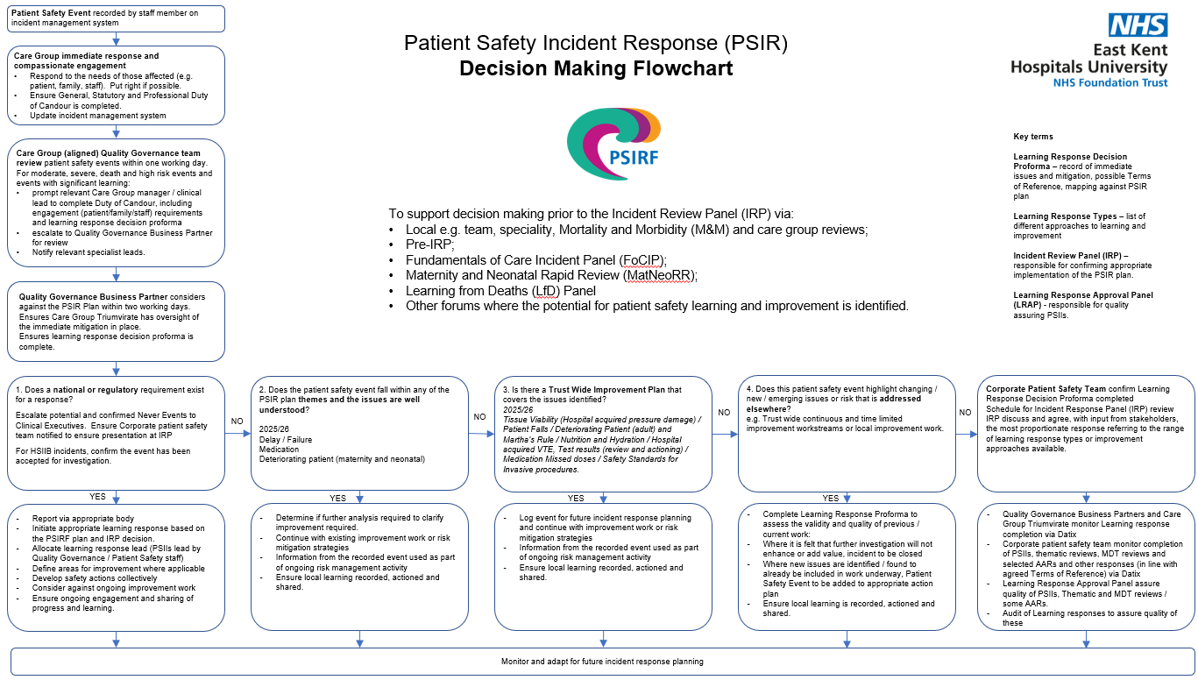
Appendix 2: PSIRF Governance structure – initiation
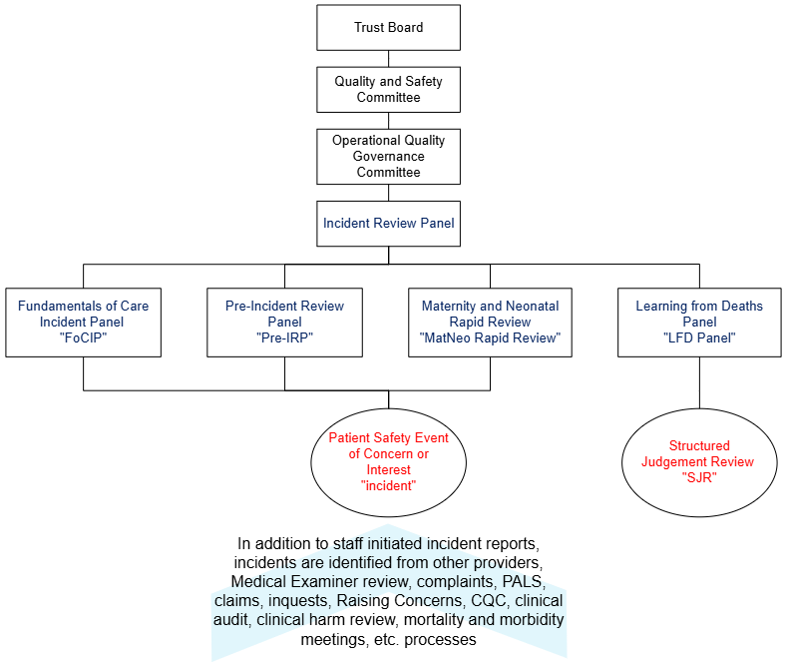
Appendix 3: Infection Prevention and Control PSIRF Plan 2025/26
If, on initial review, there are exceptional circumstances or significant potential for learning related to any of the IPC incident types, an incident should be reported and the incident escalated to the Patient Safety Team for PSIRF review.
Incident type | Apportioning criteria / source | Mandatory Reporting | Report an incident? | IPC review required? | Learning response method | PSII required? | Governance route
Outbreak  No nosocomial deaths | N/A | N/A | Yes | Yes | - Outbreak meeting or local discussion (<2 cases)  - non TB respiratory outbreaks (includes public health) | No | - Email alert to clinical teams  - IPCC and Q&SC reports  - IPC ICB
Outbreak  Nosocomial deaths | N/A | N/A | Yes | Yes | - Outbreak meeting / Post Infection Review (PIR)  - Consultation with PHE re: next steps  - Notify DIPC / patient safety | IRP and CNMO and CMO decision | - Email alert to clinical teams  - ICB  - IPCC and Q&SC reports  - IPCC if PSII commissioned
C.difficile  Toxin positive | All cases | UKHSA HCAI DCS | Yes | Yes | - IPC Rapid review / PIR (within 7 days)  - Inclusion in Thematic reviews bi-monthly (panel) | No | - IPCC and Q&SC reports  - Sunrise alert to clinical teams  - Trust wide performance reporting  - IPC ICB  - IPR performance dashboard
C.difficile carriers (toxin neg, PCR pos) | All cases | N/A | No | Yes | N/A | No | N/A
Invasive Group A Strep (iGAS) | HOHA | UKHSA HCAI DCS | Yes | Yes | PIR | No | - Verbal / Sunrise alert/tag to relevant clinical teams  HO  - IPCC and Q&SC reports  - Sunrise alert to clinical teams  - IPC ICB  - IPR performance dashboard
Invasive Group A Strep (iGAS) | COHA | UKHSA HCAI DCS | Yes | Yes | - PIR  - Support ICB with investigation | No | - Verbal / Sunrise alert/tag to relevant clinical teams  HO  - IPCC and Q&SC reports  - Sunrise alert to clinical teams  - IPC ICB  - IPR performance dashboard
Invasive Group A Strep (iGAS) | COCA  COIA | UKHSA HCAI DCS | No | No | Support ICB with investigation | No
Gram Negative Blood Stream Infection:  Inc E.coli, Pseudomonas aeruginosa and Klebsiella sp. | HOHA  COHA | UKHSA HCAI DCS | No  (2 or more linked cases see outbreak) | Yes | PIR | No | - IPCC and Q&SC reports  - PIIs and outbreaks to IPC ICB  - IPR reporting  - Verbal alert to teams, follow up email alert to clinical teams
Gram Negative Blood Stream Infection:  Inc E.coli, Pseudomonas aeruginosa and Klebsiella sp. | COCA  COIA | UKHSA HCAI DCS | No | No | Support ICB / community with their investigation | No
MRSA bacteraemia | HOHA  COHA | UKHSA HCAI DCS | Yes | Yes | PIR (within 7 days)  Red flags escalation to Patient safety and PSIRF review | No | - IPCC and QSC  - PIIs and outbreaks to ICB  - IPR reporting  - Verbal alert to teams, follow up email alert to clinical teams
MRSA bacteraemia | COCA  COIA | UKHSA HCAI DCS | No | No | Support ICB investigation | No
MSSA Bacteraemia | HOHA  COHA | UKHSA HCAI DCS | No | Yes | PIR | No | - IPCC and Q&SC  - PIIs and outbreaks to ICB  - IPR reporting  - Verbal alert to teams, follow up email alert to clinical teams
MSSA Bacteraemia | COCA  COIA | UKHSA HCAI DCS | No | No | N/A | No | N/A
Surgical Site Infection (SSI) severe or Cluster | N/A | Mandatory SSI Surveillance Mandatory reporting Trauma and Orthopaedics | Yes | Yes | - SSI review document  - Two or more linked cases – local meeting PII | No | - Email alert to clinical teams to agree cause and actions  - IPCC and Q&SC  - IPR reporting
Patient death with C.difficile /MRSA infection documented on Part 1a of Medical Certificate of Cause of Death | HOHA  COHA | N/A | No | Yes | - IPC Rapid review (within 7 days)  - Unclear if learning - SJR  - Potential learning – PSIRF  - Notify DIPC | IRP and CNMO and CMO decision | - IPCC and Q&SC report  - Sunrise alert to clinical teams  - Trust wide performance reporting  - ICB  - IPR performance dashboard  - Possible LfDs  - Possible PSIRF

Glossary

COCA – Community onset community acquired
COIA – Community onset indeterminate acquired
COHA – Community Onset Hospital acquired/associated
CNMO – Chief Nursing and Midwifery Officer and Director of Infection Prevention and Control (DIPC)
HOHA – Hospital onset Hospital acquired/associated
ICB – Kent and Medway Integrated Care Board IPC team
IPC – Infection Prevention and Control
IPCC – Infection Prevention and Control Committee
IRP – Incident Review Panel
LfDs – Learning from deaths
N/A – not applicable
PHE – Public Health England
PII – Period of increased incidence
PSIRF – Patient Safety Incident Response Framework
Q&SC – Quality and Safety Committee
TB – Tuberculosis
UKHSA HCAI DCS – UK Health Security Agency Healthcare Acquired/Associated Infection Data Capture System

Appendix 4: Maternity and Neonatal Plan
To be inserted once finalised
Appendix 5: Learning Response types
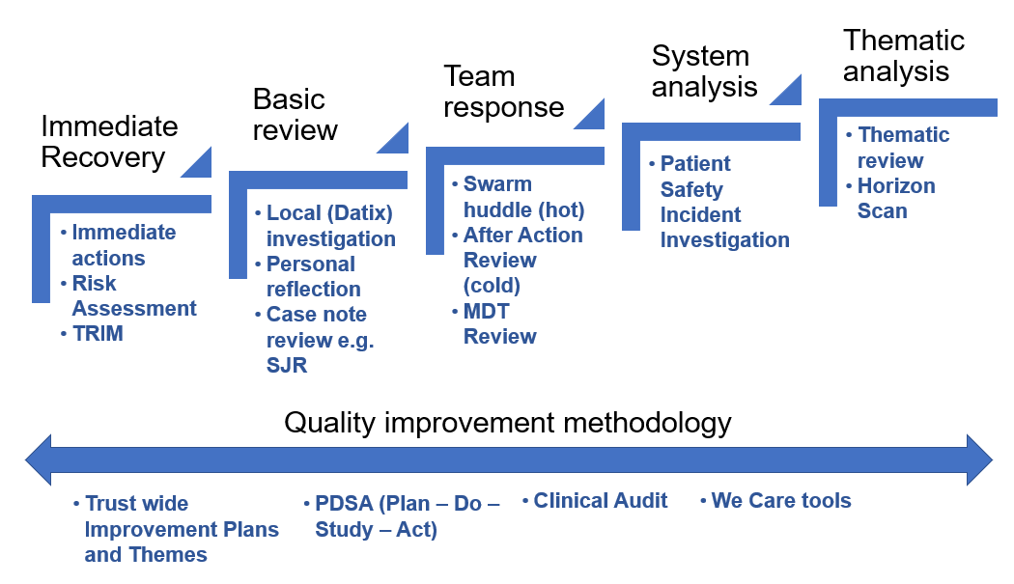
Learning response type | Learning response | Application
Immediate recovery  Address serious discomfort, injury or threat to life  Respond to concerns raised by patient/family or staff  Determine risk – likelihood of consequence | Immediate actions | Attend to the immediate needs of those affected (Patient/family/staff/other) e.g. Duty of Candour, individual debrief, TRIM, etc
 | Risk Assessment | Assess risk, e.g. severity of hazards and likelihood of recurrence.  Determination and prioritisation of control measures – immediate mitigation.
Basic  Assess what, if any, learning or further actions are required.  Limited scope for shared learning unless the individual escalates via informal or formal process. | Local (Datix) investigation | Record the facts obtained from patient/family/staff and determine what, if any, actions required to mitigate the risk of recurrence.
 | Reflection | Professional and personal learning process of assessment of the situation or experience, deriving meaning from this and determining what, if any, changes to their practice may be required.
 | Structured Judgement Review | Make safety and quality judgements statements about each phase of patient care.  Individual judgement regarding good practice and deficits in care.  Formal process to escalate concerns for further review via the Learning from Deaths process.
Team  Local or wider team review to:  Understand the perspectives of all those involved to determine ‘work as done’  Safe space promoting psychological safety  Celebrate success  Identify areas for improvement  Agree actions  Enhance teamwork through communication and collaborative problem solving  Shared learning beyond team promoted | SWARM huddle | Facilitated ‘hot’ review, held within 24 hours of an event.  Gathers all those involved in the event to analyse what happened, how it happened and what needs to be done to reduce the risk of repetition.  Enables insights and reflections to prompt learning.
 | After Action Review | Facilitated ‘cold’ review, held within a week of the event.  Creates a common understanding,  Reflection on success and required improvements.  Identifies specific recommendations and safety actions.  Learning shared beyond the team.
 | Multidisciplinary Review | A look back following multiple events using discussion rather than staff recollections.  Explores a safety theme, pathway or process rather than the individual events.  Considers how differences between work as done and work as prescribed/imagined occur.  Identifies recommendations to determine further review required and/or specific safety actions.
System  Provides a narrative of the event or events.  Considers how the work system influenced the processes and outcomes for patients/families, staff and the organisation.  Usually results in system recommendations and safety actions to enable safe care. | Patient Safety Incident Investigation | Builds as detailed narrative from information gathered and from those involved in the event.  Determines how the work system influenced processes and led to the outcomes.  Clarifies how actions taken made sense at the time.  Synthesises new meaning from the analysis to inform recommendations and safety actions aimed at improving the work system.  Can be used for single or multiple events.
Theme  Analysis of recurring events.  Clarifies where there are or potentially are risks within care processes.  Usually results in system recommendations and safety actions to enable or sustain safe care. | Thematic review | To understand common links and issues within a cluster of similar events.  Seeks to understand the barriers and enablers for safety from either individual incidents or previous learning responses.  Useful to develop Trust wide improvement plans for patient safety.
 | Horizon scan | Collates information from patients/families, staff or external stakeholders about a particular emerging theme.  Structured conversations about work as done, observations of practice and emerging patient and staff risks.  MDT iterative approach to the themes identified considering future plans and potential risks.
Quality improvement  Structured approach to improve quality and sustain improvement. | Audit | A systematic processes used to assess and improve quality and outcomes of patient care.  It establishes whether care is delivered in accordance with recognised standards.  Usually results in actions aiming to standardise quality and outcomes.
 | We Care / KENT project | Clarification of improvement priorities, methodology and metrics.
 | PDSA | Testing and analyse of small scale change to determine if it is improving the process.
Other approaches include but are not limited to:
- Structured Judgement Review is a case note review to identify learning to be discussed at speciality Mortality and Morbidity meetings and/or the Learning from Deaths Panel and shared within and between specialities.
- *Complaint investigations may include patient safety issues and learning.
- *Inquest review and preparation may include patient safety issues and identify learning. This includes responses to Prevention of Future Deaths.
- *Clinical Claim reviews may include patient safety issues and identify learning.
- *Safeguarding reviews and Section 42 investigations may include patient safety issues and identify learning.
- Obtaining clinical or non-clinical specialist opinion.
- Risk Assessment/New Risk on the Risk Register with associated mitigations and planned actions.
- Observation Guide – Observing care as delivered rather than described.
- Walkthrough Guide – structure process to collecting and analysing information regarding a task or process.
- Link Analysis Guide supports the identification of the frequency of interactions in a specific location or environment.
- Interview Guide will support the use of the cognitive interview.
- Timeline Mapping is describing what occurred in chronological order
- Work System Scan / SEIPS analysis is a checklist and documentation tool to ensure the breadth or work system that is considered (this is incorporated into AAR and Swarm huddle and routinely used in PSIIs).
- Table top review of a single incidents using a SEIPS or MDT review approach.
- Undertaking Research
- Action plan / Safety improvement plan development and implementation.

* In determining and confirming the most proportionate response under PSIRF, consideration will include whether there is scope for further learning with an additional patient safety learning response or whether a patient safety learning response may be appropriate to inform other types of investigations and reviews conducted within the Trust.

